Long-term impacts of disturbance on plant and insect communities in forest ecosystems

Thesis

Presented in Partial Fulfillment of the Requirements for the Degree Master of Science in the Graduate School of The Ohio State University

By

Aaron Tayal

Graduate Program in Entomology

The Ohio State University

2025

Thesis Committee

Kayla I. Perry

Mary Gardiner

Sam Ward

Wendy Klooster

Copyrighted by

Aaron Tayal

2025

# Abstract

Forest disturbances including invasive insect outbreaks, windstorms, and tree harvesting impact forest ecosystems by changing abiotic and biotic conditions. These disturbances, which open the canopy tree layer, create new opportunities for the growth of tree regeneration, as well as support novel insect communities. While short-term impacts of forest disturbance are well-studied, there are gaps in knowledge of long-term effects of disturbance, as well as effects of two disturbances in sequence. In Chapter 1, we investigated ash tree regeneration in the wake of emerald ash borer (EAB). We studied long-term monitoring plots near Detroit, MI where EAB has been present for over 20 years, asking whether ash (*Fraxinus* sp.) regeneration is surviving and growing, and whether this regeneration is being affected by lingering populations of EAB. We found that regeneration is proceeding differently depending on the hydrology of stands. In some hydric swamp forests, ash regeneration has reached the size of small trees (2.5-10 cm diameter at breast height), whereas in mesic riparian and xeric upland forests, ash regeneration remains in smaller size classes. Our results suggest that ash regeneration has, with few exceptions, not grown large enough to produce seeds, but may persist if parasitoid wasps can control EAB populations. In Chapter 2, we studied the short- and longer-term impacts of a tornado disturbance and subsequent salvage-logging on ground beetles (Coleoptera: Carabidae). We hypothesized that both the windthrow and subsequent salvage-logging would increase alpha-diversity initially, but that salvage-logged plots would have lower diversity in the longer-term, due to alteration of biological legacies such as woody debris. We sampled ground beetles at Powdermill Nature Reserve in Westmoreland County, Pennsylvania during the growing seasons of 2015 and 2022, identified Carabidae to species, and measured 10 functional traits of each species. Our results show that salvage-logged habitat differed in ground beetle species and traits from undisturbed forest, while unsalvaged windthrow was similar to the undisturbed forest. Species common in salvage-logged habitat tended to be smaller, flight-capable, and have proportionally larger eyes and longer rear trochanters, suggesting that environmental conditions are filtering species based on their traits. Differences between forest management treatments were still detectable nine years after salvage-logging, indicating that combined natural and anthropogenic disturbances have lasting impacts on biodiversity.

# Acknowledgments

I would like to thank my research advisor, Kayla Perry, for providing encouragement as I learned about forest entomology. She offered to lend books as well as gave excellent advice for setting up my hypotheses, deciding what I was going to record (both in the field and at the microscope), and gave helpful feedback on many presentations and these thesis chapters. I would like to thank the members of the Perry Lab for their support and advice on improving my research. And I would like to thank my committee members, the professors who taught my classes, and the graduate students in my classes. They have truly solidified my interest in the subject, and their dedication is evident.

Chapter 1 would not have been possible without the work of numerous people who set up the Michigan research plots between 2004-2008. I would like to thank Dianne Hartzler for support in relocating the research plots and being a vital resource for understanding how to prepare for the tree survey fieldwork. Tony Garro provided two summers of fieldwork assistance which involved dealing with the elements and the bugs for long hours. The teams at car rental companies and hotels also indirectly supported our fieldwork. Toby Petrice confirmed identifications of parasitoid wasps. Luciana Musetti provided advice on insect specimen collection. Jessi Raubenolt, Cesia Cerrato, and Kayla Perry provided additional fieldwork support. Kathleen Knight gave advice on prism traps and ash identification. The staff at the Huron-Clinton MetroParks and Michigan Department of Natural Resources kindly approved our research project.

Chapter 2 would not have been possible without the work of many people. Kayla Perry and Andrea Kautz designed the experiment and coordinated and carried out the entirety of insect collections at Powdermill Nature Reserve in 2015 and 2022. Kayla Perry identified all the ground beetles collected in 2015. Without their work, this project would never have happened. Suranga Basnagala provided detailed assistance to me as I learned to identify ground beetles and helped me numerous times in learning the basics of identification, giving encouraging feedback on presentations, and learning more about insect diversity. Trap collection support was done by Bryce Stouffer and Rachel Lloyd. The company which completed salvage-logging in 2013 was essential for creating the forest management treatments which we tested in this study. Pitfall trap sorting, which enabled the investigation of ground beetles, was done by Carolyn Velazquez, Cassian Filbrun, Cesia Cerrato, Diane Hartzler, Haley Marcum, John Gallander, Lizzie Arnold, and Suranga Basnagala. Cesia Cerrato helped with measuring functional traits of beetles. Bob Davidson was instrumental in confirming 2015 species identifications and providing taxonomic expertise.

Lastly, I would like to thank my family for their consistent support throughout the entirety of my degree.

# Vita

2017…………………………………………………Bishop Watterson High School

2021…………………………………………………B.S. Mathematics, The Ohio State

University

2023 to Present………………………………………Graduate Research Associate, Department of Entomology, The Ohio State University

Publications

Mattingly, K.Z., C.T.C. Day, E.S.J. Rauschert, **A. Tayal**, S.M. Hovick. 2022. Genetic and morphological comparisons of lesser celandine (Ficaria verna) invasions suggest regionally widespread clonal and sexual reproduction. Biol Invasions 25 (2023): 379-397. https://doi.org/10.1007/s10530-022-02921-4.

Palacio‐Lopez, K., S.M. Hovick, K.Z. Mattingly, L.M. Weston, N.P. Hofford, L. Finley, **A. Tayal**, and J.A. Reinartz. “Suppression of Reed Canarygrass by Assisted Succession: A Sixteen‐year Restoration Experiment.” Journal of Applied Ecology 61, no. 8 (August 2024): 1805–16. https://doi.org/10.1111/1365-2664.14705.

Fields of Study

Major Field: Entomology

# Table of Contents

Abstract ii

Acknowledgments iv

Vita vi

Table of Contents vii

List of Tables viii

List of Figures x

Chapter 1 The long-term impacts of emerald ash borer in forests near the epicenter of invasion 1

Chapter 2 . The effects of a tornado and salvage-logging on ground beetles 40

Appendix A 88

Appendix B 101

# List of Tables

**Table 1.1.** Density (± standard error) of living ash (*Fraxinus*) regeneration in hydric (10 transects), mesic (8 transects), and xeric (19 transects) forests in the Upper Huron River Watershed in Southeast Michigan, USA. Only living trees are tabulated here. Data were collected in 2024 (97 plots) and 2025 (14 plots). 18

**Table 1.2.** Relative density and relative dominance of tree genera found in the 10 hydric transects (30 plots) in 2024-2025. Only living trees are counted. Canopy trees are ≥12.5 cm DBH, while understory trees are 2.5-12.5 cm DBH. A total of 810 living canopy trees were counted in the main plots and 638 living understory trees were counted in the subplots. Shrub species were not counted. 22

**Table 1.3.** Average percentage cover (± SE) of understory cover types in 10 hydric transects (30 plots). Standard errors were calculated using n=30. 25

**Table 2.1.** Morphological traits and literature-based traits used in this study, and their connections to habitat variables that could be impacted by forest disturbance. 51

**Table 2.2.** Total trap catch of ground beetle species (Coleoptera: Carabidae) collected via pitfall traps at Powdermill Nature Reserve, Rector, Westmoreland County, Pennsylvania, USA. Sampling occurred from 27 May to 17 August, 2015, and from 1 June to 23 August, 2022. 61

**Table 2.3.** Main effects of forest management treatments (windthrow, salvaged, undisturbed forest) and year (2015, 2022) on activity-abundance, species richness, species diversity, community-weighted means (CWM) for individual traits, and functional diversity for ground beetles collected at Powdermill Nature Reserve Rector, Westmoreland County, Pennsylvania, USA. The model type column indicates if the model was a standard linear model (LM), a linear mixed-effects model with transect included as a random effect (LMM), or a generalized linear model with Poisson errors (GLM). Dashes indicate that the p-value is above 0.10. Patterns with a p-value below 0.05 are bolded. Beetles were collected between 27 May to 17 August, 2015, and from 1 June to 23 August, 2022. 1

**Table 2.4.** Means (± standard errors) of the response variables for ground beetle biodiversity. 4

**Table 2.5.** Main effects of forest management treatments (windthrow, salvaged, undisturbed forest) and year (2015, 2022) on community composition of ground beetles collected at Powdermill Nature Reserve Rector, Westmoreland County, Pennsylvania, USA. The models use the dissimilarities between plots (Bray-Curtis for taxonomic beta-diversity and inter-community mean pairwise distance in trait space for functional beta-diversity). The PERMANOVA uses the matrix of dissimilarities to partitions how much variation can be explained by treatment, year, and their interaction. The BETADISPER tests whether there are differences between groups in dispersion from the group spatial median. Dashes indicate that the p-value is above 0.10. Patterns with a p-value below 0.05 are bolded 1

**Table 2.6.** Main effects of forest management treatments (windthrow, salvaged, undisturbed forest) and year (2015, 2022) on environmental variables in the understory at Powdermill Nature Reserve, Rector, Westmoreland County, Pennsylvania, USA. All models were linear mixed-effects models with transect included as a random effect (LMM). Dashes indicate that the p-value is above 0.10. Patterns with a p-value below 0.05 are bolded. 1

**Table 2.7.** Means (± standard errors) of the environmental variables in the understory. 2

**Table A.1.** Plot locations for the 111 plots visited in this study. Each set of three plots makes up a transect. Each transect was given a hydrological class of xeric (19 transects), mesic (8 transects), or hydric (10 transects). The plot numbers go up to 114 because they skip 46-48, because transect K (Smith 2006) was not visited. 2

# List of Figures

**Figure 1.1.** A) Map of southeast Michigan, showing the locations of the seven parks where forest stands were surveyed. B) Plot design, showing the 18 m radius main plot, the 8 m radius nested subplot, and the four 4 m2 area microplots located in cardinal directions. 7

**Figure 1.2.** Ash occurrence in 37 transects in the Upper Huron River Watershed in southeast Michigan. The x-axis represents the soil hydroclass of the transect. Each data point represents a transect. Lowercase letters above bars indicate statistically significant differences at α=0.05. A) Mean density of ash seedlings (all ash with height < 1.37 m; short and tall seedling categories were combined for the graph), B) mean density of ash saplings (height ≥ 1.37 m and DBH < 2.5 cm), C) mean density of living understory ash trees (2.5 cm ≤ DBH < 10 cm), D) mean basal area of all living ash trees (DBH ≥ 2.5 cm). The basal area of living ash trees was not statistically investigated. 17

**Figure 1.3.** The presence or absence of symptoms of EAB plotted against tree diameter at breast height (DBH) for 283 ash trees. Trees were included in the analysis if they belonged to a forest plot containing at least 10 trees. Grey circles are individual trees, which are plotted as y=1 for presence or y=0 for absence (points were vertically jittered slightly). Black line shows the overall fitted model, disregarding each specific random intercept for each plot. See Figure S4 for plots including each random intercept. Asterisk next to the lines for woodpecker predation marks, epicormic sprouts, and canopy decline indicate a slope significantly different from zero. Red triangles show the proportion of trees that have the symptom within a DBH bin. For E, tree death is defined as having a canopy condition of 5. For F, canopy decline is defined as having a canopy condition between 2-5 (minor to complete defoliation). 20

**Figure 1.4.** Basal area of living trees in 10 hydric transects (30 plots). Each dot represents a single plot. A) Canopy trees (≥ 12.5 cm DBH); B) understory trees (2.5-12.5 cm DBH). Tree genera were only included in the graph if their mean basal area was in the top seven for either canopy or understory trees. Note the difference in y-axis scale between the two graphs. Boxplot boundaries represent the 25th and 75th percentiles, while center line within the box is the median. 23

**Figure 1.5.** Nonmetric multidimensional scaling (NMDS) of the tree species composition at the 30 hydric plots visited in 2025. Each point is a plot. Data used to generate the NMDS was the basal area per hectare of each tree species, counting all trees ≥ 2.5 cm DBH. The final stress value was 0.149. Species within the red oak group (*Quercus* section *Lobatae*) were lumped together for the analysis, as were species within the white oak group (*Quercus* section *Quercus*) and the genera *Ulmus* and *Populus*. 24

**Figure 2.1.** Map of the study area. The study is located at Powdermill Nature Reserve in Rector, Westmoreland County, Pennsylvania. Red shading represents forest affected by the tornado but left unsalvaged, whereas yellow shading represents forest affected by the tornado and subsequently salvage-logged. Colored dots are drawn in the plot locations, where pitfall traps were installed. Locations of plots have been slightly adjusted on this map to coincide with shapefiles of the shaded areas. White lines connecting the plots indicate the transects, which span the forest disturbances and extend into the undisturbed forest. 46

**Figure 2.2.** Total activity-abundance (A) and species richness (B) of ground beetles collected in windthrow, salvaged, and undisturbed forest in 2015 and 2022 at Powdermill Nature Reserve, Rector, Westmoreland County, Pennsylvania, USA. Bar height is the group mean, and whiskers indicate the standard error of the mean. 59

**Figure 2.3**. Activity-abundance of open-habitat or habitat-generalist ground beetle species (A) and forest-specialist species (B) collected in windthrow, salvaged, and undisturbed forest in 2015 and 2022 at Powdermill Nature Reserve, Rector, Westmoreland County, Pennsylvania, USA. The forest affinity information was collected from Larochelle and Larivière (2003). Bar height is the group mean, and whiskers indicate the standard error of the mean. 60

**Figure 2.4.** Community-weighted mean (CWM) traits of ground beetles collected in windthrow, salvaged, and undisturbed forest plots in 2015 and 2022. Circular points are observations from 2015, while triangles are observations from 2022. Sample size is 6 plots for windthrow, 6 plots for salvaged, and 12 plots for undisturbed forest. (A) CWM body length, measured as the sum of head length, pronotum length, and elytron length. (B) CWM flight capability, as indicated in the literature (Larochelle and Larivière 2003). Values closer to 1 indicate that a higher proportion of individuals collected were identified as flight-capable species. (C) CWM eye length (posterior to anterior edge of eye) standardized to body length. (D) CWM meta-trochanter length standardized to body length. (E) CWM antenna length standardized to body length. (F) CWM water affinity, as indicated in the literature. Values closer to 1 indicate that a higher proportion of individuals collected belonged to species which prefer wet soil or live near water. A significant effect of forest management treatment was found for A-D, while no significant effects were found for E-F. 64

**Figure 2.5.** Nonmetric multidimensional scaling (NMDS) ordinations of ground beetle communities in taxonomic space (A) and functional trait space (B). Each point is a plot in a given year; shape of the point indicates the year the community was sampled, while color indicates the forest management treatment. The NMDS ordinations resulted in stress values of 0.224 for taxonomic beta-diversity and 0.181 for functional beta-diversity. 2

**Figure A.1.** The total number of small ash trees (2.5 – 10 cm DBH) found in 37 transects in the Upper Huron River Watershed. Small ash of all canopy conditions are counted. Bars are shaded based on the proportion of each ash species that was found in a transect. Green represents green, white, and/or pumpkin ash; black represents black ash; light blue represents unknown ash species. 10

**Figure A.2.** Yellow pan trap design using nested yellow bowls attached to a wooden stand and strapped to an ash tree. 10

**Figure A.3.** Captures of EAB adults from Prism traps in 2024. Collection interval 1 corresponds to June, while collection interval 2 corresponds to July. 11

**Figure A.4.** The presence or absence of symptoms of EAB plotted against tree diameter at breast height (DBH) for 283 trees in the 10 forest plots containing at least 10 trees. Colored points are individual trees, which are plotted as y=1 for presence or y=0 for absence (points were vertically jittered slightly). Points are colored based on the plot they belong to. Colored lines show the models for each estimated random intercept corresponding to each plot. 13

**Figure B.1.** Species accumulation curves for A) 2015 ground beetles and B) 2022 ground beetles. The x-axis shows the number of sampled plots, while the y-axis shows the species richness. 14

**Figure B.2.** Biplot of the first two principal component axes of the principal components analysis (PCA) of the eight numerical traits measured for 47 ground beetle species. Blue arrows with labels are the eight trait variables, which are explained in Table 1. Black text in the graph indicates the locations of each species in trait space, following the abbreviations in Table 2. The word “standard” after a variable name indicates that it has previously been divided by body length to address high correlations with body length. The species *Notiophilus aeneus* was omitted from the PCA. 15

**Figure B.3.** Biplot of the third principal component axis (y-axis) against the first principal component axis (x-axis) of the principal components analysis (PCA) of the eight numerical traits measured for 47 ground beetle species. Blue arrows with labels are the eight trait variables, which are explained in Table 1. Black text in the graph indicates the locations of each species in trait space, following the abbreviations in Table 2. The word “standard” after a variable name indicates that it has previously been divided by body length to address high correlations with body length. The species *Notiophilus aeneus* was omitted from the PCA. 16

# The long-term impacts of emerald ash borer in forests near the epicenter of invasion

Introduction

Forests are increasingly impacted by anthropogenic stressors, including the establishment and spread of nonnative species (Lovett et al. 2006). Exotic tree-feeding insects have been especially significant, causing economic and ecological impacts (Gandhi and Herms 2010, Van Driesche and Reardon 2016). These pests can undergo exponential population growth because top-down and bottom-up processes are reduced in the invaded range. Insects introduced to a new region of the globe can escape their specialist natural enemies which might otherwise control their populations (Roy et al. 2011, Duan et al. 2023). Furthermore, native tree species do not share a coevolutionary history with nonnative insects and may lack the necessary physical or chemical defenses (Villari et al. 2016, Mech et al. 2019). Release from these top-down and bottom-up controls can lead to rapid and widespread mortality of host trees. Tree mortality causes ecological consequences which have short- and long-term impacts on forest structure and function. In the short term, tree mortality forms canopy gaps that increase light availability and temperature and alter soil moisture on the forest floor (Perry and Herms 2019). Depending on the size, surrounding canopy and understory trees or advanced regeneration will respond to the available resources and grow to fill the gaps. If the host tree species has surviving seedlings, saplings, or root sprouts, this regeneration may compete to reclaim the space. However, regeneration of the host tree species can be hindered by the continual presence of the nonnative insect. Eventually, host tree species may be functionally eliminated from forests, or they may persist (McCormick and Platt 1980). If they do persist, they may do so in a different size range, or only within certain forest types (Barnes 1976).

Emerald ash borer (EAB, *Agrilus planipennis* Fairmaire) is an introduced woodboring beetle (Coleoptera: Buprestidae) that has had substantial direct and indirect ecological impacts in forests (Klooster et al. 2018). First identified near Detroit, Michigan in 2002, EAB has since spread throughout the eastern United States and Canada. Extensive mortality of North American ash (*Fraxinus* spp.) has occurred in regions where EAB has become established. For example, mixed deciduous forests near the epicenter of the EAB invasion experienced more than 99% mortality of canopy ash by 2009 (Klooster et al. 2013). Ash trees with EAB larvae tunneling in their vascular system exhibit symptoms like bark splitting, epicormic sprouting, canopy foliage dieback, and death (Knight et al. 2014). Concurrent with the death of mature ash, viable seed production declined precipitously, which threatens to eliminate the ash from forests (Klooster et al. 2013). To attempt control of EAB populations, several biological control agents native to east Asia have been widely released in eastern North America. Three parasitoid wasp species have established and are impacting EAB populations (Duan et al. 2015, 2023, Aker et al. 2022, Quinn et al. 2023).

Although the majority of mature ash have died, ash seedlings and saplings that were too small to be colonized by EAB during the initial wave of mortality are abundant in many forest understories (Aubin et al. 2015, Ward et al. 2021). If this regeneration grows large enough to reproduce and generate viable seeds, then ash could remain a long-term component of eastern North American forests. However, EAB populations persist in post-outbreak forests, albeit at low densities (Duan et al. 2015). As ash saplings grow to larger sizes, they become susceptible, increasing the likelihood that persisting populations of EAB will kill them (Duan et al. 2017). Recent evidence suggests that the introduced parasitoids could provide enough EAB-population control to protect regenerating ash in post-outbreak forests (Duan et al. 2015, McCullough 2019). *Tetrastichus planipennisi* Yang (Hymenoptera: Eulophidae) parasitizes EAB larvae through the thinner bark of young ash trees (<12 cm in diameter) (Abell et al. 2012, Duan et al. 2023), while the longer ovipositor of *Spathius galinae* Belokobylskij (Hymenoptera: Braconidae) may allow it to parasitize EAB larvae within ash trees up to about 39 cm in diameter (Murphy et al. 2017). Meanwhile, the tiny *Oobius agrili* Zhang & Huang (Hymenoptera: Encyrtidae) parasitizes EAB eggs in bark crevices (Quinn et al. 2023). The long-term persistence of ash populations in natural forests of North America will depend on the dynamic interactions among the cohort of immature ash in the forest understory, competing plants, low-density EAB populations, and introduced parasitoids.

Although EAB attacks ash trees in a variety of forest types (Smith et al. 2015), the long-term persistence of ash may occur only in a subset of the forest types which it once occupied. Forests where ash is found include abandoned agricultural fields (Morris et al. 2023), mixed hardwood forests on slopes (Royo and Knight 2012), riparian areas along streams (Engelken et al. 2020), river floodplains (Siegert et al. 2021), swamps formed from glacial lake plains (Abella et al. 2019), and depressional areas fed by ground or surface water (Golet et al. 1993). These forests can be classified using a variety of abiotic characteristics, but hydrology is one of the most impactful because of its effect on tree survival and species composition (Megonigal et al. 1997, Niinemets and Valladares 2006). Forest stands may be classified as xeric upland, mesic riparian, or hydric swamp. Ash species vary in their hydrological niches, with white ash (*Fraxinus americana* L.) preferring xeric or mesic sites, green ash (*Fraxinus pennsylvanica* Marsh) preferring mesic or hydric sites, and black ash (*Fraxinus nigra* Marsh) preferring hydric sites (Burns and Honkala 1990, Wagner and Todd 2015). Black ash is notable because it is often extremely abundant in hydric forests, and has adaptations to continue transpiration even when the ground is flooded (Telander et al. 2015, Kolka et al. 2018). Because canopy ash mortality may have had a larger impact in hydric swamps, and because these forests experience seasonal flooding which stresses plant roots, tree regeneration in hydric swamps deserve further study.

Given the uncertain future of ash in eastern North American forests, it is important to understand the potential for ash survival and regeneration in invaded forests with low-density EAB populations and a history of biological control releases. We resurveyed long-term forest research sites established during the early stages of ash mortality near the epicenter of invasion to investigate the occurrence and health of ash populations more than two decades after the detection of EAB. Our first objective was to quantify the abundance and health of ash regeneration in hydric, mesic, and xeric forests. We predicted that newly germinated seedlings would be absent due to a lack of seed-producing ash trees, and that the incidence of signs and symptoms of EAB would increase with increasing ash tree diameter (Klooster et al. 2013, Duan et al. 2017, Ward et al. 2021) due to the continued presence of EAB in these forests. Furthermore, we predicted that occurrence of ash regeneration would depend on soil hydrology of the forest, due to the associations between hydrology and ash species, canopy gap size, abiotic stressors, and understory vegetation dynamics. Our second objective was to evaluate whether introduced parasitoid natural enemies of EAB could be recovered at our sites. To further explore the responses in hydric forests, our third objective was to characterize changes in plant communities over time following the loss of ash.

Methods

Study area

This study was conducted in 37 transects previously established in 2004-2008 in mixed hardwood stands on public land within the Upper Huron River Watershed in southeast Michigan (Table S1) (Smith 2006; Klooster et al. 2014; Smith et al. 2015). Forest transects were established in the Huron-Clinton Metroparks (Indian Springs, Kensington, and Hudson Mills) and Michigan State Recreation Areas (Pontiac, Highland, Proud Lake, and Island Lake) (Figure 1a). Transects were initially characterized by the dominant ash species present (*F. americana*, *F. pennsylvanica*, or *F. nigra*) and hydrologic conditions (xeric, mesic, or hydric soils). Transects in well-drained upland forests with white ash were classified as xeric (19 transects). Transects with moderately well-drained soils with mostly green ash were classified as mesic (8 transects). Transects in floodplains with water-saturated soils, standing water for part of the year, and black ash and/or green ash were classified as hydric (10 transects). Transects were located 24-45 km from the epicenter of EAB invasion in Canton, Michigan (Siegert et al. 2014), and have a long history of EAB. EAB was present in most transects in 2004-2005, and 99% of ash above 2.5 cm diameter were killed by 2009 (Klooster et al. 2013). Aside from hydrology, transects also varied in total tree basal area and density, tree species diversity, and ash basal area and density (Smith et al. 2015). Other than ash, common tree genera included maple (*Acer*), oak (*Quercus*), cherry (*Prunus*), hickory (*Carya*), tuliptree (*Liriodendron*), aspen and cottonwood (*Populus*), elm (*Ulmus*), basswood (*Tilia*), hophornbeam (*Ostrya*), and musclewood (*Carpinus*) (Smith et al. 2015). The region is a post-glaciated landscape, with moraines forming the upland areas. In some cases, precipitation seeps through the moraines and fills lowland areas with mineral rich water (Kost and O’Connor 2003).

Within each transect, three replicate 18 m radius circular plots (0.1 ha) were previously established with a multiscale sampling design to facilitate vegetation surveys (Fig. 1b). Each plot was composed of an 18 m radius main plot, one nested 8 m radius subplot, and four 4.06 m2 microplots, one in each cardinal direction. When established in 2004-2008, all plots contained at least two mature ash trees. Additional details on plot establishment and characterization are provided in Smith (2006). In the main plot, subplot, and microplots, we resurveyed ash trees, saplings, and seedlings, respectively, during the growing seasons in 2024 (30 transects) and 2025 (the remaining 7 transects).

**Figure 1.1.** A) Map of southeast Michigan, showing the locations of the seven parks where forest stands were surveyed. B) Plot design, showing the 18 m radius main plot, the 8 m radius nested subplot, and the four 4 m2 area microplots located in cardinal directions.

Ash abundance and health

To assess the abundance and health of ash, canopy ash trees (≥10 cm diameter at breast height, DBH) were surveyed within the entire 18 m radius main plots, understory ash trees (2.5-10 cm DBH) and living ash saplings (≥137 cm in height but <2.5 cm DBH) were surveyed within the central 8 m radius subplots, and living ash seedlings (<137 cm in height) were surveyed within the 4 m2 microplots. All seedlings were checked for the presence of cotyledons which would indicate they were newly germinated (Klooster et al. 2013). Ash seedlings were counted in two height categories, <25 cm and >25 cm, and the percentage cover of ash seedlings in microplots was estimated (Klooster et al. 2013).

When present, canopy and understory ash (>2.5 cm DBH) were assessed individually for DBH, species, and health. All DBH measurements were taken at a height of 137 cm (Ward et al. 2021). Due to difficulties in distinguishing green and white ash, species designations were grouped into three categories: 1) black ash; 2) all other species of ash, including white ash, green ash, and potentially pumpkin ash (*Fraxinus profunda* Bush); and 3) unknown ash species because the tree was dead. After recording ash species, the tree was checked for signs and symptoms of EAB, including the presence of D-shaped emergence holes, woodpecker predation marks, bark splitting, epicormic sprouts, and basal sprouts. Furthermore, the canopy condition was rated using a 1 to 5 scale, where 1 represented a healthy canopy, 5 represented complete defoliation of the canopy (possibly still with living epicormic sprouts), and 2-4 represented increasing stages of decline (Smith 2006, Klooster et al. 2013, Knight et al. 2014). For statistical analyses, we simplified the canopy condition variable into two binary variables, *ash tree decline* and *ash tree death*. *Ash tree decline* was coded as 1 if the canopy condition showed any signs of decline (i.e. if canopy condition ≥ 2) and 0 if the canopy condition = 1. *Ash tree death* was coded as 1 if canopy condition = 5, and 0 otherwise (adapted from Hoven et al. 2020).

EAB trapping

In 2024, we used purple-prism traps and multi-funnel traps to assess EAB presence at six of the seven study parks (all except Hudson Mills Metropark, Table S2). Two purple-prism traps were installed at each park, for a total of 12 prism traps. Additionally, three multi-funnel (Lindgren) traps were installed at one park, Pontiac Lake Recreation Area. Traps were hung on or near the biggest ash trees that could be found in preliminary site visits. Traps were installed between May 29 and June 5, 2024 (627-734 GDD, base 50 °F, single sine method), and removed between July 23 and July 25, 2024 (1733-1770 GDD) (“Online Phenology and Degree-day Models” 2022). Purple prism traps used standard purple (“Coroplast purple”) colored board coated with glue (TAD Insect Trap Coating, Great Lakes IPM). Traps were hung at varying heights and near ash of varying size classes, depending on what was found at a park (Table S2). All traps were baited with Manuka oil and a fresh lure was installed halfway through the summer, between June 25 and July 3 (1146-1283 GDD). All buprestid beetles were removed from purple prism traps monthly, and from multi-funnel traps weekly, and EAB were counted and sexed (Parsons 2008).

Parasitoid sampling

In 2024, yellow pan traps were used to determine whether the introduced biological control agents were present at one of the parks, Pontiac Lake Recreation Area. Plot 53 at Pontiac Lake (Transect: M, Hydrology: mesic) was chosen because initial visits showed large numbers of regenerating ash. A yellow pan trap was composed of two nested yellow plastic bowls attached to the trunk of a small ash tree and filled with a collection liquid (USDA–APHIS/ARS/FS 2021). The USDA design was modified by using polypropylene webbing straps instead of nails to attach to the tree (Figure S2). On June 4, 2024, 15 traps were attached at a height of 5-6 feet to small green or white ash trees with diameters between 3.2 and 9.6 cm DBH (Table S3). The collection liquid was 20% propylene glycol in water, with 1 drop of unscented dish soap. Traps were collected weekly until August 8, 2024, by pouring the collection liquid through a fine mesh paint filter (listed as 190 micron, actually ~300 micron = 0.3 mm), and rinsing with distilled water. Since the smallest introduced parasitoid, *Oobius agrili*, averages 0.95 mm long (Zhang et al. 2005), a 0.3 mm mesh size was sufficient to collect all three parasitoid species. Paint filters were cooled on ice within 30 minutes and frozen within 1 day (USDA–APHIS/ARS/FS 2021).

To sort trap contents, a paint filter was placed into a petri dish and 70% isopropanol in distilled water was added. The introduced biological control agents of EAB were identified using USDA guidelines (USDA–APHIS/ARS/FS 2021), before being confirmed by expert identification (Toby Petrice, personal communication). Specifically, the pan traps were searched for *Tetrastichus planipennisi* (Chalcidoidea: Eulophidae: Tetrastichinae), *Spathius galinae* and *S. agrili* (Ichneumonoidea: Braconidae: Doryctinae) and *Oobius agrili* (Chalcidoidea: Encyrtidae). Besides these species, the overall insect communities in pan traps were investigated. The orders Hymenoptera, Coleoptera, Diptera (except small larvae < 1 mm), Lepidoptera, and Hemiptera were counted. All Hymenoptera except Symphyta were sorted to superfamily level (Goulet and Huber 1993). Within the Ichneumonoidea, the families Ichneumonidae and Braconidae were distinguished. Within Chalcidoidea, the families Mymaridae and Encyrtidae were distinguished (Schauff and Grissel 1990).

Vegetation survey in hydric transects

In 2025, non-ash canopy trees (≥12.5 cm DBH) and understory trees (2.5-12.5 cm DBH) were counted in the 18 m radius main plot and the 8 m radius subplot, respectively, to investigate which species of trees are found in the hydric plots. The threshold between understory and canopy was set at 12.5 cm to be consistent with previous studies (Klooster et al. 2013, Smith et al. 2015). Only the 10 transects (30 plots) classified as hydric were surveyed. Trees were identified to species if possible and rated as living or dead (dead trees could still have living epicormic sprouts). Trees that divided into two or more branches below breast height (137 cm) were considered as the same tree and were counted if their sum of diameters was greater than the threshold (12.5 cm for the main plot or 2.5 cm for the subplot). Stems putatively connected below ground by root systems were considered as separate trees (Abella et al. 2019). Ash trees were counted at the same transects in 2024, so only non-ash trees were counted when transects were revisited in 2025. Although ash trees in the 10-12.5 cm DBH range were counted in the main plot in 2024, these ash trees did not meet the 12.5 cm threshold and were not included in the results for the tree survey. In addition to tree surveys, percentage cover was estimated for woody shrubs, graminoids (grasses, cattails, and sedges), skunk cabbage (*Symplocarpus foetidus* (L.) Salisb.), ferns, and standing water. The percentage cover of the shrubs poison sumac (*Toxicodendron vernix* (L.) Kuntze), spicebush (*Lindera benzoin* L.), winterberry (*Ilex verticillata* (L.) A.Gray), and glossy buckthorn (*Frangula alnus* Mill.) were scored individually. Percentage cover was visually estimated for each of these categories by standing at 8 m in the NE, SE, SW, and NW quadrants of the 18 m radius plot. The four estimates for each cover type were averaged for a plot-level estimate.

Statistical analysis

Counts of ash canopy and understory trees, ash saplings, and ash seedlings were each summed across the three plots in a transect, which is the unit of replication. Densities were calculated in units of stems per hectare. For canopy and understory trees, density of standing dead trees (canopy condition = 5) was calculated separately from density of living trees (canopy condition < 5). Basal area was calculated for living canopy and understory trees using the formula Σ(π*(d/2)2), where d is the DBH of each individual tree stem (Hoven et al. 2020). Multiple stems of a single tree were considered individually for basal area calculations but were considered as the same tree for tree counts.

The existing categorization of transects (n=37) by hydrological class (xeric: 19 transects, mesic: 8 transects, hydric: 10 transects, Table S1) was used to test whether the abundance of ash differs based on hydrology. The response variables were number of short ash seedlings (count), number of tall ash seedlings (count), mean percentage cover of ash seedlings (continuous), number of ash saplings (count), and number of living understory ash trees (count). Due to a low number of observations, the number of canopy ash (≥10 cm DBH) was not tested statistically. A separate model was created for each response variable. Hydrological class (xeric, mesic, or hydric) was treated as the fixed effect predictor and park where transect was located as random intercepts to account for unique site conditions at each of the seven parks. For each count response variable, a Poisson generalized linear mixed-effects model (GLMM) with a log link function was implemented using the package ‘lme4’ (Bates et al. 2015) in R (R Core Team 2024). The package ‘DHARMa’ was used to determine if the observed data was adequately modelled by the GLMM (Hartig 2024). Whenever the Poisson GLMM was determined to be overdispersed, a new model was created using the negative binomial error structure. This was implemented using the ‘lme4’ and ‘MASS’ (Venables et al. 2002) packages in R. The residuals of the negative binomial GLMM were similarly examined to verify model fit. Furthermore, the Akaike Information Criterion (AIC) was compared between the Poisson and negative binomial models to verify improvement in fit. The models for number of saplings and number of understory trees were singular fits, so the random effect of park for these response variables was dropped. For the mean percentage cover of ash seedlings, a linear mixed effects model with normally distributed residuals was used. The mean percentage cover was transformed using the function f(x)=ln(x+1) to satisfy the assumption of homogeneity of variances. For all response variables, the R package ‘car’ (Fox and Weisberg 2019) was used to test for overall differences between hydrological classes, and Tukey contrasts were calculated using the R package ‘emmeans’ (Lenth 2024).

To test the hypothesis that ash tree diameter would be positively correlated with signs and symptoms of EAB attack, generalized linear mixed-effects models with binomial error structure and logit link functions were implemented using the package ‘lme4’ (Bates et al. 2015). The binary (y/n) response variables tested were *woodpecker predation marks*, *bark splitting*, *epicormic sprouts*, *basal sprouts*, *ash tree decline*, and *ash tree death*. The fixed effect predictor variable was tree diameter at breast height (DBH). Plot was included as a random intercept to account for non-independence of trees in a plot. A Z-test was used to test the null hypothesis of no relationship between DBH and the EAB symptom. For our analysis, understory and overstory ash trees were pooled, and any tree was excluded if it belonged to a plot where less than 10 trees were found, which yielded a sample size of 283 trees (a cutoff of 5 trees in a plot was also tested and did not change the direction or significance of the results). To assess the accuracy of the models, trees were binned into increments of 1 cm diameter, and the proportion of trees in each bin showing the EAB symptom was calculated. A model was judged as a good fit if the model trendline passed through the proportions for each bin.

To understand differences in forest community composition, the tree species composition of plots in 2024-2025 was investigated using nonmetric multidimensional scaling (NMDS). The Bray-Curtis dissimilarity between each of the 30 plots was calculated using the basal area (≥ 2.5 cm DBH) of each tree species. Tree species were included in the analysis if they had ≥ 10 trees observed. The white oaks (*Quercus alba*, *Q. bicolor*, and *Q. macrocarpa*), red oaks (*Q. rubra* and *Q. palustris*), poplars (*Populus deltoides* and *P. grandidentata*), and elms (*Ulmus* sp.) were not identified to species level for the NMDS analysis.

Results

In our survey of the 37 transects, we found 2981 ash seedlings, 1037 ash saplings, 276 living and 54 dead standing understory ash trees, and 7 living and 2 dead standing canopy (>10 cm DBH) ash trees. The basal area of living ash trees (≥ 2.5 cm DBH) at the transect level ranged between 0 and 2.60 m2/ha but averaged only 0.24 m2/ha. Ash seedlings were observed in 36 of the transects, but none had cotyledons (although two individual ash seedlings with cotyledons were found just outside of microplot survey areas). Only four ash trees were found producing seeds in the 18 m radius plots, including a 2.9 cm DBH green ash and three black ash trees ranging from 6.57 to 11.5 cm DBH. EAB adults were trapped at most parks, but in low densities (Figure S3). Three introduced biological control agents were recovered, *Spathius galinae* (3 individuals collected), *Oobius agrili* (2 individuals), and *Tetrastichus planipennisi* (2 individuals). Recovered introduced parasitoids comprised 0.46% (7/1537) of the Hymenoptera caught in pan traps.

Abundance of ash among forest types

The average density of ash seedlings ranged from 0-54,000 stems/ha (0-5.4 stems/m2), with an average of 16,500 stems/ha (1.65 stems/m2). Of these ash seedlings, approximately half were in the shorter size class (0-25 cm tall) while the other half were in the taller size class (25-137 cm tall) (Table 1). Ash seedlings covered an average of 10.7% of the forest floor across all 37 transects. Ash seedling densities and percentage cover were lowest in hydric transects, relative to mesic and xeric transects (Figure 2A; short seedlings model: χ2=12.6322, 2 df, p=0.002; tall seedlings model: χ2=19.123, p<0.001, percentage cover model: χ2=17.721, p<0.001). The density of ash saplings (>137 cm tall and <2.5 cm DBH) was similar among hydrological classes (χ2=0.26, p=0.88) (Fig. 2B). A total of 330 understory (2.5-10 cm DBH) ash trees were found, and of these, 276 were living (canopy condition ≠ 5), while 54 were dead and standing. Hydric transects had more understory ash trees than xeric transects and marginally more understory ash trees than mesic transects (Fig. 2C; χ2=14.6, p=0.001). Of the 330 understory ash trees, 131 were identified as being green, white, or pumpkin ash, while 178 were identified as black ash, and 21 were unidentified *Fraxinus* (Figure S1). Only 9 canopy ash trees (≥ 10 cm DBH) were found in all the plots, of which 7 trees were living. Living canopy ash trees within the plots ranged in diameter from 10.3 cm DBH to 12.4 cm DBH.

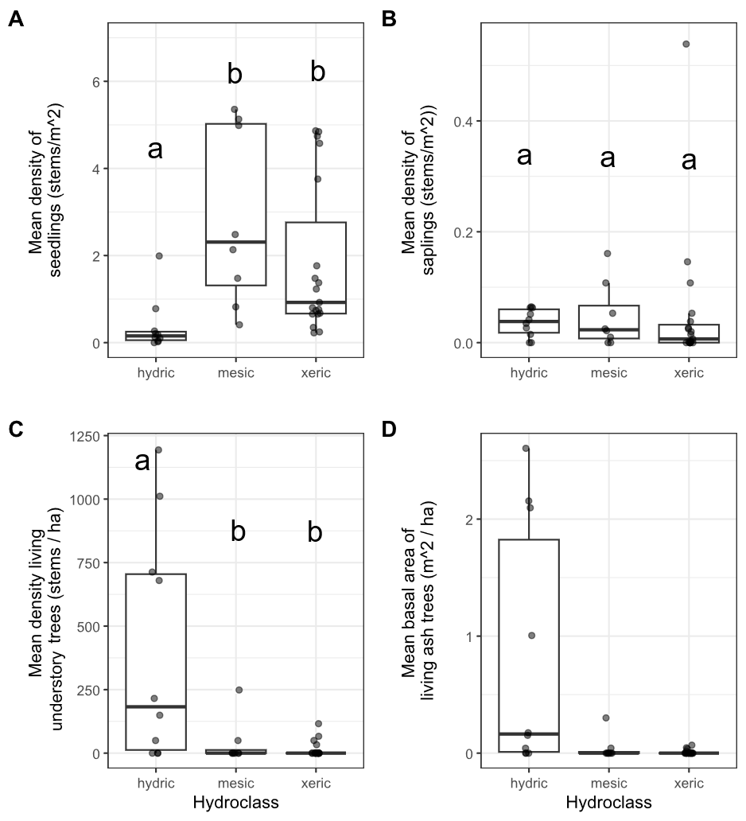

**Figure 1.2.** Ash occurrence in 37 transects in the Upper Huron River Watershed in southeast Michigan. The x-axis represents the soil hydroclass of the transect. Each data point represents a transect. Lowercase letters above bars indicate statistically significant differences at α=0.05. A) Mean density of ash seedlings (all ash with height < 1.37 m; short and tall seedling categories were combined for the graph), B) mean density of ash saplings (height ≥ 1.37 m and DBH < 2.5 cm), C) mean density of living understory ash trees (2.5 cm ≤ DBH < 10 cm), D) mean basal area of all living ash trees (DBH ≥ 2.5 cm). The basal area of living ash trees was not statistically investigated.

**Table 1.1.** Density (± standard error) of living ash (*Fraxinus*) regeneration in hydric (10 transects), mesic (8 transects), and xeric (19 transects) forests in the Upper Huron River Watershed in Southeast Michigan, USA. Only living trees are tabulated here. Data were collected in 2024 (97 plots) and 2025 (14 plots).

|  |  |  |
| --- | --- | --- |
| Size class | Hydrology class | Ash ha-1 |
| Short seedlings (<25 cm tall) | Hydric | 1,334 ± 952 |
|  | Mesic | 15,420 ± 4,920 |
|  | Xeric | 9,895 ± 2,458 |
|  | Combined | 8,776 ± 1,824 |
|  |  |  |
| Tall seedlings (25-137 cm tall) | Hydric | 2,381 ± 994 |
|  | Mesic | 13,085 ± 2,563 |
|  | Xeric | 8,351 ± 1,625 |
|  | Combined | 7,761 ± 1,189 |
|  |  |  |
| Saplings (>137 cm tall and <2.5 cm DBH) | Hydric | 360 ± 79 |
|  | Mesic | 472 ± 205 |
|  | Xeric | 517 ± 286 |
|  | Combined | 465 ± 152 |
|  |  |  |
| Understory trees (2.5 – 10 cm DBH) | Hydric | 401 ± 145 |
|  | Mesic | 37 ± 31 |
|  | Xeric | 14 ± 7 |
|  | Combined | 124 ± 48 |
|  |  |  |
| Canopy trees (>10 cm DBH) | Hydric | 2 ± 2 |
|  | Mesic | 0 |
|  | Xeric | 0 |
|  | Combined | 0 |

Signs and symptoms of EAB

Of the symptoms of EAB, bark splitting was the most common and was found on 193 (57%) ash trees (DBH ≥ 2.5 cm). Epicormic sprouts were found on 122 (36%) ash trees. Basal sprouts were found on 54 (16%) ash trees, while woodpecker predation marks were found on 46 (14%) ash trees. Out of a total of 338 trees, 229 (68%) had canopy condition=1 (meaning they were healthy), 33 (10%) had canopy condition=2, 13 (4%) had canopy condition=3, 7 (2%) had canopy condition=4, and 55 (16%) had canopy condition=5 (meaning they had a dead canopy). The D-shaped emergence holes from EAB were observed on a low percentage of ash trees, with only 8 trees (2%) recorded with visible exit holes.

The presence of woodpecker predation marks was positively correlated with tree diameter (DBH), with a 1 cm increase in DBH increasing the odds of woodpecker marks by a factor of 1.24 (Z=2.46, p=0.013) (Figure 3A). Similarly, presence of epicormic sprouts was positively correlated with DBH, with a 1 cm increase in DBH increasing the odds of epicormic sprouts by a factor of 1.31 (Z=3.49, p<0.001) (Figure 3C). The presence of canopy foliage decline was positively correlated with DBH, such that a 1 cm increase in DBH increased the odds of canopy decline by a factor of 1.22 (Z=2.89, p=0.004) (Figure 3F). Even though canopy decline was positively correlated with DBH, a sizeable proportion of the larger ash regeneration still had a healthy canopy: of the 127 standing ash trees above 5 cm DBH, 72 (57%) had canopy condition=1. No relationships were observed between DBH and bark splitting (Z=1.64, p=0.102), presence of basal sprouts (Z=1.16, p=0.245), and tree death (Z=0.21, p=0.831) (Figure 3, B, D, and E).

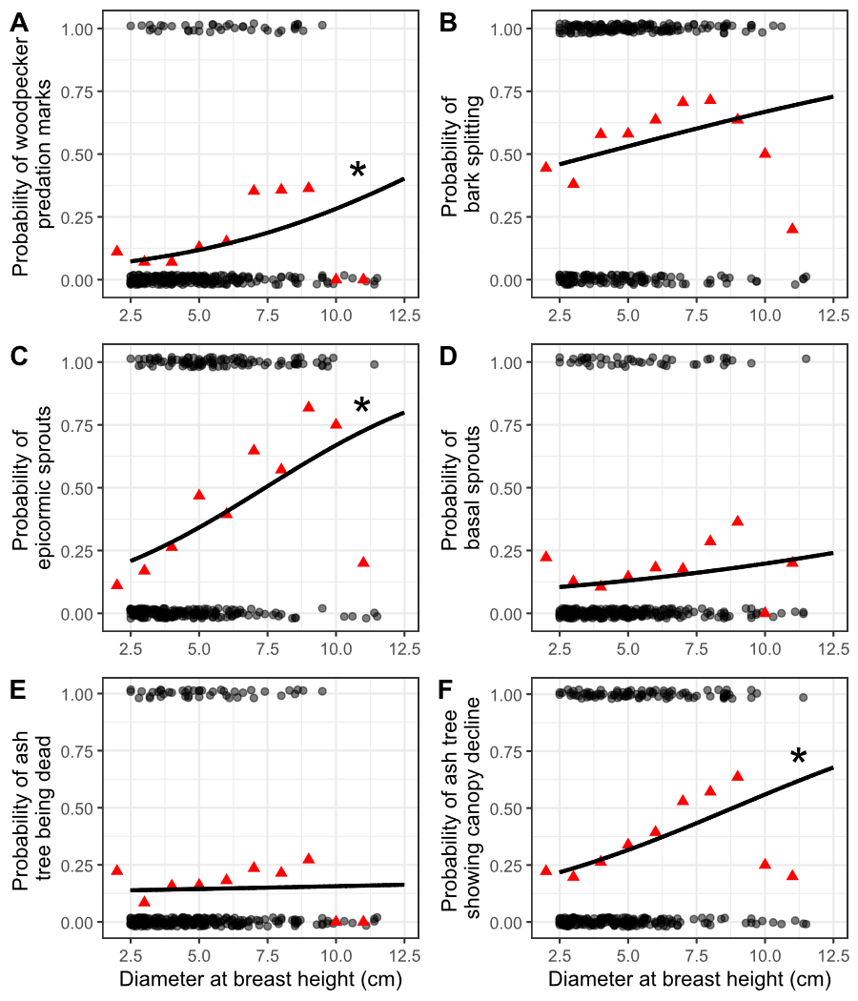

**Figure 1.3.** The presence or absence of symptoms of EAB plotted against tree diameter at breast height (DBH) for 283 ash trees. Trees were included in the analysis if they belonged to a forest plot containing at least 10 trees. Grey circles are individual trees, which are plotted as y=1 for presence or y=0 for absence (points were vertically jittered slightly). Black line shows the overall fitted model, disregarding each specific random intercept for each plot. See Figure S4 for plots including each random intercept. Asterisk next to the lines for woodpecker predation marks, epicormic sprouts, and canopy decline indicate a slope significantly different from zero. Red triangles show the proportion of trees that have the symptom within a DBH bin. For E, tree death is defined as having a canopy condition of 5. For F, canopy decline is defined as having a canopy condition between 2-5 (minor to complete defoliation).

Plant communities in hydric stands

We identified 810 living canopy trees comprising 18 genera in the 10 hydric transects (Table 2). The most common species in the canopy (≥ 12.5 cm DBH) was silver maple (*Acer saccharinum* L.), followed by elm (*Ulmus* sp.), and basswood (*Tilia americana* L.). In the understory (2.5 ≤ DBH < 12.5 cm), 638 living trees were found, of which the most common species were musclewood (*Carpinus caroliniana* Walter), black ash (*Fraxinus nigra*), and green ash (*Fraxinus pennsylvanica*, possibly with some *F. americana* and *F. profunda*). The basal area of living trees in the canopy and understory averaged 21.1 m2/ha and 2.8 m2/ha, respectively (not counting understory shrubs). Of the ground-level cover types estimated in hydric plots, graminoids and skunk cabbage had the highest percentage cover values (Table 3). The invasive shrubs glossy buckthorn and autumn olive (*Elaeagnus umbellata* Thunb.) were present, but with lower percentage cover values than the native shrubs spicebush and winterberry. The NMDS ordination (Figure 5) indicates a grouping of sample plots with high basal area of silver maple on the left side of the graph. Meanwhile, the upper center of the graph contains plots with species such as sugar maple (*Acer saccharum* Marshall). On the lower right side of the graph are plots with high basal area of yellow birch (*Betula alleghaniensis* Britt.) and/or tamarack (*Larix laricina* (Du Roi) K. Koch). The plots with high basal area of green ash tended to be in the forests with silver maple, whereas the plots with high basal area of black ash tended to be in forests with tamarack and/or yellow birch, although black and green ash also co-occurred in some plots.

**Table 1.2.** Relative density and relative dominance of tree genera found in the 10 hydric transects (30 plots) in 2024-2025. Only living trees are counted. Canopy trees are ≥12.5 cm DBH, while understory trees are 2.5-12.5 cm DBH. A total of 810 living canopy trees were counted in the main plots and 638 living understory trees were counted in the subplots. Shrub species were not counted.

|  |  |  |  |  |
| --- | --- | --- | --- | --- |
|  | Relative density, % | | Relative dominance, % | |
| Genus | Understory | Canopy | Understory | Canopy |
| *Acer* | 10.5 | 42.3 | 18.7 | 63.5 |
| *Betula* | 0.3 | 3.8 | 0.7 | 2.3 |
| *Carpinus* | 19.5 | 2.7 | 12.1 | 0.3 |
| *Carya* | 0.5 | 0.6 | 0.4 | 0.4 |
| *Cornus* | 0.5 | 0 | 0.2 | 0 |
| *Fagus* | 0.3 | 0.5 | 0.6 | 0.7 |
| *Frangula* | 7.5 | 0.1 | 3.7 | 0 |
| *Fraxinus* | 38.1 | 0 | 28.8 | 0 |
| *Juniperus* | 0 | 0.1 | 0 | 0 |
| *Larix* | 0.9 | 5.8 | 0.8 | 2.3 |
| *Ostrya* | 0.9 | 0.4 | 0.7 | 0.1 |
| *Populus* | 0 | 1.2 | 0 | 4.6 |
| *Prunus* | 0.3 | 0.5 | 0.3 | 0.4 |
| *Quercus* | 3.3 | 10 | 3.3 | 12.8 |
| *Rhamnus* | 0.2 | 0.1 | 0 | 0 |
| *Tilia* | 3.3 | 15.1 | 4.5 | 7 |
| *Ulmus* | 13.3 | 16.2 | 24.7 | 5.5 |
| *Viburnum* | 0.5 | 0.1 | 0.5 | 0 |

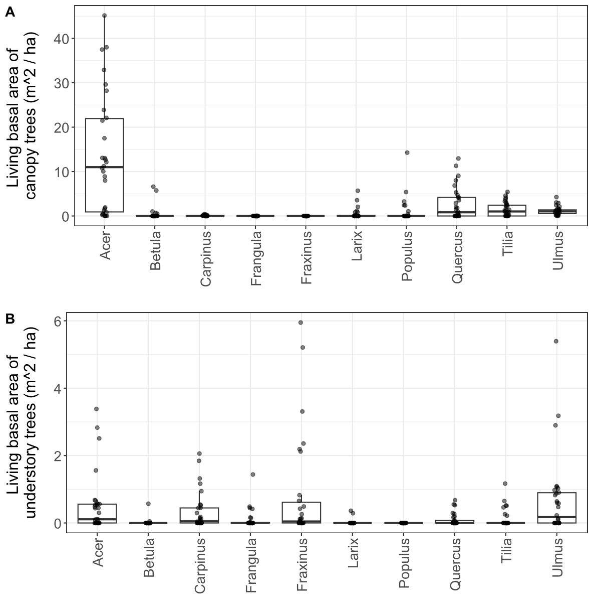

**Figure 1.4.** Basal area of living trees in 10 hydric transects (30 plots). Each dot represents a single plot. A) Canopy trees (≥ 12.5 cm DBH); B) understory trees (2.5-12.5 cm DBH). Tree genera were only included in the graph if their mean basal area was in the top seven for either canopy or understory trees. Note the difference in y-axis scale between the two graphs. Boxplot boundaries represent the 25th and 75th percentiles, while center line within the box is the median.

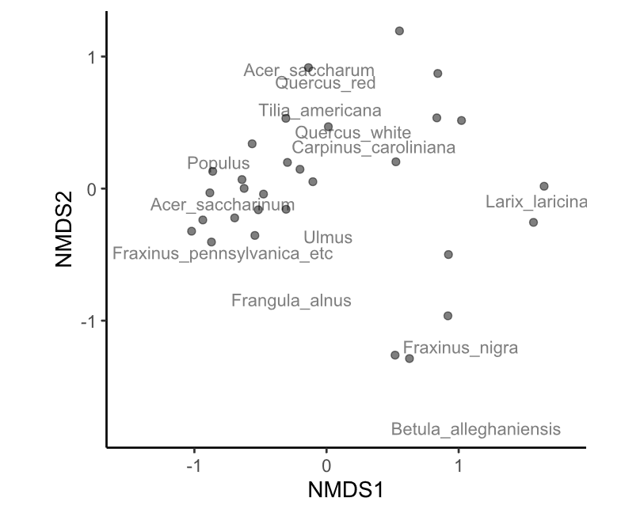

**Figure 1.5.** Nonmetric multidimensional scaling (NMDS) of the tree species composition at the 30 hydric plots visited in 2025. Each point is a plot. Data used to generate the NMDS was the basal area per hectare of each tree species, counting all trees ≥ 2.5 cm DBH. The final stress value was 0.149. Species within the red oak group (*Quercus* section *Lobatae*) were lumped together for the analysis, as were species within the white oak group (*Quercus* section *Quercus*) and the genera *Ulmus* and *Populus*.

**Table 1.3.** Average percentage cover (± SE) of understory cover types in 10 hydric transects (30 plots). Standard errors were calculated using n=30.

|  |  |  |  |  |
| --- | --- | --- | --- | --- |
| Cover type | Scientific name | Mean percent cover (%) ± SE | | |
| Water |  | 9.8 | ± | 2.6 |
| Graminoids | Poales | 52.7 | ± | 5.0 |
| Skunk cabbage | *Symplocarpus foetidus* | 37.6 | ± | 5.0 |
| Ferns |  | 16.5 | ± | 2.9 |
| Spicebush | *Lindera benzoin* | 19.2 | ± | 4.4 |
| Winterberry | *Ilex verticillata* | 5.7 | ± | 1.9 |
| Glossy buckthorn | *Frangula alnus* | 3.6 | ± | 1.2 |
| Poison sumac | *Toxicodendron vernix* | 2.1 | ± | 0.9 |
| Other woody shrubs | *Elaeagnus umbellata, Cornus* sp.*, Rosa* sp.*, Vaccinium* sp.*, Corylus* sp., etc. | 5.0 | ± | 0.8 |

Discussion

Over two decades since EAB was first detected in North America, we characterized ash survival and regeneration in forests that have experienced the longest history of EAB impacts. We found that ash regeneration was still present in these post-outbreak forests, although EAB continues to impact populations of ash. Ash regeneration remained at the seedling or sapling stages in mesic and xeric forests, but in hydric forests, ash regeneration consisted of trees in size classes susceptible to EAB. Parasitoids introduced to control EAB populations have established in the region, and we recovered three species, albeit in low numbers.

Stages of ash regeneration varied based on forest soil hydrology. In dry xeric and riparian mesic forests, ash seedlings were a prominent component of the understory layer, but ash trees >2.5 cm DBH were mostly absent. In hydric swamp forests, we found low numbers of seedlings, but higher densities of ash in the 2.5-10 cm DBH range. This suggests a difference in growth rate, whereby ash regeneration tended to be more advanced in hydric forests. In our study locations, the hydric transects previously had a higher density of ash in the canopy than mesic or xeric transects, which, following canopy ash mortality, may have resulted in multi-tree gaps (Klooster 2012). Furthermore, overall canopy tree cover was lower in hydric forests than mesic or xeric forests (Smith 2006, Klooster 2012). Multi-tree gaps and high light-availability likely allowed surviving ash regeneration to grow quickly as EAB populations declined following canopy ash mortality. Furthermore, black and green ash, which are highly tolerant of flooding, likely had an advantage in hydric forests over other co-occurring plants, such as *C. caroliniana*, which are less flood tolerant (Table S4) (Niinemets and Valladares 2006). In contrast, mesic and xeric forests may have developed mostly single-tree gaps from isolated ash canopy trees, allowing neighboring non-ash canopy trees to fill the gaps before saplings could grow substantially. In fact, saplings underneath mature canopy trees may require more than one tree-fall event in order to reach the canopy, due to the rapid canopy expansion of neighboring mature trees (Runkle and Yetter 1987). Other studies of forests after EAB invasion have similarly found rapid growth of canopy trees, such as sugar maples, to fill gaps left by ash mortality (Costilow et al. 2017, Hoven et al. 2020).

Although ash seedlings were abundant in these post-outbreak forests, newly germinated ash seedlings were not observed, as indicated by the lack of cotyledons on almost all (99.9 %) of ash seedlings observed in 2024-2025. The most plausible explanation is that ash seedlings are simply persisting from before 2008, when new germination from the seed bank ceased. While mortality and promotions in size class appear to have impacted some seedlings, a sizeable number (~16,500 seedlings ha-1 for those under 137 cm tall) remain in these long-term monitoring plots (Klooster et al. 2013). While this density of surviving seedlings is on the higher side of values obtained by other studies, it generally confirms the consensus that ash seedlings persist for long time periods in forest understories (Engelken et al. 2020, Siegert et al. 2021, Morris et al. 2023). In particular, ash seedlings seem more capable of long-term persistence in mesic and xeric forests, whereas in hydric forests competition with graminoids and seasonal flooding can limit seedling abundances (Engelken et al. 2020, Abella et al. 2024). Importantly, our study only found isolated examples of ash seeds growing on ash trees (four trees total in plots), indicating that the seedbank is not being replenished. This stands in contrast to other studies, where the ash canopy trees were not all killed by EAB, and in which seed production continued even after EAB invasion (Kashian 2016, Robinett and McCullough 2019, Morris et al. 2023). It is likely that in forests where ash trees make up the vast majority of trees in a stand, like in the study by Kashian, ash trees survive for longer after EAB introduction, and may continue to produce seeds, whereas in our study sites seed production ceased (Knight et al. 2013, Kashian 2016).

We found that ash tree regeneration continues to be damaged and killed by EAB, but some trees are surviving well into the susceptible size range. We found that symptoms of EAB including the incidence of canopy decline, woodpecker predation marks, and epicormic sprouts all increased with increasing tree diameter. However, bark splits, basal sprouts, and tree death did not show any significant relationship with ash tree diameter. In particular, the distribution of bark splits across a range of ash diameters suggests that even some 2.5 cm DBH ash are being affected by EAB oviposition. Ash bigger than 4 cm DBH may be more suitable for larval development, but female EAB still oviposit on stems as small as 2 cm DBH (Timms et al. 2006, Aubin et al. 2015). Even though EAB symptoms were common, we still found sizeable numbers of ash trees with healthy canopies in the 2.5-10 cm DBH range. This contrasts with data from 2009, when almost no ash >2.5 cm DBH were living (Klooster et al. 2013). Although ash trees are recovering, they have not yet attained sizes larger than 12.5 cm DBH in our study plots.

We found that in hydric swamp forests where EAB has been present for more than 15 years, there were a diversity of canopy tree compositions and understory vegetation types. We chose to investigate these forests in detail because black ash swamps provide both ecological and cultural services, including habitat for insects and birds, as well as raw materials for basket weaving by Tribal Nations (Gandhi et al. 2014, Wagner and Todd 2015, Youngquist et al. 2017, Bolen 2020). Furthermore, ash is a dominant tree in swamp forests of the northern US and Canada, meaning that EAB is currently having dramatic impacts on black ash in northern states such as Minnesota (Golet et al. 1993, Kolka et al. 2018, Siegert et al. 2023). We investigated tree composition in our hydric plots to determine which species are thriving after canopy ash mortality, and found that silver maple was abundant, especially in the canopy. This species thrives in alluvial soils and is highly tolerant of seasonal flooding (Table S4) (Burns and Honkala 1990, Niinemets and Valladares 2006, Bolton et al. 2018). However, some transects were not dominated by silver maple, but instead contained tamarack and sometimes yellow birch. These two species are typical of cooler, northern forests, whereas silver maple is commonly found further south of our study sites (Barnes 1976, Braun 1989, Burns and Honkala 1990, Kost and O’Connor 2003, Kartesz 2015). Regeneration of green ash primarily occurred alongside silver maple, whereas black ash regeneration was commonly associated with tamarack or yellow birch, although the two ash species were sometimes found in the same stands. These observed associations between tree species might be informative for land managers who are considering planting replacement tree seedlings underneath ash canopies in order to maintain forest cover (Bolton et al. 2018, Palik et al. 2021). Similarly to our results, other studies of black ash regeneration after EAB invasion have found variable numbers of black ash in the 2.5-10 cm DBH range, but a near absence of black ash trees larger then 14 cm DBH (Engelken et al. 2020, Siegert et al. 2021). Our results indicate that once 15 years have passed since peak EAB densities, black ash regeneration remains alive in many swamp forests. Although black ash only produces many seeds every 5-7 years, and the seeds can take 2 years to germinate, our observation of isolated seed production of black ash indicates the possibility for black ash to persist in the forest (Benedict and David 2003). Future research should focus on forest attributes that may affect black ash regeneration success, including water pH, nutrient levels, and seasonal flooding pattern (Golet et al. 1993).

Three species of parasitoids introduced to control EAB populations were recovered in these post-outbreak forests, specifically at Pontiac Lake Rec. Area. Although these parasitoids cannot prevent canopy ash mortality in forests naïve to EAB, they may help protect regenerating ash trees in post-outbreak forests (Duan et al. 2017, Kashian et al. 2018, Jones et al. 2019). We detected *T. planipennisi*, which has been shown to effectively reduce the abundance of EAB, through a combination of multiple generations per year, multiple wasps developing from a single EAB larvae, and effective dispersal capability (Duan et al. 2011, Jones et al. 2019, 2020, USDA–APHIS/ARS/FS 2021). Similarly, we detected *S. galinae*, a parasitoid native to the Russian Far East which can spread rapidly and parasitize EAB larvae within larger ash trees, due to its long ovipositor (Duan et al. 2021, Aker et al. 2022). Finally, we detected *O. agrili*, an egg parasitoid which times its lifecycle to when EAB females are ovipositing in the bark of ash trees (Petrice et al. 2021a). Our recovery of *O. agrili* is encouraging, given that its small size could make dispersal challenging, and that parasitism of EAB eggs could provide another layer of biological control (Quinn et al. 2022a, 2023). Although we recovered all three biological control agents known to have established in the region (Duan et al. 2023, mapBioControl 2024), we collected these parasitoids in low abundance (7 individuals total). Yellow pan traps are an inefficient method to detect larval parasitoids, and do not permit estimation of parasitism rates (Rutledge et al. 2021). However, they can be a useful nondestructive method for quantifying parasitoid populations if the sample size is sufficiently large, and may be particularly suited to monitoring *O. agrili* populations (Petrice et al. 2021b).

Our findings in forests of southeast Michigan, 15 years after peak ash mortality, show that ash is still present in forests. Parasitoids may be playing a role in the health of the ash regeneration, but further research is necessary. Specifically, parasitoids should be surveyed in hydric swamp forests with regenerating black ash; most previous studies have focused on parasitoids in stands of green or white ash (Abell et al. 2014, Quinn et al. 2022b). We found that in hydric stands, ash trees between 2.5-10 cm DBH were common, whereas in 2009 this size of tree had been completely killed by EAB. Furthermore, some regeneration exhibited symptoms of EAB, like epicormic sprouts, whereas others in the same stand appeared completely healthy. Multiple factors could be involved in the survival and growth of ash regeneration, including reduced EAB density due to declines in living ash phloem (Duan et al. 2015, Siegert et al. 2021), the development of ash tree resistance to EAB (Koch et al. 2015, Villari et al. 2016), site conditions including sunlight and water levels (Knight et al. 2013, Davis et al. 2017), and parasitoid natural enemies. Future research could focus on the host-location strategies of parasitoids, which could improve our knowledge of whether parasitoids could disperse to ash trees that are newly infested with EAB, or if parasitoids only disperse to declining ash (Johnson et al. 2014, Chen et al. 2016, Wilson et al. 2024). In summary, the continued presence of ash in forests of southeast Michigan is far from guaranteed, but instead depends on multiple top-down and bottom-up ecological processes.

References

Abell, K. J., L. S. Bauer, J. J. Duan, and R. Van Driesche. 2014. Long-term monitoring of the introduced emerald ash borer (Coleoptera: Buprestidae) egg parasitoid, Oobius agrili (Hymenoptera: Encyrtidae), in Michigan, USA and evaluation of a newly developed monitoring technique. Biological Control 79:36–42.

Abell, K. J., J. J. Duan, L. Bauer, J. P. Lelito, and R. G. Van Driesche. 2012. The effect of bark thickness on host partitioning between Tetrastichus planipennisi (Hymen: Eulophidae) and Atanycolus spp. (Hymen: Braconidae), two parasitoids of emerald ash borer (Coleop: Buprestidae). Biological Control 63:320–325.

Abella, S. R., C. E. Hausman, J. F. Jaeger, K. S. Menard, T. A. Schetter, and O. J. Rocha. 2019. Fourteen years of swamp forest change from the onset, during, and after invasion of emerald ash borer. Biological Invasions 21:3685–3696.

Abella, S. R., K. S. Menard, T. A. Schetter, and C. E. Hausman. 2024. Species and landscape variation in tree regeneration and 17 years of change in forested wetlands invaded by emerald ash borer. Forest Ecology and Management 557:121750.

Aker, S. A., R. B. De Andrade, J. J. Duan, and D. S. Gruner. 2022. Rapid Spread of an Introduced Parasitoid for Biological Control of Emerald Ash Borer (Coleoptera: Buprestidae) in Maryland. Journal of Economic Entomology 115:381–386.

Aubin, I., F. Cardou, K. Ryall, D. Kreutzweiser, and T. Scarr. 2015. Ash regeneration capacity after emerald ash borer (EAB) outbreaks: Some early results. The Forestry Chronicle 91:291–298.

Barnes, B. V. 1976. Succession in deciduous swamp communities of southeastern Michigan formerly dominated by American elm. Canadian Journal of Botany 54:19–24.

Bates, D., M. Mächler, B. Bolker, and S. Walker. 2015. Fitting Linear Mixed-Effects Models Using **lme4**. Journal of Statistical Software 67.

Benedict, L., and R. David. 2003. Propogation protocol for black ash. Native Plants.

Bolen, A. 2020. A Silent Killer: Black Ash Basket Makers are Battling a Voracious Beetle to Keep Their Heritage Alive. National Museum of the American Indian 21.

Bolton, N., J. Shannon, J. Davis, M. Grinsven, N. Noh, S. Schooler, R. Kolka, T. Pypker, and J. Wagenbrenner. 2018. Methods to Improve Survival and Growth of Planted Alternative Species Seedlings in Black Ash Ecosystems Threatened by Emerald Ash Borer. Forests 9:146.

Braun, E. L. 1989. The woody plants of Ohio: trees, shrubs and woody climbers, native, naturalized, and escaped. Ohio State University Press, Columbus, Ohio.

Burns, R., and B. Honkala. 1990. Silvics of North America: Volume 2, Hardwoods.

Chen, Y., M. D. Ulyshen, and T. M. Poland. 2016. Abundance of volatile organic compounds in white ash phloem and emerald ash borer larval frass does not attract *Tetrastichus planipennisi* in a Y‐tube olfactometer. Insect Science 23:712–719.

Costilow, K. C., K. S. Knight, and C. E. Flower. 2017. Disturbance severity and canopy position control the radial growth response of maple trees (Acer spp.) in forests of northwest Ohio impacted by emerald ash borer (Agrilus planipennis). Annals of Forest Science 74:10.

Davis, J. C., J. P. Shannon, N. W. Bolton, R. K. Kolka, and T. G. Pypker. 2017. Vegetation responses to simulated emerald ash borer infestation in *Fraxinus nigra* dominated wetlands of Upper Michigan, USA. Canadian Journal of Forest Research 47:319–330.

Duan, J. J., L. S. Bauer, K. J. Abell, M. D. Ulyshen, and R. G. Van Driesche. 2015. Population dynamics of an invasive forest insect and associated natural enemies in the aftermath of invasion: implications for biological control. Journal of Applied Ecology 52:1246–1254.

Duan, J. J., L. S. Bauer, and R. G. Van Driesche. 2017. Emerald ash borer biocontrol in ash saplings: The potential for early stage recovery of North American ash trees. Forest Ecology and Management 394:64–72.

Duan, J. J., J. R. Gould, N. F. Quinn, T. R. Petrice, B. H. Slager, T. M. Poland, L. S.

Bauer, C. E. Rutledge, J. S. Elkinton, and R. G. Van Driesche. 2023. Protection of North American ash against emerald ash borer with biological control: ecological premises and progress toward success. BioControl 68:87–100.

Duan, J. J., C. B. Oppel, M. D. Ulyshen, L. S. Bauer, and J. LeLito. 2011. Biology and Life History of *Tetrastichus planipennisi* (Hymenoptera: Eulophidae), a Larval Endoparasitoid of the Emerald Ash Borer (Coleoptera: Buprestidae). Florida Entomologist 94:933–940.

Duan, J. J., R. G. Van Driesche, J. M. Schmude, N. F. Quinn, T. R. Petrice, C. E. Rutledge, T. M. Poland, L. S. Bauer, and J. S. Elkinton. 2021. Niche partitioning and coexistence of parasitoids of the same feeding guild introduced for biological control of an invasive forest pest. Biological Control 160:104698.

Engelken, P. J., M. E. Benbow, and D. G. McCullough. 2020. Legacy effects of emerald ash borer on riparian forest vegetation and structure. Forest Ecology and Management 457:117684.

Fox, J., and S. Weisberg. 2019. An {R} Companion to Applied Regression. Sage, Thousand Oaks {CA}.

Gandhi, K. J. K., and D. A. Herms. 2010. Direct and indirect effects of alien insect herbivores on ecological processes and interactions in forests of eastern North America. Biological Invasions 12:389–405.

Gandhi, K. J. K., A. Smith, D. M. Hartzler, and D. A. Herms. 2014. Indirect Effects of Emerald Ash Borer-Induced Ash Mortality and Canopy Gap Formation on Epigaeic Beetles. Environmental Entomology 43:546–555.

Golet, F. C., J. A. Allen, U. S. Fish, and W. Service. 1993. Ecology of Red Maple Swamps in the Glaciated Northeast: A Community Profile. U.S. Department of the Interior, Fish and Wildlife Service.

Goulet, H., and J. T. Huber. 1993. Hymenoptera of the world: an identification guide to families. Agriculture Canada, Ottawa.

Hartig, F. 2024. DHARMa: Residual Diagnostics for Hierarchical (Multi-Level / Mixed) Regression Models. R.

Hoven, B. M., K. S. Knight, V. E. Peters, and D. L. Gorchov. 2020. Release and suppression: forest layer responses to emerald ash borer (Agrilus planipennis)-caused ash death. Annals of Forest Science 77:10.

Johnson, T. D., J. P. Lelito, and K. F. Raffa. 2014. Responses of two parasitoids, the exotic Spathius agrili Yang and the native Spathius floridanus Ashmead, to volatile cues associated with the emerald ash borer, Agrilus planipennis Fairmaire. Biological Control 79:110–117.

Jones, M. I., J. R. Gould, H. J. Mahon, and M. K. Fierke. 2020. Phenology of Emerald Ash Borer (Coleoptera: Buprestidae) and Its Introduced Larval Parasitoids in the Northeastern United States. Journal of Economic Entomology 113:622–632.

Jones, M. I., J. R. Gould, M. L. Warden, and M. K. Fierke. 2019. Dispersal of emerald ash borer (Coleoptera: Buprestidae) parasitoids along an ash corridor in western New York. Biological Control 128:94–101.

Kartesz, J. T. 2015. The Biota of North America Program (BONAP). North American Plant Atlas. (http://bonap.net/napa), Chapel Hill, N.C.

Kashian, D. M. 2016. Sprouting and seed production may promote persistence of green ash in the presence of the emerald ash borer. Ecosphere 7:e01332.

Kashian, D. M., L. S. Bauer, B. A. Spei, J. J. Duan, and J. R. Gould. 2018. Potential Impacts of Emerald Ash Borer Biocontrol on Ash Health and Recovery in Southern Michigan. Forests 9:296.

Klooster, W., K. Gandhi, L. Long, K. Perry, K. Rice, and D. Herms. 2018. Ecological Impacts of Emerald Ash Borer in Forests at the Epicenter of the Invasion in North America. Forests 9:250.

Klooster, W. S. 2012. Forest Responses to Emerald Ash Borer-Induced Ash Mortality. PhD Thesis, The Ohio State University.

Klooster, W. S., D. A. Herms, K. S. Knight, C. P. Herms, D. G. McCullough, A. Smith, K. J. K. Gandhi, and J. Cardina. 2013. Ash (Fraxinus spp.) mortality, regeneration, and seed bank dynamics in mixed hardwood forests following invasion by emerald ash borer (Agrilus planipennis). Biological Invasions 16:859–873.

Knight, K. S., J. P. Brown, and R. P. Long. 2013. Factors affecting the survival of ash (Fraxinus spp.) trees infested by emerald ash borer (Agrilus planipennis). Biological Invasions 15:371–383.

Knight, K. S., B. P. Flash, R. H. Kappler, J. A. Throckmorton, B. Grafton, and C. E. Flower. 2014. Monitoring Ash (Fraxinus spp.) Decline and Emerald Ash Borer (Agrilus planipennis) Symptoms in Infested Areas. General Technical Report, U.S. Department of Agriculture, Forest Service, Northern Research Station.

Koch, J. L., D. W. Carey, M. E. Mason, T. M. Poland, and K. S. Knight. 2015. Intraspecific variation in Fraxinus pennsylvanica responses to emerald ash borer (Agrilus planipennis). New Forests 46:995–1011.

Kolka, R., A. D’Amato, J. Wagenbrenner, R. Slesak, T. Pypker, M. Youngquist, A. Grinde, and B. Palik. 2018. Review of Ecosystem Level Impacts of Emerald Ash Borer on Black Ash Wetlands: What Does the Future Hold? Forests 9:179.

Kost, M. A., and R. P. O’Connor. 2003. Natural Features Inventory and Management Recommendations for Kensington and Oakwoods Metroparks. Michigan Natural Features Inventory, Huron-Clinton Metropolitan Authority.

Lenth, R. V. 2024. emmeans: Estimated Marginal Means, aka Least-Squares Means. R.

Lovett, G. M., C. D. Canham, M. A. Arthur, K. C. Weathers, and R. D. Fitzhugh. 2006. Forest Ecosystem Responses to Exotic Pests and Pathogens in Eastern North America. BioScience 56:395.

mapBioControl (Midwest Invasive Species Information Network). 2024.

McCormick, J. F., and R. B. Platt. 1980. Recovery of an Appalachian Forest Following the Chestnut Blight or Catherine Keever-You Were Right! American Midland Naturalist 104:264.

McCullough, D. G. 2019. Challenges, tactics and integrated management of emerald ash borer in North America. Forestry: An International Journal of Forest Research 93:197–211.

Mech, A. M., K. A. Thomas, T. D. Marsico, D. A. Herms, C. R. Allen, M. P. Ayres, K. J. K. Gandhi, J. Gurevitch, N. P. Havill, R. A. Hufbauer, A. M. Liebhold, K. F. Raffa, A. N. Schulz, D. R. Uden, and P. C. Tobin. 2019. Evolutionary history predicts high‐impact invasions by herbivorous insects. Ecology and Evolution 9:12216–12230.

Megonigal, J. P., W. H. Conner, S. Kroeger, and R. R. Sharitz. 1997. Aboveground Production in Southeastern Floodplain Forests: A Test of the Subsidy-Stress Hypothesis. Ecology 78:370–384.

Morris, T. D., J. R. Gould, J. Drake, and M. K. Fierke. 2023. Status of ash forests and regeneration a decade after first detection of emerald ash borer infestation in New York state. Forest Ecology and Management 549:121464.

Murphy, T. C., R. G. Van Driesche, J. R. Gould, and J. S. Elkinton. 2017. Can Spathius galinae attack emerald ash borer larvae feeding in large ash trees? Biological Control 114:8–13.

Niinemets, Ü., and F. Valladares. 2006. Tolerance to Shade, Drought, and Waterlogging of Temperate Northern Hemisphere Trees and Shrubs. Ecological Monographs 76:521–547.

Online Phenology and Degree-day Models. 2022. . https://uspest.org/dd/model_app.

Palik, B. J., A. W. D’Amato, R. A. Slesak, D. Kastendick, C. Looney, and J. Kragthorpe. 2021. Eighth-year survival and growth of planted replacement tree species in black ash (Fraxinus nigra) wetlands threatened by emerald ash borer in Minnesota, USA. Forest Ecology and Management 484:118958.

Parsons, G. 2008. Emerald Ash Borer: A guide to identification and comparison to similar species. Michigan State University Department of Entomology.

Perry, K., and D. Herms. 2019. Dynamic Responses of Ground-Dwelling Invertebrate Communities to Disturbance in Forest Ecosystems. Insects 10:61.

Petrice, T. R., L. S. Bauer, D. L. Miller, T. M. Poland, and F. W. Ravlin. 2021a. A Phenology Model for Simulating *Oobius agrili* (Hymenoptera: Encyrtidae) Seasonal Voltinism and Synchrony With Emerald Ash Borer Oviposition. Environmental Entomology 50:280–292.

Petrice, T. R., L. S. Bauer, D. L. Miller, J. S. Stanovick, T. M. Poland, and F. W. Ravlin. 2021b. Monitoring field establishment of the emerald ash borer biocontrol agent Oobius agrili Zhang and Huang (Hymenoptera: Encyrtidae): Sampling methods, sample size, and phenology. Biological Control 156:104535.

Quinn, N. F., J. J. Duan, and J. Elkinton. 2022a. Monitoring the impact of introduced emerald ash borer parasitoids: factors affecting Oobius agrili dispersal and parasitization of sentinel host eggs. BioControl 67:387–394.

Quinn, N. F., J. S. Gould, C. E. Rutledge, A. Fassler, J. S. Elkinton, and J. J. Duan. 2022b. Spread and phenology of Spathius galinae and Tetrastichus planipennisi, recently introduced for biocontrol of emerald ash borer (Coleoptera: Buprestidae) in the northeastern United States. Biological Control 165:104794.

Quinn, N. F., T. R. Petrice, J. M. Schmude, T. M. Poland, L. S. Bauer, C. E. Rutlege, R. G. Van Driesche, J. S. Elkinton, and J. J. Duan. 2023. Postrelease assessment of *Oobius agrili* (Hymenoptera: Encyrtidae) establishment and persistence in Michigan and the Northeastern United States. Journal of Economic Entomology 116:1165–1170.

R Core Team. 2024. R: A Language and Environment for Statistical Computing. R Foundation for Statistical Computing, Vienna, Austria.

Robinett, M. A., and D. G. McCullough. 2019. White ash ( *Fraxinus americana* ) survival in the core of the emerald ash borer ( *Agrilus planipennis* ) invasion. Canadian Journal of Forest Research 49:510–520.

Roy, H. E., L.-J. Lawson Handley, K. Schönrogge, R. L. Poland, and B. V. Purse. 2011. Can the enemy release hypothesis explain the success of invasive alien predators and parasitoids? BioControl 56:451–468.

Royo, A. A., and K. S. Knight. 2012. White ash (Fraxinus americana) decline and mortality: The role of site nutrition and stress history. Forest Ecology and Management 286:8–15.

Runkle, J. R., and T. C. Yetter. 1987. Treefalls Revisited: Gap Dynamics in the Southern Appalachians. Ecology 68:417–424.

Rutledge, C. E., R. G. Van Driesche, and J. J. Duan. 2021. Comparative efficacy of three techniques for monitoring the establishment and spread of larval parasitoids recently introduced for biological control of emerald ash borer, Agrilus planipennis (Coleoptera: Buprestidae). Biological Control 161:104704.

Schauff, M. E., and E. . Grissel. 1990. Key From: A handbook of the families of Nearctic Chalcidoidea (Hymenoptera). Entomological Society of Washington (Washington, D.C.) Handbook 1:1-85.

Siegert, N. W., P. J. Engelken, and D. G. McCullough. 2021. Changes in demography and carrying capacity of green ash and black ash ten years after emerald ash borer invasion of two ash-dominant forests. Forest Ecology and Management 494:119335.

Siegert, N. W., D. G. McCullough, T. Luther, L. Benedict, S. Crocker, K. Church, and J. Banks. 2023. Biological invasion threatens keystone species indelibly entwined with Indigenous cultures. Frontiers in Ecology and the Environment 21:310–316.

Smith, A. 2006. Effects of Community Structure on Forest susceptibility and Response to the Emerald Ash Borer Invasion of the Huron River Watershed in Southeast Michigan. Master’s Thesis, The Ohio State University.

Smith, A., D. A. Herms, R. P. Long, and K. J. K. Gandhi. 2015. Community composition and structure had no effect on forest susceptibility to invasion by the emerald ash borer (Coleoptera: Buprestidae). The Canadian Entomologist 147:318–328.

Telander, A. C., R. A. Slesak, A. W. D’Amato, B. J. Palik, K. N. Brooks, and C. F. Lenhart. 2015. Sap flow of black ash in wetland forests of northern Minnesota, USA: Hydrologic implications of tree mortality due to emerald ash borer. Agricultural and Forest Meteorology 206:4–11.

Timms, L. L., S. M. Smith, and P. De Groot. 2006. Patterns in the within‐tree distribution of the emerald ash borer *Agrilus planipennis* (Fairmaire) in young, green‐ash plantations of south‐western Ontario, Canada. Agricultural and Forest Entomology 8:313–321.

USDA–APHIS/ARS/FS. 2021. Emerald Ash Borer Biological Control Release and Recovery Guidelines. USDA–APHIS–ARS–FS, Riverdale, Maryland.

Van Driesche, R., and R. Reardon. 2016. The Use of Classical Biological Control to Preserve Forests in North America. USDA Forest Service, Morgantown, WV.

Venables, W. N., B. D. Ripley, and W. N. Venables. 2002. Modern applied statistics with S. 4th ed. Springer, New York.

Villari, C., D. A. Herms, J. G. A. Whitehill, D. Cipollini, and P. Bonello. 2016. Progress and gaps in understanding mechanisms of ash tree resistance to emerald ash borer, a model for wood‐boring insects that kill angiosperms. New Phytologist 209:63–79.

Wagner, D. L., and K. J. Todd. 2015. Chapter 2: Ecological Impacts of Emerald Ash Borer. Page Biology and Control of Emerald Ash Borer. USDA Forest Service.

Ward, S. F., A. M. Liebhold, R. S. Morin, and S. Fei. 2021. Population dynamics of ash across the eastern USA following invasion by emerald ash borer. Forest Ecology and Management 479:1–8.

Wilson, C. J., T. R. Petrice, T. M. Poland, and D. G. McCullough. 2024. Tree species richness and ash density have variable effects on emerald ash borer biological control by woodpeckers and parasitoid wasps in post-invasion white ash stands. Environmental Entomology 53:544–560.

Youngquist, M. B., S. L. Eggert, A. W. D’Amato, B. J. Palik, and R. A. Slesak. 2017. Potential Effects of Foundation Species Loss on Wetland Communities: A Case Study of Black Ash Wetlands Threatened by Emerald Ash Borer. Wetlands 37:787–799.

Zhang, Y.-Z., D.-W. Huang, T.-H. Zho, H.-P. Liu, and L. S. Bauer. 2005. Two new species of egg parasitoids (Hymenoptera: Encyrtidae) of wood-boring beetle pests from China. Phytoparasitica 33:253–260.

# . The effects of a tornado and salvage-logging on ground beetles

Introduction

Natural disturbances, including fires, windstorms, floods, droughts, and insect outbreaks, have occurred in forests for millions of years (Lindenmayer et al. 2012). In forests of the eastern United States, wind disturbance from hurricanes, derechos (straight-line windstorms), and tornados is a dominant disturbance regime (Fischer et al. 2013). When windstorms knock down canopy trees, the increased sunlight reaching the understory and forest floor can induce environmental changes. Soil temperature extremes can increase, moisture can change depending on reduced evapotranspiration but increased summer temperature, leaf litter depth can decrease due to faster decomposition, and understory plants increase their growth rates (Greenberg and Forrest 2003, Urbanovicova et al. 2014, Barber and Widick 2017). The growth of understory plants interacts with tree mortality and the creation of canopy gaps to alter microclimatic conditions (Perry et al. 2018). The fallen canopy trees cause an influx of woody debris, including both coarse and fine woody debris. Uprooted trees create tip-up mounds that alter topography of the forest floor (Perry and Herms 2019). While wind disturbance changes canopy cover and abiotic conditions, it also leaves behind many living trees, understory shrubs and herbaceous plants, seeds, root systems, soils, and surviving animals. These elements left intact after a disturbance are called biological legacies, and they influence short- and long-term changes in forest structure and function (Lindenmayer et al. 2012).

Harvesting the fallen trees after a natural disturbance is called salvage-logging, and this management practice is a common response to windstorms (Lindenmayer et al. 2012). Salvage logging can help landowners recover the economic value of the fallen trees, or it may be motivated towards reducing fire risk, insect outbreak risk, or safety hazard (Thorn et al. 2014, Perry and Herms 2019). However, there is a growing interest in managing forests in ways that conserve biodiversity, including insect populations that are threatened globally due to environmental change (Wagner 2019). This includes understanding how management practices such as salvage-logging impact insect biodiversity (Thorn et al. 2018). For example, salvage-logging alters the biological legacies left by windstorms by reducing the amount and diversity of woody debris, as well as by disturbance of understory plants, potential for soil compaction from machinery, and modified tree species composition (McNabb et al. 2001, Curtze et al. 2018, Slyder et al. 2020). The combination of natural wind disturbance followed by salvage-logging disturbance could cause longer-lasting changes to the ecosystem.

To understand how insect biodiversity is affected by forest management, an indicator taxon can be used, which is a starting point for characterizing the response of the insect community (Langor and Spence 2006). Ground beetles (Coleoptera: Carabidae) are useful indicators because they are taxonomically well known, sensitive to abiotic and biotic conditions, and sensitive to forest disturbance (Koivula 2011). Ground beetles are diverse in multiple habitats, including both mature forests and early successional habitats such as tallgrass prairies, agricultural fields, urban areas, clearcuts, and floodplains (Silverman et al. 2008, Lambeets et al. 2008, Lundgren and McCravy 2011). Within mature forests, ground beetle communities can differ based on predominate tree species, managed vs. old-growth forest, and forests with dense vs open ground vegetation (Werner and Raffa 2000, Browne et al. 2014, Perry et al. 2018). Thus, the occurrence and species composition of ground beetles can indicate fine-scale differences in habitat.

Two processes occur to the ground beetle community after a forest disturbance: influx of new species and decline of some resident species. After canopy gaps open and early successional plants begin to grow, a guild of open-habitat and generalist ground beetles typically disperses to the disturbed area. This group, including certain species of *Amara*, *Anisodactylus*, *Harpalus*, and *Chlaenius*, may immediately increase following disturbance, or may take a few years to locate the site, depending on landscape structure (Sklodowski and Garbalinska 2011, Lee et al. 2017, Barber and Widick 2017). While open-habitat species increase after disturbance, there is also a decline of forest-adapted ground beetles, often over multiple years (Riley and Browne 2011). For example, in Minnesota, jack pine stands that were wind-disturbed or salvaged-logged 1-3 years prior had lower numbers of *Pterostichus pensylvanicus* LeConte, *Pterostichus coracinus* (Newman), and *Sphaeroderus lecontei* Dejean than undisturbed sites (Gandhi et al. 2008). In a pine forest in Poland, forest-specialists decreased in proportional abundance over a six-year period following a tornado (Sklodowski and Garbalinska 2011). These observed decreases in forest-adapted ground beetles after windstorms and salvage-logging could be caused by a variety of factors, including environmental changes such as increased sunlight, increased summer soil temperature, and decreased leaf litter (Greenberg and Forrest 2003). Although many microclimate variables stabilize after multiple years of tree regeneration following a disturbance, other variables, such as woody debris deposition or removal, remain for decades (Gore and Patterson III 1986, Perry and Herms 2019). Studies of green-logging in Alberta indicate that differences in beetle communities between mature and clearcut forests remain even after 27 years (Pohl et al. 2007). Thus, it is unclear how long it could take for forest-adapted ground beetles to return to areas impacted by windstorms and salvage-logging, and this subject deserves further study to inform salvage-logging practices that may increase with climate change.

While much is known about how the taxonomic composition of ground beetle communities changes after forest disturbance, less is known about how these disturbances may impact the functional diversity of beetles via changes in traits. Studies have documented that ground beetle species common in tornado-disturbed forests were smaller in size, incorporated plant material or seeds into their diets, and were capable of flight, compared to those characteristic of undisturbed forest (Sklodowski and Garbalinska 2011, Perry and Herms 2019). However, ground beetle traits can vary even among, for example, equally-sized, carnivorous, flight-incapable species. For instance, ground beetles exhibit trait syndromes (Fountain-Jones et al. 2015) associated with locomotion strategy (Forsythe 1991), including surface-walking, pushing through leaf litter, burrowing, and climbing plants (Erwin 1979, Larochelle and Larivière 2003). Ground beetle species also differ in their soil moisture preference, and this trait plays an important role in habitat selection (Thiele 1977). Because forest disturbance can affect leaf litter and vegetation cover, soil density, woody debris volume, and soil moisture, these habitat changes could favor species with certain locomotion strategies and moisture preferences. Research is needed to determine if the effect of forest disturbance on ground beetles is mediated by their species-specific traits.

Our objective is to use ground beetles to study the long-term impacts of salvage-logging after a tornado. To do this, we compared the taxonomic and functional diversity of ground beetle communities among undisturbed forest (hereafter “forest”), unsalvaged windthrow (hereafter: “windthrow”), and salvage-logged windthrow (hereafter: “salvaged”) treatments, at three and ten years after a tornado. We predicted that the alpha-diversity (both taxonomic and functional) would be higher for windthrow and salvaged plots than forest control plots after only three years, due to the immigration of open-habitat species and the persistence of some forest species. After ten years, we predicted that salvaged plots would decline in alpha diversity because species that rely on woody debris would not use salvage-logged habitat (Pearce et al. 2003). We predicted that the species and trait composition of windthrow plots would be intermediate between those of salvaged and forest control, due to the intermediate level of disturbance created by windthrow. Finally, we predicted that salvaged plots would support a higher abundance of species with proportionally larger eyes, shorter antennae, and higher water affinity, traits which may increase fitness in a high sunlight, high soil moisture habitat (Bauer and Kredler 1993, McNabb et al. 2001).

Methods

Study site

Research was conducted at Powdermill Nature Preserve (PNR) in Rector, Westmoreland County, Pennsylvania (40° 9' 35.3052'' N, 79° 16' 18.3684'' W). This preserve was established as the field research station for the Carnegie Museum of Natural History in 1956 and is largely temperate deciduous forest. The annual precipitation for the years 2012-2022 was between 45 and 70 in. with a mean of 53 in. (weather station: USC00362183) (“National Centers for Environmental Information: Past Weather” 2012-2022). In June 2012, a tornado uprooted or snapped many canopy trees in two large areas of the forest, each about 120 × 480 m (Figure 1). These two areas are on north- or northwest-facing slopes, which were dominated by maple (*Acer* sp.), tuliptree (*Liriodendron tulipifera* L.) and black cherry (*Prunus serotina* Ehrh*.*) (Murphy et al. 2015), with an understory of predominately spicebush (*Lindera benzoin* L.) (Calinger et al. 2015). The tornado created patchy areas of canopy openness: the impacted areas had canopy openness values of 25% up to 90% (Slyder et al. 2020). The elevation of the impacted area ranges from around 1650 ft. to 1750 ft. A waterway, Laurel Run, is found along the west side of the study area.

**Figure 2.1.** Map of the study area. The study is located at Powdermill Nature Reserve in Rector, Westmoreland County, Pennsylvania. Red shading represents forest affected by the tornado but left unsalvaged, whereas yellow shading represents forest affected by the tornado and subsequently salvage-logged. Colored dots are drawn in the plot locations, where pitfall traps were installed. Locations of plots have been slightly adjusted on this map to coincide with shapefiles of the shaded areas. White lines connecting the plots indicate the transects, which span the forest disturbances and extend into the undisturbed forest.

From mid-summer through winter of 2013, half of each wind-disturbed area was salvage-logged using heavy machinery to remove both fallen and residual standing trees. In 2015, three transects were established across each area of forest impacted by the tornado (total 6 transects) (Figure 1). Transects were established across the windthrow and salvaged disturbances that extended 50 m into the surrounding undisturbed forest on each side. Along each transect, four plots were established: one plot in windthrow, one in salvaged, and two in the surrounding undisturbed forest. This resulted in a sample size of 24 plots, wherein all data collection occurred.

Ground beetle sampling and identification

Ground beetles were sampled using unbaited barrier pitfall traps in 2015 and 2022, representing three and ten years post-tornado (two and nine years post-salvage-logging). Pitfall traps preferentially collect insects that are more active and mobile, and consequently the number of ground beetles caught in pitfalls is reported as activity-abundance (Gandhi et al. 2008). Barrier pitfall traps consisted of two pairs of plastic cups (each pair having an inner 500 mL cup and an outer 1 L cup) which were placed into the ground so that the lip of the cup was flush with the ground surface. The two pairs of cups were placed 1 m from each other, and garden edging (Suncast® eco edge) was placed between them to create a barrier. Cups were filled 4 cm high with propylene glycol (recreational vehicle and marine antifreeze, Peak Company Old World Industries, Clear Lake, Texas) with a few drops of detergent. Masonite board (100 cm2) was placed at 3 cm above each cup to prevent flooding from rain. Steel hardware cloth was secured over cups using 30 cm stakes to limit mammal disturbance.

Pitfall trap sampling was conducted continuously over the growing seasons in 2015 and 2022. Trap catch was collected every two weeks, and cups were refilled with propylene glycol. In 2015, pitfall traps were installed on 27-28 May, and samples were collected on 9-10 June, 24-25 June, 8 July, 22 July, 5 August, and 17 August. In 2022, traps were installed on 1-2 June, and samples were collected on 15 June, 29 June, 13 July, 27 July, 11 August, and 23 August. Trap catch was collected by pouring the sample through a fine mesh strainer and storing the contents in a specimen cup with 70% ethanol until sorting and identification. In 2022, two additional trapping intervals were collected, on 6 September and 20 September, but these intervals were omitted from analyses so that the years 2015 and 2022 would have equivalent sampling season lengths.

Ground beetles (Carabidae) were identified to species using taxonomic keys (Lindroth 1961, Freitag 1969, Bousquet 2010, Bousquet and Messer 2010, Hunting 2013, Harden and Guarnieri 2017). Nomenclature followed Bousquet (2012). Species vouchers were deposited at the C. A. Triplehorn Insect Collection (OSUC), Museum of Biological Diversity, The Ohio State University, Columbus, Ohio where each specimen was given a unique identifier label (Table S1).

Trait measurements

We selected eight morphological traits of beetles that have previously been shown to relate to habitat preference (Table 1) (Fountain-Jones, Baker, and Jordan 2015). These traits are body length, antenna length, eye protrusion, eye length, pronotum width, abdomen width, rear leg length, and rear trochanter length. Traits were measured under a dissecting microscope using an ocular micrometer to the nearest 0.1 mm. For each species, traits were measured on up to six individuals, three males and three females (Fountain-Jones, Baker, and Jordan 2015), although we did not achieve this number for rare species. The six individuals were chosen in a way that attempted to encompass the intraspecific variation in body size observed for the species. Most (185/202) specimens used for trait measurement were collected at Powdermill Nature Reserve, but a few (17/202) measured specimens were collected in Erie and Cuyahoga counties, Ohio (Table S1). These specimens were used to supplement the sample size when less than six measurable individuals were collected at Powdermill. To control for variation in beetle body size, relative measurements of all morphological traits were calculated as their ratio to body length for each individual (Ribera et al. 2001). Trait measurements were then averaged across individuals of a species to calculate species-specific means.

In addition to morphological traits, we utilized the reference Larochelle and Larivière (2003) to provide information for three additional traits: flight capability, water affinity, and forest affinity. Flight capability was coded as 1 if the species is flight-capable, 0 if the species is flight-incapable, and 0.5 if the species exhibits wing dimorphism. Water affinity was coded as 0 for xerophilous species, 1 for hygrophilous species, and 0.5 for intermediate species. Water affinity was treated as a physiological trait, because ground beetle species often have consistent humidity preferences in behavioral studies (Thiele 1977). Forest affinity was coded as “forest-specialist,” “open-habitat,” or “eurytopic” (meaning the species is found in forest clearings or in both forest and open habitats). Because only two species we found were recorded as open-habitat species in the literature, we pooled eurytopic and open-habitat species for the statistical analysis

**Table 2.1.** Morphological traits and literature-based traits used in this study, and their connections to habitat variables that could be impacted by forest disturbance.

|  |  |  |
| --- | --- | --- |
| **Trait** | **Connection to habitat** | **References** |
| Body length (mm) | Shorter body length was found for ground beetles caught in wind-disturbed forests, relative to undisturbed forests. Body length is correlated with many other morphological traits. | (Barton et al. 2011, Sklodowski and Garbalinska 2011) |
| Antenna length (mm) | Tactile hunter species, which rely on sense of touch more than vision, tend to have longer antennae. Longer antenna length relative to body length was found for ground beetles caught under a tree, versus in the open. | (Bauer and Kredler 1993, Barton et al. 2011) |
| Eye protrusion (mm) | A greater eye protrusion was found in a tree-climbing ground beetle, and it may allow partial overlap in the frontal visual field. However, greater eye protrusion might prevent a ground beetle from moving through thick vegetation or soil. | (Talarico et al. 2007) |
| Eye length (mm) | Diurnal ground beetle species and/or those adapted to open environments tend to rely on vision for predator avoidance or prey detection, and thus might have longer eyes. | (Talarico et al. 2007) |
| Pronotum width (mm) | A proportionally wider pronotum can be found in robust-bodied beetles, which tend to be found within open habitats. A narrow pronotum can be an adaptation to reaching prey within hard-to-reach soil crevices or snail shells. A narrow pronotum may also be related to the beetle having an unobstructed view behind its eyes. | (Thiele 1977, Forsythe 1991, Barton et al. 2011) |
| Abdomen width (mm) | Similar pattern to pronotum width, with species having proportionally wider abdomens tending to be found in open habitats. | (Barton et al. 2011) |
| Rear leg length (mm) | Open habitats seem to favor ground beetle species with shorter legs relative to body length. Ground beetles with longer legs may be weaker at pushing through dense substrates. | (Forsythe 1991, Barton et al. 2011) |
| Rear trochanter length (mm) | The rear trochanter connects to the femur of the rear leg. Ground beetles have a bean-shaped rear trochanter that allows them to move between narrow crevices between bark, leaf litter, or soil. The muscle in the rear trochanter allows the rear leg to create a force in the dorsal direction, which expands the space and allows the beetle to move through constricted areas. The trochanter is longer, on average, in species that push themselves through soil and underneath leaf litter. It is shorter in species that walk or run above the surface of the substrate. | (Forsythe 1991, Talarico et al. 2007) |
| Flight capability (range: 0-1) | Flight-capable species (macropterous and with fully developed flight musculature) can exploit patchy, temporary habitats. Conversely, flight incapable species may have higher fitness within stable habitats. | (Ribera et al. 2001, Venn 2016) |

Continued

Table 2.1 Continued

|  |  |  |
| --- | --- | --- |
| **Trait** | **Connection to habitat** | **References** |
| Water affinity (range: 0-1) | Habitats vary in the saturation of the substrate with water, and water preference varies between ground beetle species, with some species found near riverbanks or other bodies of water, others found in moist leaf litter, and others found in dry soil. A preference for low humidity may be related to overwintering within tree stumps and logs, versus in the soil. | (Thiele 1977) |
| Forest affinity (forest specialist, eurytopic, or open-habitat) | Some ground beetle species tend to be caught in forests, underneath trees, whereas other species tend to be caught in fields, prairies, pastures, and other open habitats. | (Silverman et al. 2008) |

Forest floor environment

Environmental variables on the forest floor were quantified to assess differences among windthrow, salvaged, and undisturbed forest. Percentage canopy openness was measured using a spherical crown densiometer directly above the pitfall traps to assess light availability on the forest floor. Canopy openness was measured on 9-10 June in 2015, and on 1-2 June in 2022. Percentage cover of ground-level vegetation, leaf litter, bare ground, fine woody debris (<10 cm diameter at the large end), coarse woody debris (≥ 10 cm diameter), and rocks were estimated in two randomly selected 1 m2 quadrats around each pitfall trap. Ground cover estimates were collected on 9 June and 7 July and on 1-2 June and 13 July in 2022. Values from the two quadrats around each pitfall trap were averaged together for a site-level mean. Soil moisture was measured at three locations adjacent to each pitfall trap using a Dynamax Inc. (Houston, Texas) TH20 portable soil moisture meter with a Theta Probe ML2x sensor in 2015. Soil moisture measurements were taken biweekly when pitfall samples were collected, for a total of six dates per year. The 18 soil moisture readings at each plot were averaged together for a single mean for the year.

Statistical analysis

To determine if our sampling effort was adequate to characterize the ground beetle community, we used species accumulation curves (SACs) and Chao estimators. For each year and treatment, we created a SAC with number of sampled plots on the x-axis. This was implemented using the *specaccum* function in the R package ‘vegan’ with the ‘random’ setting, which finds the mean SAC by permuting the order of the plots (Oksanen et al. 2024, R Core Team 2024). The Chao1 estimator was used to estimate a lower bound on the true species richness of ground beetles (Chao and Chiu 2016). This estimator incorporates the number of singletons and doubletons to estimate the number of undetected species and was implemented using the function “ChaoSpecies” in the R package “SpadeR” (Chao et al. 2016).

Before calculating abundance metrics, we accounted for occasional loss of trap catch due to animal disturbance (Perry et al. 2018). Trap catches were standardized based on an 84-day trapping season (6 collection intervals * 14 days per interval). Plots where the trap catch was lost for an interval were corrected by dividing the trap catch by the number of days that the pitfall trap was operational, then multiplying by 84 days. We calculated total activity-abundance of ground beetles as the sum of the activity-abundances of all species at a plot. Furthermore, we decomposed total activity-abundance into two groups: the contribution from forest specialist species, and the contribution from species that are eurytopic or specialize in open-habitats (Larochelle and Larivière 2003). To investigate alpha-diversity at the plot level, we calculated species richness (number of species) and Shannon diversity using the package “HillR” (Li 2018). Shannon diversity was calculated using the formula exp(-Σpiln(pi)), which is the same as the Hill number of order 1. This metric takes values between 1 and the species richness, depending on the degree to which the relative abundances are equal.

We conducted a principal components analysis (PCA) using morphological traits of ground beetles to identify key axes of variation (Swenson 2014). All continuous traits had already been standardized by dividing by body length. We centered each continuous trait to a mean of 0, scaled to a variance of 1, and ran the PCA using the function “prcomp” in the R package “stats” (R Core Team 2024). We removed the species *Notiophilus aeneus* (Herbst, 1806) from the PCA analysis because inclusion of this rare species, which has unusual morphology, noticeably changed the PC axes (Table S2). After running the PCA, we added *Notiophilus* back into the analysis by centering and scaling its data using the previously-calculated scaling coefficients and then projecting the values onto the PC axes using the loading values.

We used trait data in combination with ground beetle counts to calculate functional alpha-diversity. We used the first four PC axes, which together explained 89% of the variance in the data, along with the categorical variables *Water affinity* and *Flight capability*, to calculate a Gower dissimilarity matrix between all ground beetle species in trait space using the package “FD” (Laliberte et al. 2014). The categorical variables were treated as ordinal data and the “metric” method was used to calculate dissimilarity, so that a wing dimorphic species would be counted as intermediate in its flight capability. After obtaining the dissimilarity matrix, we calculated functional alpha diversity for each plot by computing the intra-plot mean dissimilarity between pairs of species in trait space. Each calculation of dissimilarity between a pair of species was weighted by the product of the species’ relative abundances at the plot, so that more abundant species had a larger influence on functional alpha diversity (Swenson 2014). The calculation was carried out using the function *mpd* in the R package “picante” (Kembel et al. 2010).

To investigate the average traits of ground beetles at each plot, we calculated community-weighted mean (CWM) trait values. The CWM is the average trait value of all species found at a plot, weighted by the species’ relative abundances. These were calculated for all functional traits, including water affinity and flight capability, using the function “functcomp” in the R package “FD” (Laliberte et al. 2014).

We compared ground beetle communities among forest management treatment and years using linear mixed-effects models with the R package “lme4” (Bates et al. 2015) and “lmerTest” (Kuznetsova et al. 2017). Our response variables were total activity-abundance, activity-abundance of open-habitat and eurytopic species, activity-abundance of forest-specialist species, species richness, Shannon diversity, functional alpha diversity, and community-weighted mean (CWM) traits. In addition to treatment (windthrow, salvaged, undisturbed forest) and year (2015, 2022), we included a treatment*year interaction term in the models. Transect was included as a random effect to account for spatial structure in the data (Figure 1). For some models, the variance of the residuals differed based on the fitted value (heteroscedasticity), so we transformed these response variables using the function f(x)=ln(x) before rerunning the model. In one case, the function g(x)=ln(x+1) was used due to the presence of zeros in the response variable. In some models, a singular fit was obtained, so we removed the random effect term for transect. Because species richness is a count response variable, we used a Poisson generalized linear model (GLM) with the package “stats” (R Core Team 2024). Models were subjected to hypothesis testing using type III sums-of-squares using the package “stats” (R Core Team 2024), or the package “car” (Fox and Weisberg 2019) for the GLM. When the ANOVA showed a significant effect for treatment, pairwise comparisons between treatment groups were made using the package “emmeans” (Lenth 2024).

A similar linear mixed effects model framework was used to assess changes in environmental conditions among forest management treatments over time. Response variables were canopy openness, percentage cover of ground-level vegetation, percentage cover of leaf litter, and soil moisture. Differences in soil moisture among treatments were investigated separately for 2015 and 2022 because a different meter was used for each year.

Measures of beta-diversity were used to investigate changes in taxonomic and functional composition of ground beetle communities among forest management treatments. Taxonomic beta-diversity was calculated using Bray-Curtis dissimilarities between the ground beetle species at each plot using the package “vegan” (Oksanen et al. 2024). The species abundance matrix was first row-standardized to convert the data to relative abundances before the Bray-Curtis dissimilarity between pairs of plots was calculated. We visualized the dissimilarity matrix in two-dimensional space using nonmetric multidimensional scaling (NMDS). Next, we used a permutational multivariate analysis of variance (PERMANOVA) approach to determine if species composition varied by forest management treatment or by year, using 99,999 permutations. Treatment differences were investigated using the pairwiseAdonis package (Martinez Arbizu 2017) and interactions were investigated by running separate PERMANOVAs for each year. Furthermore, we used an analysis of multivariate homogeneity of group dispersions with the “betadisper” function in the “vegan” package to test if the treatments differed in their dispersions. Mirroring taxonomic beta-diversity, we calculated distances between plots using inter-plot mean pairwise distance in trait space with the function “comdist” in the R package “picante” (Kembel et al. 2010). Using the previously calculated Gower dissimilarity matrix, the “comdist” function calculates the expected distance in trait space between an individual beetle drawn randomly from the first plot and an individual beetle drawn randomly from the second plot. The NMDS, PERMANOVA and beta-dispersion analyses were performed in a similar manner.

Results

Across 2015 and 2022 between the months of June and August, a total of 1537 individuals comprising 47 species of ground beetles were collected (Table 2). Of these 47 species, 27 were caught both in 2015 and in 2022, 10 species were caught only in 2015, and 10 species were caught only in 2022. The most abundant species were *Pterostichus moestus* Say (15.1% of individuals collected), *Chlaenius emarginatus* Say (10.5%), and *Sphaeroderus stenostomus* (10.3%). Of the 47 species caught, 2 were classified in Larochelle and Larivière (2003) as open-habitat specialists, 24 were eurytopic (ie. habitat generalist), 20 were forest-specialist, and one species had unknown habitat affinity. The Chao1 estimator for the true number of ground beetle species in 2015 was 47.1 species (95% conf. int. 39.3 - 82.2 species) while in 2022 the Chao1 estimator was 79.2 species (95% conf. int. 46.2 – 230.7 species). Thus, our sampling effort captured approximately 37/47 = 79% of the estimated species present in 2015, and 37/79 = 47% of the estimated species present in 2022. Species accumulation curves for each treatment and year showed that species richness had begun to level out with increasing number of plots (Figure S2).

Species richness and activity-abundance of ground beetles were affected by forest management treatment, and in some cases, year of sampling. Species richness of ground beetles was higher in salvaged plots than forest control plots, while windthrow plots were intermediate (Fig. 2B, Tables 3-4). However, Shannon diversity was similar among treatments and years. Activity-abundance showed a pattern of interaction between treatment and year. In 2015, activity-abundance was higher in salvaged plots relative to windthrow and forest controls, but this pattern disappeared in 2022, as total activity-abundance was similar among treatments (Fig. 2A). When the activity-abundance of open-habitat and generalist species was counted, it was higher in salvaged plots than forest plots (Fig. 3A). Forest specialist activity-abundance was similar among treatments and years. However, there was a non-significant trend of increased forest specialist activity-abundance in salvaged plots in 2015, followed by a decrease in salvaged plots in 2022 (Fig. 3B).

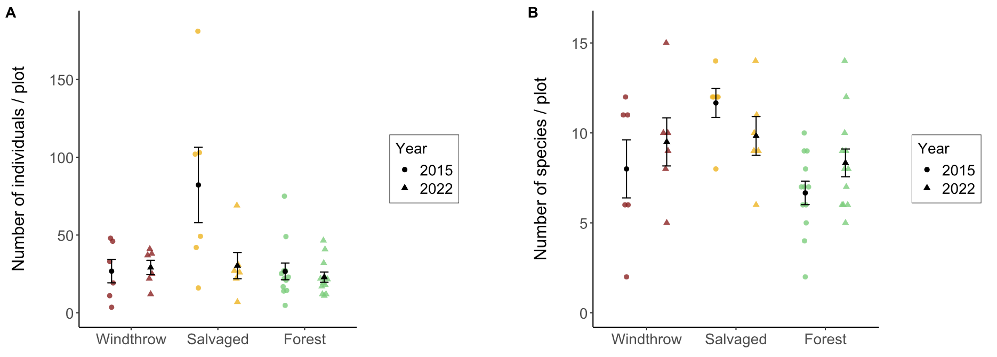

**Figure 2.2.** Total activity-abundance (A) and species richness (B) of ground beetles collected in windthrow, salvaged, and undisturbed forest in 2015 and 2022 at Powdermill Nature Reserve, Rector, Westmoreland County, Pennsylvania, USA. Bar height is the group mean, and whiskers indicate the standard error of the mean.

.

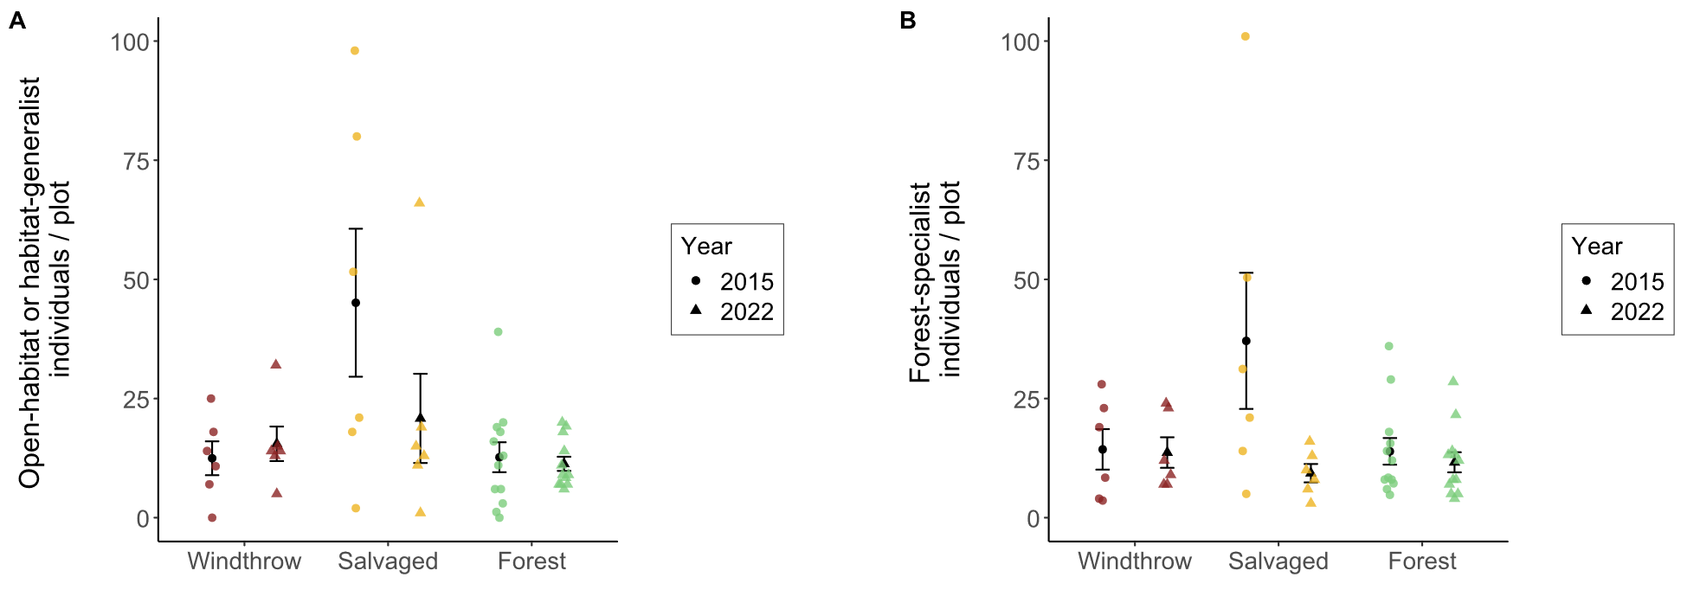

**Figure 2.3**. Activity-abundance of open-habitat or habitat-generalist ground beetle species (A) and forest-specialist species (B) collected in windthrow, salvaged, and undisturbed forest in 2015 and 2022 at Powdermill Nature Reserve, Rector, Westmoreland County, Pennsylvania, USA. The forest affinity information was collected from Larochelle and Larivière (2003). Bar height is the group mean, and whiskers indicate the standard error of the mean.

**Table 2.2.** Total trap catch of ground beetle species (Coleoptera: Carabidae) collected via pitfall traps at Powdermill Nature Reserve, Rector, Westmoreland County, Pennsylvania, USA. Sampling occurred from 27 May to 17 August, 2015, and from 1 June to 23 August, 2022.

|  |  |  |  |  |  |
| --- | --- | --- | --- | --- | --- |
| Tribe | Species | Code | 2015 | 2022 | Total |
| Notiophilini |  |  |  |  |  |
|  | *Notiophilus aeneus* (Herbst, 1806) | No.ae | 2 | 1 | 3 |
| Cychrini |  |  |  |  |  |
|  | *Sphaeroderus canadensis* | Sp.ca | 35 | 7 | 42 |
|  | *Sphaeroderus stenostomus* | Sp.st | 76 | 82 | 158 |
|  | *Scaphinotus viduus*  (Dejean, 1826) | Sc.vi | 1 | 1 | 2 |
|  | *Scaphinotus imperfectus* (Horn, 1861) | Sc.im | 0 | 3 | 3 |
| Carabini |  |  |  |  |  |
|  | *Carabus goryi* Dejean, 1831 | Ca.go | 66 | 33 | 99 |
| Pterostichini |  |  |  |  |  |
|  | *Lophoglossus scrutator* (LeConte, 1846) | Lo.sc | 0 | 1 | 1 |
|  | *Pterostichus mutus* (Say, 1823) | Pt.mu | 1 | 0 | 1 |
|  | *Pterostichus corvinus* (Dejean, 1828) | Pt.co | 6 | 0 | 6 |
|  | *Pterostichus sayanus* Csiki, 1930 | Pt.sa | 0 | 1 | 1 |
|  | *Pterostichus coracinus* (Newman, 1838) | Pt.co | 28 | 14 | 42 |
|  | *Pterostichus melanarius* (Illiger, 1798) | Pt.me | 1 | 0 | 1 |
|  | *Pterostichus lachrymosus* (Newman, 1838) | Pt.la | 27 | 45 | 72 |
|  | *Pterostichus stygicus* (Say, 1823) | Pt.st | 62 | 70 | 132 |
|  | *Pterostichus hamiltoni* Horn, 1880 | Pt.ha | 0 | 1 | 1 |
|  | *Pterostichus moestus* (Say, 1823) | Pt.mo | 185 | 47 | 232 |
|  | *Pterostichus diligendus* (Chaudoir, 1868) | Pt.di | 1 | 1 | 2 |
|  | *Pterostichus rostratus* (Newman, 1838) | Pt.ro | 36 | 22 | 58 |
|  | *Pterostichus adoxus* (Say, 1823) | Pt.ad | 19 | 80 | 99 |
|  | *Pterostichus tristis* (Dejean, 1828) | Pt.tr | 10 | 31 | 41 |
|  | *Cyclotrachelus fucatus*  (Freitag, 1969) | Cy.fu | 5 | 1 | 6 |
|  | *Cyclotrachelus convivus* (LeConte, 1853) | Cy.co | 1 | 0 | 1 |
|  | *Cyclotrachelus sigillatus* (Say, 1823) | Cy.si | 22 | 52 | 74 |
| Chlaeniini |  |  |  |  |  |
|  | *Chlaenius emarginatus* Say, 1823 | Ch.em | 137 | 25 | 162 |
|  | *Chlaenius laticollis* Say, 1823 | Ch.la | 2 | 0 | 2 |

Continued

Table 2.2 Continued

|  |  |  |  |  |  |
| --- | --- | --- | --- | --- | --- |
| Tribe | Species | Code | 2015 | 2022 | Total |
| Licinini |  |  |  |  |  |
|  | *Dicaelus politus* Dejean, 1826 | Di.po | 54 | 13 | 67 |
|  | *Dicaelus teter* Bonelli, 1813 | Di.te | 68 | 10 | 78 |
| Harpalini |  |  |  |  |  |
|  | *Notiobia nitidipennis* (LeConte, 1847) | No.ni | 6 | 0 | 6 |
|  | *Anisodactylus harrisii* LeConte, 1863 | An.ha | 2 | 1 | 3 |
|  | *Anisodactylus melanopus* (Haldeman, 1843) | An.me | 1 | 0 | 1 |
|  | *Anisodactylus nigerrimus* (Dejean, 1831) | An.ni | 3 | 5 | 8 |
|  | *Amphasia interstitialis* (Say, 1823) | Am.in | 6 | 0 | 6 |
|  | *Agonoleptus thoracicus* (Casey, 1914) | Ag.th | 0 | 1 | 1 |
|  | *Harpalus spadiceus* Dejean, 1829 | Ha.sp | 1 | 11 | 12 |
|  | *Trichotichnus autumnalis* (Say, 1823) | Tr.au | 10 | 2 | 12 |
| Sphodrini |  |  |  |  |  |
|  | *Pseudamara arenaria* (LeConte, 1847) | Ps.ar | 2 | 1 | 3 |
| Platynini |  |  |  |  |  |
|  | *Olisthopus parmatus*  (Say, 1823) | Ol.pa | 3 | 2 | 5 |
|  | *Agonum ferreum* Haldeman, 1843 | Ag.fe | 1 | 0 | 1 |
|  | *Agonum fidele* Casey, 1920 | Ag.fi | 31 | 3 | 34 |
|  | *Agonum retractum* LeConte, 1846 | Ag.re | 1 | 0 | 1 |
|  | *Platynus decentis* (Say, 1823) | Pl.de | 0 | 1 | 1 |
|  | *Platynus tenuicollis* (LeConte, 1846) | Pl.te | 3 | 5 | 8 |
|  | *Platynus angustatus* Dejean, 1828 | Pl.an | 19 | 17 | 36 |
| Lebiini |  |  |  |  |  |
|  | *Cymindis limbata* Dejean, 1831 | Cy.li | 0 | 1 | 1 |
|  | *Cymindis platicollis* (Say, 1823) | Cy.pl | 0 | 1 | 1 |
|  | *Apenes lucidula* (Dejean, 1831) | Ap.lu | 0 | 8 | 8 |
| Galeritini |  |  |  |  |  |
|  | *Galerita bicolor* (Drury, 1773) | Ga.bi | 0 | 3 | 3 |
| Total |  |  | 934 | 603 | 1537 |

The principal components analysis (PCA) of the eight numerical traits generated a set of axes, of which the first four axes together explained 89% of the variance (Table S2). The first PC axis (39% of the variance) was associated with proportionally shorter antennae, shorter rear legs, and wider pronotum (Figure S3). The second axis (26% of the variance) was associated with proportionally longer eyes, higher eye protrusion, and shorter body length. The third axis (14% of the variance) was associated with proportionally shorter rear trochanter and wider abdomen (Figure S4). The fourth axis (11% of the variance) was associated with proportionally wider abdomen and longer body length.

A subset of functional traits showed differences among treatments, but functional alpha-diversity was similar among forest management treatments and across years (Tables 3-4). The CWM body length was greater for forest plots than salvaged plots, while windthrow plots were intermediate (Fig. 5A). This indicates that species of larger body length made up a higher proportion of trap captures in forest plots than salvaged plots. When we examined morphological traits of the eyes and antenna, we found that CWM proportional eye length was greater for salvaged plots than windthrow or forest plots (Fig. 5C). Thus, species abundant in salvaged plots had longer eyes relative to their body size. However, we did not detect differences in CWM proportional antenna length (Fig. 5E). When considering the morphological traits associated with locomotion strategy, we found that CWM proportional trochanter length was greater for salvaged plots than windthrow or forest (Fig. 5D). This means species common in salvaged plots tended to have a longer rear trochanter relative to their body length, versus species common in windthrow or forest plots. Finally, when looking at the literature-based traits, we found that flight capability varied by treatment and treatment:year interaction, but no patterns were detected for water affinity (Tables 3-4). Specifically, a higher proportion of individuals belonging to flight-capable species were collected in salvaged plots in 2015, but this pattern disappeared by 2022 (Fig. 5E).

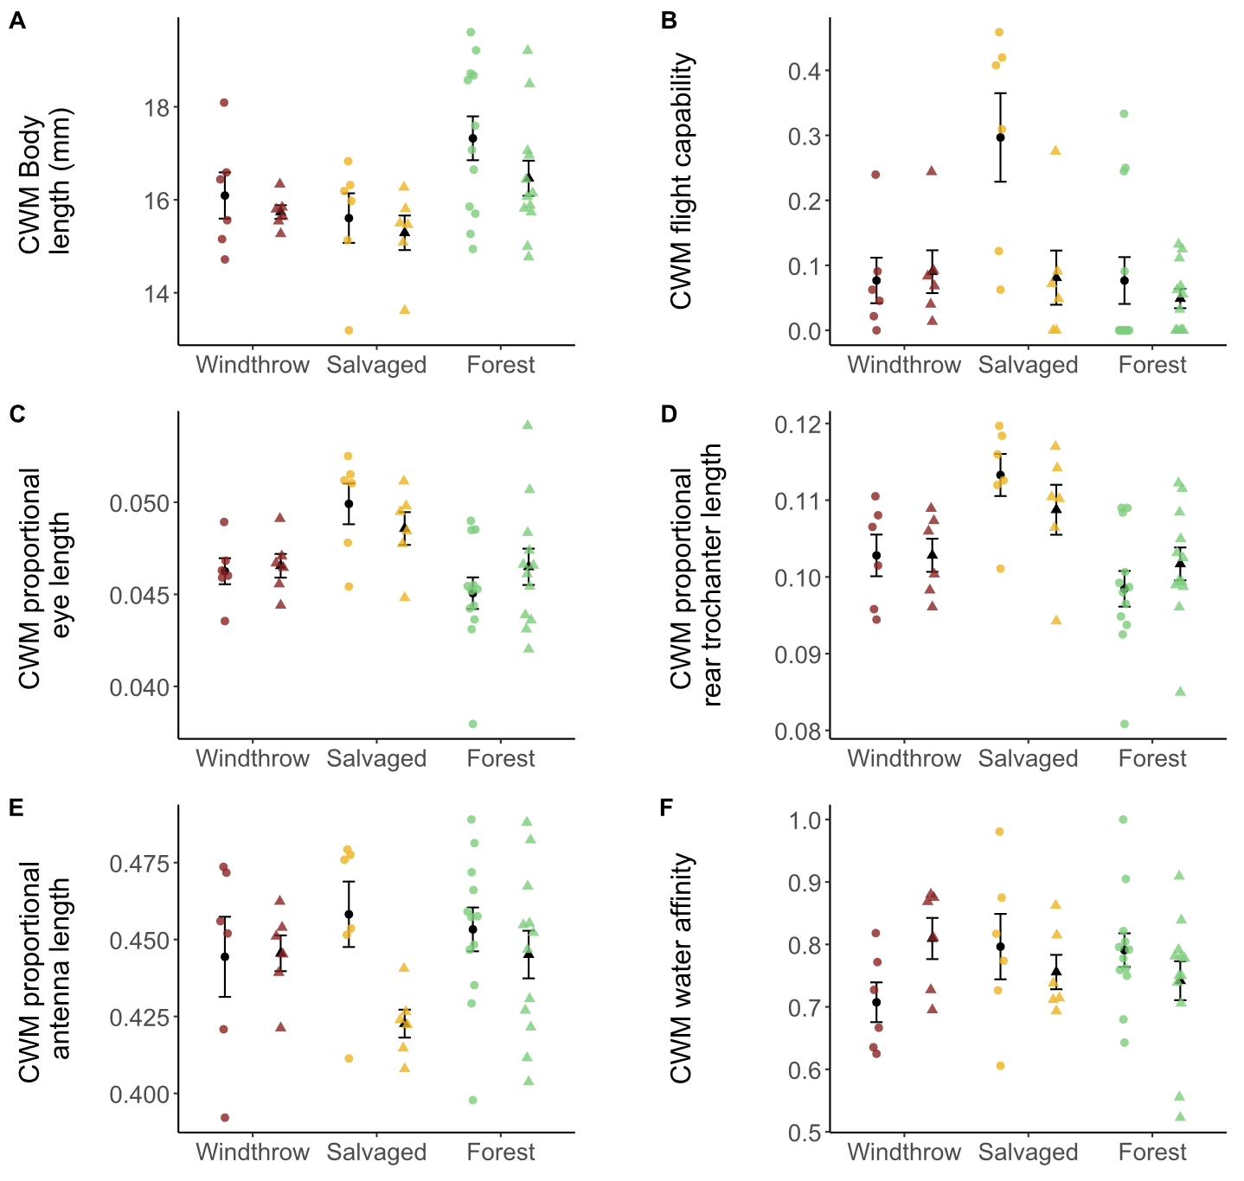

**Figure 2.4.** Community-weighted mean (CWM) traits of ground beetles collected in windthrow, salvaged, and undisturbed forest plots in 2015 and 2022. Circular points are observations from 2015, while triangles are observations from 2022. Sample size is 6 plots for windthrow, 6 plots for salvaged, and 12 plots for undisturbed forest. (A) CWM body length, measured as the sum of head length, pronotum length, and elytron length. (B) CWM flight capability, as indicated in the literature (Larochelle and Larivière 2003). Values closer to 1 indicate that a higher proportion of individuals collected were identified as flight-capable species. (C) CWM eye length (posterior to anterior edge of eye) standardized to body length. (D) CWM meta-trochanter length standardized to body length. (E) CWM antenna length standardized to body length. (F) CWM water affinity, as indicated in the literature. Values closer to 1 indicate that a higher proportion of individuals collected belonged to species which prefer wet soil or live near water. A significant effect of forest management treatment was found for A-D, while no significant effects were found for E-F.

**Table 2.3.** Main effects of forest management treatments (windthrow, salvaged, undisturbed forest) and year (2015, 2022) on activity-abundance, species richness, species diversity, community-weighted means (CWM) for individual traits, and functional diversity for ground beetles collected at Powdermill Nature Reserve Rector, Westmoreland County, Pennsylvania, USA. The model type column indicates if the model was a standard linear model (LM), a linear mixed-effects model with transect included as a random effect (LMM), or a generalized linear model with Poisson errors (GLM). Dashes indicate that the p-value is above 0.10. Patterns with a p-value below 0.05 are bolded. Beetles were collected between 27 May to 17 August, 2015, and from 1 June to 23 August, 2022.

|  |  |  |  |  |  |  |  |
| --- | --- | --- | --- | --- | --- | --- | --- |
| Response variable | Model  type | Treatment  (Windthrow, Salvaged, Forest) | | Year (2015, 2022) | | Treatment*Year interaction | |
|  |  |  | |  | |  |  |
|  |  | Statistic | p | Statistic | p | Statistic | p |
|  |  |  |  |  |  |  |  |
| Total activity-abundance | LMM* | **F= 5.7** | **0.007** | F=1.9 | - | **F=4.5** | **0.018** |
|  |  |  |  |  |  |  |  |
| Activity abundance of open-habitat and habitat-generalist species | LMM* | **F=3.6** | **0.037** | F=0.01 | - | F=2.4 | - |
|  |  |  |  |  |  |  |  |
| Activity abundance of forest-specialist species | LMM* | F=0.7 | - | F=3.4 | 0.075 | F=2.7 | 0.079 |
|  |  |  |  |  |  |  |  |
| Species richness | GLM | **X2=11.5** | **0.003** | X2=2.2 | - | X2=3.2 | - |
|  |  |  |  |  |  |  |  |
| Shannon diversity | LMM | F= 1.0 | - | F= 1.3 | - | F= 0.2 | - |

*: a log transformation was done on the response variable to improve the model’s satisfaction of assumptions

Continued

Table 2.3 Continued

|  |  |  |  |  |  |  |  |
| --- | --- | --- | --- | --- | --- | --- | --- |
| Response variable | Model  type | Treatment  (Windthrow, Salvaged, Forest) | | Year (2015, 2022) | | Treatment*Year interaction | |
|  |  |  |  |  |  |  |  |
|  |  | Statistic | p | Statistic | p | Statistic | p |
| Functional alpha-diversity | LM | F=0.4 | - | F= 0.001 | - | F= 1.5 | - |
|  |  |  |  |  |  |  |  |
| CWM Body length | LM | **F=5.8** | **0.006** | F=2.6 | - | F=0.3 | - |
|  |  |  |  |  |  |  |  |
| CWM Standardized antenna length | LMM | F=0.6 | - | F=3.9 | 0.056 | F=2.0 | - |
|  |  |  |  |  |  |  |  |
| CWM Standardized rear leg length | LMM | F=0.4 | - | F=1.6 | - | F=1.9 | - |
|  |  |  |  |  |  |  |  |
| CWM Standardized eye length | LMM | **F=8.1** | **0.001** | F=0.03 | - | F=1.3 | - |
|  |  |  |  |  |  |  |  |
| CWM Standardized eye protrusion | LMM | F= 1.9 | - | F= 0.3 | - | F= 0.9 | - |
|  |  |  |  |  |  |  |  |
| CWM Standardized pronotum width | LMM | F= 1.2 | - | F= 1.2 | - | F= 0.05 | - |

Continued

Table 2.3 Continued

|  |  |  |  |  |  |  |  |
| --- | --- | --- | --- | --- | --- | --- | --- |
| Response variable | Model  type | Treatment  (Windthrow, Salvaged, Forest) | | Year (2015, 2022) | | Treatment*Year interaction | |
|  |  |  |  |  |  |  |  |
|  |  | Statistic | p | Statistic | p | Statistic | p |
| CWM Standardized abdomen width | LMM | F= 0.4 | - | F= 0.6 | - | F= 0.6 | - |
|  |  |  |  |  |  |  |  |
| CWM Standardized rear trochanter length | LMM | **F= 11.4** | **<0.001** | F= 0.05 | - | F= 1.4 | - |
|  |  |  |  |  |  |  |  |
| CWM Water affinity | LM | F=0.1 | - | F= 0.1 | - | F= 2.7 | 0.082 |
|  |  |  |  |  |  |  |  |
| CWM Flight capability | LMM* | **F= 5.7** | **0.007** | F= 3.5 | 0.068 | **F= 3.9** | **0.028** |

*: a log transformation was done on the response variable to improve the model’s satisfaction of assumptions

**Table 2.4.** Means (± standard errors) of the response variables for ground beetle biodiversity.

|  |  |  |  |  |  |  |  |
| --- | --- | --- | --- | --- | --- | --- | --- |
|  |  | Unit |  | Year | Windthrow | Salvaged | Forest |
| Sample size |  | Plots |  | 2015 | n=6 | n=6 | n=12 |
|  |  |  |  | 2022 | n=6 | n=6 | n=12 |
|  |  |  |  |  |  |  |  |
| Total activity- |  | Beetles per 84 trap days |  | 2015 | 26.8 ± 7.5 | 82.2 ± 24.3 | 26.6 ± 5.4 |
| abundance |  |  |  | 2022 | 29.2 ± 4.6 | 30.3 ± 8.4 | 22.9 ± 3.3 |
|  |  |  |  |  |  |  |  |
| Activity abundance of |  | Beetles per 84 trap days |  | 2015 | 0 ± 0 | 0.90 ± 0.32 | 0 ± 0 |
| open-habitat species |  |  |  | 2022 | 0 ± 0 | 0.67 ± 0.67 | 0.23 ± 0.15 |
|  |  |  |  |  |  |  |  |
| Activity abundance of |  | Beetles per 84 trap days |  | 2015 | 12.4 ± 3.6 | 44.2 ± 15.4 | 12.7 ± 3.1 |
| eurytopic species |  |  |  | 2022 | 15.5 ± 3.6 | 20.2 ± 8.7 | 11.1 ± 1.4 |
|  |  |  |  |  |  |  |  |
| Activity abundance of |  | Beetles per 84 trap days |  | 2015 | 14.3 ± 4.2 | 37.1 ± 14.3 | 13.9 ± 2.8 |
| forest-specialist species |  |  |  | 2022 | 13.7 ± 3.2 | 9.3 ± 1.9 | 11.6 ± 2.1 |
|  |  |  |  |  |  |  |  |
| Species richness |  | Number of species |  | 2015 | 8.0 ± 1.6 | 11.7 ± 0.8 | 6.7 ± 0.7 |
|  |  |  |  | 2022 | 9.5 ± 1.3 | 9.8 ± 1.1 | 8.3 ± 0.8 |
|  |  |  |  |  |  |  |  |
| Shannon diversity |  | Effective number of species |  | 2015 | 6.5 ± 1.2 | 6.3 ± 1.0 | 5.1 ± 0.5 |
|  |  |  |  | 2022 | 7.0 ± 0.9 | 6.7 ± 1.0 | 6.4 ± 0.6 |

Continued

Table 2.4 Continued

|  |  |  |  |  |  |  |  |
| --- | --- | --- | --- | --- | --- | --- | --- |
|  |  | Unit |  | Year | Windthrow | Salvaged | Forest |
| Functional alpha- |  | Within-plot mean pairwise |  | 2015 | 0.16 ± 0.02 | 0.18 ± 0.01 | 0.15 ± 0.01 |
| diversity |  | distance in trait space |  | 2022 | 0.17 ± 0.01 | 0.16 ± 0.01 | 0.17 ± 0.01 |
|  |  |  |  |  |  |  |  |
| CWM Body length |  | mm |  | 2015 | 16.09 ± 0.50 | 15.61 ± 0.53 | 17.32 ± 0.47 |
|  |  |  |  | 2022 | 15.74 ± 0.15 | 15.29 ± 0.37 | 16.46 ± 0.38 |
|  |  |  |  |  |  |  |  |
| CWM Standardized |  | Fraction of body length |  | 2015 | 0.444 ± 0.013 | 0.458 ± 0.011 | 0.453 ± 0.007 |
| antenna length |  |  |  | 2022 | 0.446 ± 0.006 | 0.423 ± 0.005 | 0.445 ± 0.008 |
|  |  |  |  |  |  |  |  |
| CWM Standardized |  | Fraction of body length |  | 2015 | 0.731 ± 0.014 | 0.752 ± 0.013 | 0.744 ± 0.013 |
| rear leg length |  |  |  | 2022 | 0.740 ± 0.006 | 0.712 ± 0.008 | 0.739 ± 0.009 |
|  |  |  |  |  |  |  |  |
| CWM Standardized eye |  | Fraction of body length |  | 2015 | 0.046 ± 0.001 | 0.05 ± 0.001 | 0.045 ± 0.001 |
| length |  |  |  | 2022 | 0.047 ± 0.001 | 0.049 ± 0.001 | 0.046 ± 0.001 |
|  |  |  |  |  |  |  |  |
| CWM Standardized eye |  | Fraction of body length |  | 2015 | 0.052 ± 0.001 | 0.054 ± 0.001 | 0.051 ± 0.001 |
| protrusion |  |  |  | 2022 | 0.052 ± 0.000 | 0.053 ± 0.001 | 0.052 ± 0.001 |
|  |  |  |  |  |  |  |  |
| CWM Standardized |  | Fraction of body length |  | 2015 | 0.263 ± 0.002 | 0.265 ± 0.002 | 0.262 ± 0.003 |
| pronotum width |  |  |  | 2022 | 0.265 ± 0.001 | 0.268 ± 0.002 | 0.264 ± 0.001 |

Continued

Table 2.4 Continued

|  |  |  |  |  |  |  |  |
| --- | --- | --- | --- | --- | --- | --- | --- |
|  |  | Unit |  | Year | Windthrow | Salvaged | Forest |
| CWM Standardized |  | Fraction of body length |  | 2015 | 0.349 ± 0.006 | 0.351 ± 0.005 | 0.353 ± 0.004 |
| abdomen width |  |  |  | 2022 | 0.357 ± 0.003 | 0.349 ± 0.003 | 0.354 ± 0.003 |
|  |  |  |  |  |  |  |  |
| CWM Standardized rear |  | Fraction of body length |  | 2015 | 0.103 ± 0.003 | 0.113 ± 0.003 | 0.098 ± 0.002 |
| trochanter length |  |  |  | 2022 | 0.103 ± 0.002 | 0.109 ± 0.003 | 0.102 ± 0.002 |
|  |  |  |  |  |  |  |  |
| CWM Water affinity |  | 0, 0.5, or 1 |  | 2015 | 0.71 ± 0.03 | 0.80 ± 0.05 | 0.79 ± 0.03 |
|  |  |  |  | 2022 | 0.81 ± 0.03 | 0.76 ± 0.03 | 0.74 ± 0.03 |
|  |  |  |  |  |  |  |  |
| CWM Flight capability |  | 0, 0.5, or 1 |  | 2015 | 0.08 ± 0.04 | 0.30 ± 0.07 | 0.08 ± 0.04 |
|  |  |  |  | 2022 | 0.09 ± 0.03 | 0.08 ± 0.04 | 0.05 ± 0.01 |

The taxonomic and functional composition of ground beetle communities differed among forest management treatments (Table 5). Ground beetle communities in salvaged plots were taxonomically distinct from undisturbed forest, and taxonomic composition changed over time from 2015 to 2022 (Fig. 6A). Functional composition showed an interaction between treatment and year, whereby salvaged plots differed from windthrow and undisturbed forest in 2015, but these differences were not detected in 2022 (Fig. 6B). Neither treatment groups nor years differed significantly in dispersion from their spatial medians.

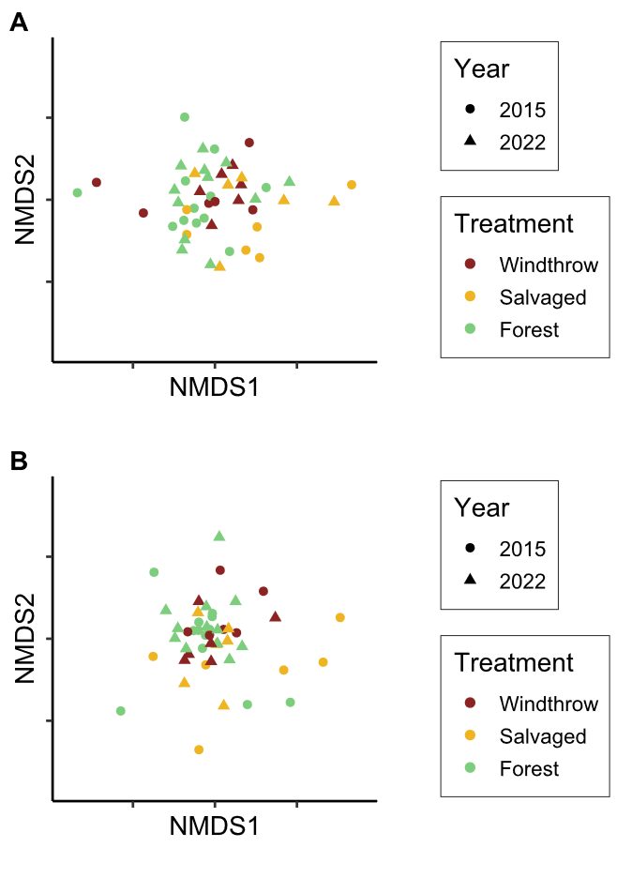

**Figure 2.5.** Nonmetric multidimensional scaling (NMDS) ordinations of ground beetle communities in taxonomic space (A) and functional trait space (B). Each point is a plot in a given year; shape of the point indicates the year the community was sampled, while color indicates the forest management treatment. The NMDS ordinations resulted in stress values of 0.224 for taxonomic beta-diversity and 0.181 for functional beta-diversity.

**Table 2.5.** Main effects of forest management treatments (windthrow, salvaged, undisturbed forest) and year (2015, 2022) on community composition of ground beetles collected at Powdermill Nature Reserve Rector, Westmoreland County, Pennsylvania, USA. The models use the dissimilarities between plots (Bray-Curtis for taxonomic beta-diversity and inter-community mean pairwise distance in trait space for functional beta-diversity). The PERMANOVA uses the matrix of dissimilarities to partitions how much variation can be explained by treatment, year, and their interaction. The BETADISPER tests whether there are differences between groups in dispersion from the group spatial median. Dashes indicate that the p-value is above 0.10. Patterns with a p-value below 0.05 are bolded

|  |  |  |  |  |  |  |  |  |
| --- | --- | --- | --- | --- | --- | --- | --- | --- |
| Beta-diversity type |  | Dissimilarity metric | Treatment  (Windthrow, Salvaged, Forest) | | Year (2015, 2022) | | Treatment*Year interaction | |
|  |  |  |  | |  | |  |  |
|  |  |  | Statistic | p | Statistic | p | Statistic | p |
| Taxonomic  PERMANOVA |  | Bray-Curtis | **F=1.7** | **0.019** | **F=3.8** | **<0.001** | F=1.0 | - |
|  |  |  |  |  |  |  |  |  |
| Taxonomic  BETADISPER |  | Bray-Curtis | F=0.6 | - | F=0.3 | - | Not tested | Not tested |
|  |  |  |  |  |  |  |  |  |
| Functional  PERMANOVA |  | comdist* | **F=1.6** | **0.001** | F=1.3 | 0.078 | **F=1.3** | **0.046** |
|  |  |  |  |  |  |  |  |  |
| Functional BETADISPER |  | comdist* | F=0.7 | - | F=2.8 | - | Not tested | Not tested |

* : inter-community mean pairwise distance in trait space

The forest floor environment changed among the forest management treatments over time (Tables 6-7). In 2015, canopy openness was higher above salvaged plots than windthrow or undisturbed forest plots. By 2022, canopy openness above salvaged plots had decreased, but remained higher, on average, than forest plots. In 2015, salvaged plots had higher vegetation cover than windthrow, and windthrow had higher vegetation cover than forest controls, but these patterns had almost disappeared by 2022. Meanwhile, percentage cover of leaf litter showed the opposite pattern. In 2015, salvaged plots had the lowest leaf litter cover, followed by windthrow plots and then forest controls with the highest leaf litter cover. By 2022, these differences had mostly, but not entirely, disappeared. Soil moisture was similar among forest management treatments, both in 2015 and in 2022.

**Table 2.6.** Main effects of forest management treatments (windthrow, salvaged, undisturbed forest) and year (2015, 2022) on environmental variables in the understory at Powdermill Nature Reserve, Rector, Westmoreland County, Pennsylvania, USA. All models were linear mixed-effects models with transect included as a random effect (LMM). Dashes indicate that the p-value is above 0.10. Patterns with a p-value below 0.05 are bolded.

|  |  |  |  |  |  |  |  |  |
| --- | --- | --- | --- | --- | --- | --- | --- | --- |
| Response variable |  | Model  type | Treatment  (Windthrow, Salvaged, Forest) | | Year (2015, 2022) | | Treatment*Year interaction | |
|  |  |  |  | |  | |  |  |
|  |  |  | Statistic | p | Statistic | p | Statistic | p |
| Canopy openness |  | LMM* | **F=47.2** | **<0.001** | **F=45.9** | **<0.001** | **F=19.9** | **<0.001** |
|  |  |  |  |  |  |  |  |  |
| Vegetation percentage cover |  | LMM | **F=15.6** | **<0.001** | F=0.7 | - | **F=5.7** | **0.007** |
| Leaf litter percentage cover |  | LMM | **F=20.0** | **<0.001** | F= 0.8 | - | **F=8.8** | **0.001** |
|  |  |  |  |  |  |  |  |  |
| Soil moisture (2015) |  | LMM | F=0.08 | - | Not tested | Not tested | Not tested | Not tested |
| Soil moisture (2022) |  | LMM | F=0.2 | - | Not tested | Not tested | Not tested | Not tested |

*: a log transformation was done on the response variable to improve the model’s satisfaction of assumptions

**Table 2.7.** Means (± standard errors) of the environmental variables in the understory.

|  |  |  |  |  |  |  |  |
| --- | --- | --- | --- | --- | --- | --- | --- |
|  |  | Unit |  | Year | Forest | Salvaged | Windthrow |
| Canopy openness |  | 0-100% |  | 2015 | 9.1 ± 0.4 | 82.3 ± 3.4 | 13.7 ± 2.5 |
|  |  |  |  | 2022 | 7.7 ± 0.5 | 19.7 ± 10.8 | 9.1 ± 1.3 |
|  |  |  |  |  |  |  |  |
| Ground-level vegetation |  | 0-100% |  | 2015 | 21.6 ± 2.8 | 73.0 ± 6.0 | 42.1 ± 10.4 |
| percentage cover |  |  |  | 2022 | 35.1 ± 4.2 | 47.7 ± 11.3 | 41.9 ± 6.7 |
|  |  |  |  |  |  |  |  |
| Leaf litter percentage cover |  | 0-100% |  | 2015 | 61.2 ± 3.6 | 5.2 ± 3.5 | 35.4 ± 7.3 |
|  |  |  |  | 2022 | 43.1 ± 4.5 | 31.5 ± 9.5 | 39.6 ± 5.8 |
|  |  |  |  |  |  |  |  |
| Soil moisture$ |  | 0-1.129 |  | 2015 | 0.59 ± 0.04 | 0.61 ± 0.07 | 0.60 ± 0.04 |
|  |  | 0-100% |  | 2022 | 44.8 ± 3.5 | 47.6 ± 2.5 | 48.7 ± 7.4 |

$: A different soil sensor was used in 2022 than was used in 2015, so readings are only comparable between treatments within a year.

Discussion

This study investigated the effects of disturbance caused by wind and subsequent salvage logging on ground beetle communities over time. We found that ground beetles differed both taxonomically and functionally between windthrow and salvaged forest, consistent with other studies (Koivula and Spence 2006, Gandhi et al. 2008). Salvage-logging, which removed all standing and downed trees, supported ground beetle communities that were distinct in species and trait composition, compared to windthrow and undisturbed forest which were more similar to one another. Although differences between treatments were largest two years after salvaging in 2015, some differences in species and traits persisted in 2022, nine years after salvaging. These findings suggest that the impacts of salvage logging after a natural disturbance continue to affect forest invertebrates for more than a decade, even as tree regeneration begins.

Ground beetle activity-abundance, species richness, and community composition were similar among windthrow and undisturbed forest in 2015 and 2022. This finding was inconsistent with our hypothesis that ground beetle alpha-diversity would increase in unsalvaged windthrow relative to undisturbed forest. Other studies have found slightly elevated ground beetle alpha-diversity and altered community composition in windthrow relative to reference forest (Gandhi et al. 2008, Sklodowski and Garbalinska 2011, Barber and Widick 2017). Wind from strong storms increases standing and downed woody debris, changes abiotic conditions on the soil surface, and stimulates the growth of ground-level vegetation, all of which can alter the structure and composition of arthropod communities (Urbanovicova et al. 2014, Wermelinger et al. 2017). Some of these changes were confirmed by our study, which found increases in percentage cover of ground level vegetation along with decreases in leaf litter. However, instead of a complete reorganization of the ground beetle community, windthrows commonly support many of the same species found in undisturbed forest (Lee et al. 2017). Similarly, our study saw the persistence of forest-specialists in unsalvaged windthrows rather than any pronounced influx of generalists or open-habitat species.

Windthrow followed by salvage-logging resulted in distinct ground beetle communities and elevated species richness relative to undisturbed forest. Habitat-generalists increased in abundance two years after salvaging, altering ground beetle community composition, which supports our initial hypothesis. At nine years after salvaging, ground beetle communities remained taxonomically distinct, suggesting that legacies of windthrow were altered by the logging process. Our results align with many studies of salvage-logging and green-logging, where complete canopy removal resulted in an initial influx of flight-capable species (Pearce et al. 2003, Niemelä et al. 2007, Silverman et al. 2008, Gandhi et al. 2008). We observed an influx of habitat generalists such as *C. emarginatus*, but open-habitat specialists from the genera *Amara* and *Harpalus* were not present, contrary to other studies (Pearce et al. 2003, Silverman et al. 2008, Riley and Browne 2011). This finding may reflect the surrounding landscape, which is mostly forested and likely did not support source populations of open-habitat species. We also found some forest-specialists, such as *P. moestus*, thrived initially in salvage-logged habitat, which may indicate their ability to tolerate altered abiotic conditions (Riley and Browne 2011), adopt new food sources (Lee et al. 2017), utilize any rapidly decomposing branches left by salvaging (Hamilton 1884, Thorn et al. 2014), or travel back and forth between salvaged and unsalvaged habitat during different times of the year (Ohwaki et al. 2015). However, salvaged habitat after nine years supported mostly habitat-generalists such as *P. stygicus*, suggesting that logging may have reduced the woody debris resources necessary for certain species (Gore and Patterson III 1986, Larochelle and Larivière 2003, Pearce et al. 2003).

Contrary to our hypothesis, we found that functional alpha-diversity was similar among forest management treatments and across years, despite the increase in species richness after salvaging. We expected that the influx of open-habitat species and habitat-generalists following windthrow and salvage-logging would increase functional diversity due to the presence of novel traits such as flight capability or traits associated with specialized modes of feeding (Lee et al. 2017, Nardi et al. 2022). While functional alpha-diversity did not differ, functional beta-diversity between forest management treatments supported our hypothesis. Specifically, the functional community composition of salvage-logged forest was distinct from that of windthrow and undisturbed forest in 2015. The environmental conditions within salvaged plots, including higher light levels, lower leaf litter depth (Greenberg and Forrest 2003), temperature extremes (Urbanovicova et al. 2014), altered vegetation (Spicer et al. 2023), and changes in prey types (Wermelinger et al. 2017) can act as filters that select for a different suite of functional traits (Bauer and Kredler 1993, Inward et al. 2011, Ng et al. 2018, Sultaire et al. 2021). Species common in salvaged forests had proportionally longer eyes and rear trochanters in both years, and were more flight capable in 2015, partially supporting our hypothesis. Larger eye size can relate to open habitat preference, diurnal activity, and visual-hunting strategy (Bauer and Kredler 1993, Ribera et al. 1999, Talarico et al. 2007). Species with larger rear trochanters can expand crevices between layers of substrate, whereas species with shorter rear trochanters tend to walk or run on the surface (Evans 1977, Forsythe 1981). Further research could investigate why salvage-logging favored species with longer trochanters, even though salvaged forest tended to have lower leaf litter cover and higher vegetation cover. The abundance of flight-capable species often increases in the first few years after disturbance, then decreases over time with forest regeneration (Sklodowski and Garbalinska 2011, Riley and Browne 2011). We found that salvage-logging favored flight capable species in 2015, but not in 2022, which may reflect the rapid tree regeneration occurring in salvaged forest (Curtze et al. 2018). Finally, species common in undisturbed forest tended to have longer bodies, which may reflect that larger forest-specialists can decline in disturbed forests (Sklodowski and Garbalinska 2011).

The process of salvage-logging following a natural disturbance such as wind can alter important biological legacies that shape short- and long-term recovery in forests. These legacies include the size-distribution of tree seedlings (Slyder et al. 2020), the size, age, and microclimate around downed woody debris (Thorn et al. 2014), and the abundance and richness of herbaceous plants in the understory (Elliott et al. 2002, Spicer et al. 2023). Using ground beetles as environmental indicators, we documented shifts in community composition that occurred due to salvage-logging. Our results suggest that habitat generalists benefitted from salvaging, but some species with specialized modes of feeding were disadvantaged (Sultaire et al. 2021). Furthermore, we saw larger differences in community composition than we did in alpha-diversity, suggesting that species turnover is occurring. Finally, differences between treatment groups (for example, in taxonomic composition and CWM meta-trochanter length) persisted even after nine years. These findings suggest that conservation-minded land managers should leave a portion of windthrow stands unsalvaged to conserve ground beetle biodiversity in the long term.

References

Barber, N. A., and W. L. Widick. 2017. Localized Effects of Tornado Damage on Ground Beetle Communities and Vegetation in a Forested Preserve. Natural Areas Journal 37:489–496.

Barton, P. S., H. Gibb, A. D. Manning, D. B. Lindenmayer, and S. A. Cunningham. 2011. Morphological traits as predictors of diet and microhabitat use in a diverse beetle assemblage: MORPHOLOGICAL TRAITS OF BEETLES. Biological Journal of the Linnean Society 102:301–310.

Bates, D., M. Mächler, B. Bolker, and S. Walker. 2015. Fitting Linear Mixed-Effects Models Using **lme4**. Journal of Statistical Software 67.

Bauer, T., and M. Kredler. 1993. Morphology of the compound eyes as an indicator of life-style in carabid beetles. Canadian Journal of Zoology 71:799–810.

Bousquet, Y. 2010. Illustrated identification guide to adults and larvae of northeastern North American ground beetles: Coleoptera : Carabidae. Pensoft, Sofia.

Bousquet, Y. 2012. Catalogue of Geadephaga (Coleoptera: Adephaga) of America, north of Mexico. ZooKeys 245:1–1722.

Bousquet, Y., and P. Messer. 2010. Redescription of Stenolophus thoracicus Casey (Coleoptera, Carabidae, Harpalini), a valid species. ZooKeys 53:25–31.

Browne, R., S. Maveety, L. Cooper, and K. Riley. 2014. Ground Beetle (Coleoptera: Carabidae) Species Composition in the Southern Appalachian Mountains. Southeastern Naturalist 13:407–422.

Calinger, K., E. Calhoon, H. Chang, J. Whitacre, J. Wenzel, L. Comita, and S. Queenborough. 2015. Historic Mining and Agriculture as Indicators of Occurrence and Abundance of Widespread Invasive Plant Species. PLOS ONE 10:e0128161.

Chao, A., and C. Chiu. 2016. Species Richness: Estimation and Comparison. Pages 1–26 *in* R. S. Kenett, N. T. Longford, W. W. Piegorsch, and F. Ruggeri, editors. Wiley StatsRef: Statistics Reference Online. First edition. Wiley.

Chao, A., K. H. Ma, T. C. Hsieh, and C. Chiu. 2016. SpadeR: Species-Richness Prediction and Diversity Estimation with R.

Curtze, A. C., T. A. Carlo, and J. W. Wenzel. 2018. The Effects of a Tornado Disturbance and a Salvaged Timber Extraction on the Seed-Rain and Recruitment Community of an Eastern Temperate Deciduous Forest. Northeastern Naturalist 25:627.

Elliott, K. J., S. L. Hitchcock, and L. Krueger. 2002. Vegetation Response to Large Scale Disturbance in a Southern Appalachian Forest: Hurricane Opal and Salvage Logging. Journal of the Torrey Botanical Society 129:48.

Erwin, T. L. 1979. Thoughts on the Evolutionary History of Ground Beetles: Hypotheses Generated from Comparative Faunal Analyses of Lowland Forest Sites in Temperate and Tropical Regions. Pages 539–592 *in* T. L. Erwin, G. E. Ball, D. R. Whitehead, and A. L. Halpern, editors. Carabid Beetles: Their Evolution, Natural History, and Classification. Springer Netherlands, Dordrecht.

Evans, M. E. G. 1977. Locomotion in the Coleoptera Adephaga, especially Carabidae. Journal of Zoology 181:189–226.

Fischer, A., P. Marshall, and A. Camp. 2013. Disturbances in deciduous temperate forest ecosystems of the northern hemisphere: their effects on both recent and future forest development. Biodiversity and Conservation 22:1863–1893.

Forsythe, T. G. 1981. Running and Pushing in Relationship to Hind Leg Structure in Some Carabidae (Coleoptera). The Coleopterists Bulletin 35:353–378.

Forsythe, T. G. 1991. Feeding and locomotory functions in relation to body form in five species of ground beetle (Coleoptera: Carabidae). Journal of Zoology 223:233–263.

Fountain-Jones, N. M., S. C. Baker, and G. J. Jordan. 2015. Moving beyond the guild concept: developing a practical functional trait framework for terrestrial beetles. Ecological Entomology 40:1–13.

Fox, J., and S. Weisberg. 2019. An {R} Companion to Applied Regression. Sage, Thousand Oaks {CA}.

Freitag, R. 1969. A revision of the species of the genus Evarthrus LeConte (Coleoptera: Carabidae). Quaestiones Entomologicae 5:88–212.

Gandhi, K. J. K., D. W. Gilmore, S. A. Katovich, W. J. Mattson, J. C. Zasada, and S. J. Seybold. 2008. Catastrophic windstorm and fuel-reduction treatments alter ground beetle (Coleoptera: Carabidae) assemblages in a North American sub-boreal forest. Forest Ecology and Management 256:1104–1123.

Gore, J. A., and W. A. Patterson III. 1986. Mass of downed wood in northern hardwood forests in New Hampshire: potential effects of forest management. Canadian Journal of Forest Research 16:335–339.

Greenberg, C. H., and T. G. Forrest. 2003. SEASONAL ABUNDANCE OF GROUND-OCCURRING MACROARTHROPODS IN FOREST AND CANOPY GAPS IN THE SOUTHERN APPALACHIANS. Southeastern Naturalist 2:591–608.

Hamilton, J. 1884. THE SURVIVAL OF THE FITTEST AMONG CERTAIN SPECIES OF PTEROSTICHUS AS DEDUCED FROM THEIR HABITS. The Canadian Entomologist 16:73–77.

Harden, C. W., and F. G. Guarnieri. 2017. Illustrated Key and Photo Atlas of the Snail-eating Ground Beetles in the Genus Scaphinotus Dejean (Coleoptera: Carabidae: Cychrini) Occurring in the Mid-Atlantic Region. The Maryland Entomologist 7:16–34.

Hunting, W. 2013. A taxonomic revision of the Cymindis (Pinacodera) limbata species group (Coleoptera, Carabidae, Lebiini), including description of a new species from Florida, U.S.A. ZooKeys 259:1–73.

Inward, D. J. G., R. G. Davies, C. Pergande, A. J. Denham, and A. P. Vogler. 2011. Local and regional ecological morphology of dung beetle assemblages across four biogeographic regions: Ecological morphology of dung beetle assemblages. Journal of Biogeography 38:1668–1682.

Kembel, S. W., P. D. Cowan, M. R. Helmus, W. K. Cornwell, H. Morlon, D. D. Ackerly, S. P. Blomberg, and C. O. Webb. 2010. Picante: R tools for integrating phylogenies and ecology. Bioinformatics 26:1463–1464.

Koivula, M. 2011. Useful model organisms, indicators, or both? Ground beetles (Coleoptera, Carabidae) reflecting environmental conditions. ZooKeys 100:287–317.

Koivula, M., and J. R. Spence. 2006. Effects of post-fire salvage logging on boreal mixed-wood ground beetle assemblages (Coleoptera, Carabidae). Forest Ecology and Management 236:102–112.

Kuznetsova, A., P. B. Brockhoff, and R. H. B. Christensen. 2017. **lmerTest** Package: Tests in Linear Mixed Effects Models. Journal of Statistical Software 82.

Laliberte, E., P. Legendre, and B. Shipley. 2014. FD: measuring functional diversity from multiple traits, and other tools for functional ecology. R.

Lambeets, K., M. L. Vandegehuchte, J. Maelfait, and D. Bonte. 2008. Understanding the impact of flooding on trait‐displacements and shifts in assemblage structure of predatory arthropods on river banks. Journal of Animal Ecology 77:1162–1174.

Langor, D. W., and J. R. Spence. 2006. Arthropods as ecological indicators of sustainability in Canadian forests. The Forestry Chronicle 82:344–350.

Larochelle, A., and M.-C. Larivière. 2003. A natural history of the ground-beetles (Coleoptera: Carabidae) of America north of Mexico. Pensoft Publ, Sofia.

Lee, C. M., T.-S. Kwon, and K. Cheon. 2017. Response of ground beetles (Coleoptera: Carabidae) to forest gaps formed by a typhoon in a red pine forest at Gwangneung Forest, Republic of Korea. Journal of Forestry Research 28:173–181.

Lenth, R. V. 2024. emmeans: Estimated Marginal Means, aka Least-Squares Means. R.

Li, D. 2018. hillR: taxonomic, functional, and phylogenetic diversity and similarity through Hill Numbers. Journal of Open Source Software 3:1041.

Lindenmayer, D., P. J. Burton, and J. F. Franklin. 2012. Salvage logging and its ecological consequences. Island Press, United States.

Lindroth, C. H. 1961. The Ground-beetles of Canada and Alaska.

Lundgren, J., and K. McCravy. 2011. Carabid beetles (Coleoptera: Carabidae) of the Midwestern United States: a review and synthesis of recent research. Terrestrial Arthropod Reviews 4:63–94.

Martinez Arbizu, P. 2017. pairwiseAdonis: Pairwise Multilevel Comparison using Adonis. R.

McNabb, D. H., A. D. Startsev, and H. Nguyen. 2001. Soil Wetness and Traffic Level Effects on Bulk Density and Air‐Filled Porosity of Compacted Boreal Forest Soils. Soil Science Society of America Journal 65:1238–1247.

Murphy, S. J., L. D. Audino, J. Whitacre, J. L. Eck, J. W. Wenzel, S. A. Queenborough, and L. S. Comita. 2015. Species associations structured by environment and land‐use history promote beta‐diversity in a temperate forest. Ecology 96:705–715.

Nardi, D., F. Giannone, and L. Marini. 2022. Short-term response of ground-dwelling arthropods to storm-related disturbances is mediated by topography and dispersal. Basic and Applied Ecology 65:86–95.

National Centers for Environmental Information: Past Weather. 2012, 2022. . National Oceanic and Atmospheric Administration.

Ng, K., P. S. Barton, W. Blanchard, M. J. Evans, D. B. Lindenmayer, S. Macfadyen, S. McIntyre, and D. A. Driscoll. 2018. Disentangling the effects of farmland use, habitat edges, and vegetation structure on ground beetle morphological traits. Oecologia 188:645–657.

Niemelä, J., M. Koivula, and D. J. Kotze. 2007. The effects of forestry on carabid beetles (Coleoptera: Carabidae) in boreal forests. Journal of Insect Conservation 11:5–18.

Ohwaki, A., Y. Kaneko, and H. Ikeda. 2015. Seasonal variability in the response of ground beetles (Coleoptera: Carabidae) to a forest edge in a heterogeneous agricultural landscape in Japan. European Journal of Entomology 112:135–144.

Oksanen, J., G. Simpson, F. Blanchet, Kindt R, Legendre P, Minchin P, O’Hara R, Solymos P, Stevens M, Szoecs E, Wagner H, Barbour M, Bedward M, Bolker B, Borcard D, Carvalho G, Chirico M, De Caceres, M, Durand S, Evangelista H, FitzJohn R, Friendly M, Furneaux B, Hannigan G, Hill M, Lahti L, McGlinn D, Ouellette M, Ribeiro, and Cunha E, Smith T, Stier A, Ter Braak C, Weedon J. 2024. _vegan: Community Ecology Package_. R.

Pearce, J. L., L. A. Venier, J. McKee, J. Pedlar, and D. McKenney. 2003. Influence of habitat and microhabitat on carabid (Coleoptera: Carabidae) assemblages in four stand types. The Canadian Entomologist 135:337–357.

Perry, K., and D. Herms. 2019. Dynamic Responses of Ground-Dwelling Invertebrate Communities to Disturbance in Forest Ecosystems. Insects 10:61.

Perry, K. I., K. F. Wallin, J. W. Wenzel, and D. A. Herms. 2018. Forest disturbance and arthropods: Small‐scale canopy gaps drive invertebrate community structure and composition. Ecosphere 9:e02463.

Pohl, G. R., D. W. Langor, and J. R. Spence. 2007. Rove beetles and ground beetles (Coleoptera: Staphylinidae, Carabidae) as indicators of harvest and regeneration practices in western Canadian foothills forests. Biological Conservation 137:294–307.

R Core Team. 2024. R: A Language and Environment for Statistical Computing. R Foundation for Statistical Computing, Vienna, Austria.

Ribera, I., S. Dolédec, I. S. Downie, and G. N. Foster. 2001. EFFECT OF LAND DISTURBANCE AND STRESS ON SPECIES TRAITS OF GROUND BEETLE ASSEMBLAGES. Ecology 82:1112–1129.

Ribera, I., G. N. Foster, I. S. Downie, D. I. McCracken, and V. J. Abernethy. 1999. A comparative study of the morphology and life traits of Scottish ground beetles (Coleoptera, Carabidae). Annales Zoologici Fennici 36:21–37.

Riley, K., and R. Browne. 2011. Changes in ground beetle diversity and community composition in age structured forests (Coleoptera, Carabidae). ZooKeys 147:601–621.

Silverman, B., D. J. Horn, F. F. Purrington, and K. J. K. Gandhi. 2008. Oil Pipeline Corridor Through an Intact Forest Alters Ground Beetle (Coleoptera: Carabidae) Assemblages in Southeastern Ohio. Environmental Entomology 37:725–733.

Sklodowski, J., and P. Garbalinska. 2011. Ground beetle (Coleoptera, Carabidae) assemblages inhabiting Scots pine stands of Puszcza Piska Forest: six-year responses to a tornado impact. ZooKeys 100:371–392.

Slyder, J. B., J. W. Wenzel, A. A. Royo, M. E. Spicer, and W. P. Carson. 2020. Post-windthrow salvage logging increases seedling and understory diversity with little impact on composition immediately after logging. New Forests 51:409–420.

Spicer, M. E., A. A. Royo, J. W. Wenzel, and W. P. Carson. 2023. Understory plant growth forms respond independently to combined natural and anthropogenic disturbances. Forest Ecology and Management 543:121077.

Sultaire, S. M., A. J. Kroll, J. Verschuyl, D. A. Landis, and G. J. Roloff. 2021. Effects of varying retention tree patterns on ground beetle (Coleoptera: Carabidae) taxonomic and functional diversity. Ecosphere 12:e03641.

Swenson, N. G. 2014. Functional and Phylogenetic Ecology in R. Springer New York, New York, NY.

Talarico, F., M. Romeo, A. Massolo, P. Brandmayr, and T. Zetto. 2007. Morphometry and eye morphology in three species of Carabus (Coleoptera: Carabidae) in relation to habitat demands. Journal of Zoological Systematics and Evolutionary Research 45:33–38.

Thiele, H.-U. 1977. Carabid Beetles in Their Environments. Springer, Berlin, Heidelberg.

Thorn, S., C. Bässler, R. Brandl, P. J. Burton, R. Cahall, J. L. Campbell, J. Castro, C.-Y. Choi, T. Cobb, D. C. Donato, E. Durska, J. B. Fontaine, S. Gauthier, C. Hebert, T. Hothorn, R. L. Hutto, E.-J. Lee, A. B. Leverkus, D. B. Lindenmayer, M. K. Obrist, J. Rost, S. Seibold, R. Seidl, D. Thom, K. Waldron, B. Wermelinger, M.-B. Winter, M. Zmihorski, and J. Müller. 2018. Impacts of salvage logging on biodiversity: A meta-analysis. Journal of Applied Ecology 55:279–289.

Thorn, S., C. Bässler, T. Gottschalk, T. Hothorn, H. Bussler, K. Raffa, and J. Müller. 2014. New Insights into the Consequences of Post-Windthrow Salvage Logging Revealed by Functional Structure of Saproxylic Beetles Assemblages. PLoS ONE 9:e101757.

Urbanovicova, V., D. Miklisová, and A. Mock. 2014. Activity of epigeic arthropods in differently managed windthrown forest stands in the High Tatra Mts. North-western Journal of Zoology 10:337–345.

Venn, S. 2016. To fly or not to fly: Factors influencing the flight capacity of carabid beetles (Coleoptera: Carabidae). European Journal of Entomology 113:587–600.

Wagner, D. L. 2019. Insect Declines in the Anthropocene.

Wermelinger, B., M. Moretti, P. Duelli, T. Lachat, G. B. Pezzatti, and M. K. Obrist. 2017. Impact of windthrow and salvage-logging on taxonomic and functional diversity of forest arthropods. Forest Ecology and Management 391:9–18.

Werner, S. M., and K. F. Raffa. 2000. Effects of forest management practices on the diversity of ground-occurring beetles in mixed northern hardwood forests of the Great Lakes Region. Forest Ecology and Management.

# 

**Table A.1.** Plot locations for the 111 plots visited in this study. Each set of three plots makes up a transect. Each transect was given a hydrological class of xeric (19 transects), mesic (8 transects), or hydric (10 transects). The plot numbers go up to 114 because they skip 46-48, because transect K (Smith 2006) was not visited.

|  |  |  |  |  |  |  |
| --- | --- | --- | --- | --- | --- | --- |
| **Plot**  **number** | **Plot name** | **Park** | **Transect** | **Hydrological**  **class** | **Latitude** | **Longitude** |
| 1 | KENUPHD | Kensington | A | xeric | 42.53254195 | -83.6705388 |
| 2 | KENUPHD2 | Kensington | A | xeric | 42.53296724 | -83.67076505 |
| 3 | KENUPHD3 | Kensington | A | xeric | 42.53326356 | -83.67093244 |
| 4 | HMHD | Hudson Mills | AA | mesic | 42.37834666 | -83.91336117 |
| 5 | HMHD2 | Hudson Mills | AA | mesic | 42.3779638 | -83.91309216 |
| 6 | HMHD3 | Hudson Mills | AA | mesic | 42.37830402 | -83.91382332 |
| 7 | KENDRY | Kensington | B | xeric | 42.53544514 | -83.66722319 |
| 8 | KENDRY2 | Kensington | B | xeric | 42.53563361 | -83.66642756 |
| 9 | KENDRY3 | Kensington | B | xeric | 42.53588209 | -83.66709668 |
| 10 | HMDRY | Hudson Mills | BB | xeric | 42.37515735 | -83.91411337 |
| 11 | HMDRY2 | Hudson Mills | BB | xeric | 42.37474575 | -83.91429938 |
| 12 | HMDRY3 | Hudson Mills | BB | xeric | 42.37398156 | -83.91421887 |
| 13 | KENUP | Kensington | C | xeric | 42.53463699 | -83.66695495 |
| 14 | KENUP2 | Kensington | C | xeric | 42.53497995 | -83.66657034 |
| 15 | KENUP3 | Kensington | C | xeric | 42.53429542 | -83.66721965 |
| 16 | ILOPEN | Island Lake | CC | mesic | 42.49941418 | -83.7165664 |
| 17 | ILOPEN2 | Island Lake | CC | mesic | 42.50011316 | -83.71690408 |
| 18 | ILOPEN3 | Island Lake | CC | mesic | 42.49984426 | -83.71729405 |
| 19 | KENDRY3 | Kensington | D | xeric | 42.53784433 | -83.66665362 |

|  |  |  |  |  |  |  |
| --- | --- | --- | --- | --- | --- | --- |
| **Plot**  **number** | **Plot name** | **Park** | **Transect** | **Hydrological**  **class** | **Latitude** | **Longitude** |
| 20 | KENDRY3A | Kensington | D | xeric | 42.53794168 | -83.66596685 |
| 21 | KENDRY3B | Kensington | D | xeric | 42.53727952 | -83.66639485 |
| 22 | ILLOW | Island Lake | DD | hydric | 42.49971912 | -83.71630958 |
| 23 | ILLOW2 | Island Lake | DD | hydric | 42.50085549 | -83.7166848 |
| 24 | ILLOW3 | Island Lake | DD | hydric | 42.49794685 | -83.71775494 |
| 25 | PLINT | Proud Lake | E | xeric | 42.5759159 | -83.52099242 |
| 26 | PLINT2 | Proud Lake | E | xeric | 42.57601569 | -83.52054316 |
| 27 | PLINT3 | Proud Lake | E | xeric | 42.57637225 | -83.52026922 |
| 28 | HLMAT | Highland | EE | xeric | 42.64473456 | -83.56669535 |
| 29 | HLMAT2 | Highland | EE | xeric | 42.64590976 | -83.56680506 |
| 30 | HLMAT3 | Highland | EE | xeric | 42.64686284 | -83.56915982 |
| 31 | PLDRYMAT | Proud Lake | F | xeric | 42.57578816 | -83.52318352 |
| 32 | PLDRYMAT2 | Proud Lake | F | xeric | 42.57577574 | -83.52399007 |
| 33 | PLDRYMAT2A | Proud Lake | F | xeric | 42.57635459 | -83.52182426 |
| 34 | PLCONF | Proud Lake | G | xeric | 42.57571524 | -83.52814029 |
| 35 | PLDRYMAT3 | Proud Lake | G | xeric | 42.57581763 | -83.52740826 |
| 36 | PLDRYMAT3A | Proud Lake | G | xeric | 42.57607392 | -83.52668128 |
| 37 | PLWET | Proud Lake | H | hydric | 42.5747667 | -83.54598723 |
| 38 | PLWET2 | Proud Lake | H | hydric | 42.57474279 | -83.54632682 |
| 39 | PLWET3 | Proud Lake | H | hydric | 42.57428658 | -83.54708265 |

|  |  |  |  |  |  |  |
| --- | --- | --- | --- | --- | --- | --- |
| 40 | KENWET | Kensington | I | hydric | 42.53043348 | -83.67041583 |
| 41 | KENWET2 | Kensington | I | hydric | 42.53110591 | -83.66746124 |
| 42 | KENWET4 | Kensington | I | hydric | 42.53118814 | -83.66648081 |
| 43 | KENWET3 | Kensington | J | hydric | 42.53124676 | -83.66897599 |
| 44 | KENWET3A | Kensington | J | hydric | 42.53101609 | -83.66944111 |
| 45 | KENWET3B | Kensington | J | hydric | 42.53146534 | -83.6685188 |
| 49 | PONUP | Pontiac Lake | L | xeric | 42.67601991 | -83.48374379 |
| 50 | PONUP2 | Pontiac Lake | L | xeric | 42.67639534 | -83.48336561 |
| 51 | PONUP3 | Pontiac Lake | L | xeric | 42.67695181 | -83.48354417 |
| 52 | PONHD | Pontiac Lake | M | mesic | 42.67737591 | -83.4842027 |
| 53 | PONHD2 | Pontiac Lake | M | mesic | 42.67763539 | -83.48494077 |
| 54 | PONHD3 | Pontiac Lake | M | mesic | 42.67619344 | -83.48458083 |
| 55 | PONEAST | Pontiac Lake | N | xeric | 42.67628637 | -83.48161802 |
| 56 | PONEAST2 | Pontiac Lake | N | xeric | 42.67644003 | -83.48223133 |
| 57 | PONEAST3 | Pontiac Lake | N | xeric | 42.67655527 | -83.4827693 |
| 58 | PONRT | Pontiac Lake | O | xeric | 42.67697644 | -83.48225793 |
| 59 | PONRT2 | Pontiac Lake | O | xeric | 42.67847161 | -83.4821571 |
| 60 | PONRT3 | Pontiac Lake | O | xeric | 42.67796779 | -83.48337831 |
| 61 | ILRIP | Island Lake | P | hydric | 42.50511387 | -83.711563 |
| 62 | ILRIP2 | Island Lake | P | hydric | 42.50548015 | -83.71130397 |
| 63 | ILRIP3 | Island Lake | P | hydric | 42.50506543 | -83.71105671 |
| 64 | ILCC | Island Lake | Q | hydric | 42.49871458 | -83.71880034 |
| 65 | ILCC2 | Island Lake | Q | hydric | 42.49826164 | -83.71911588 |
| 66 | ILCC3 | Island Lake | Q | hydric | 42.49755544 | -83.7194028 |
| 67 | ISMATDRY | Indian Springs | R | mesic | 42.70259786 | -83.49652337 |
| 68 | ISMATDRY2 | Indian Springs | R | mesic | 42.70213825 | -83.49648848 |
| 69 | ISMATDRY3 | Indian Springs | R | mesic | 42.70223513 | -83.49584728 |
| 70 | ISLD | Indian Springs | S | hydric | 42.7016922 | -83.49741597 |
| 71 | ISLD2 | Indian Springs | S | hydric | 42.70129243 | -83.49740698 |
| 72 | ISLD3 | Indian Springs | S | hydric | 42.70142849 | -83.49779967 |
| 73 | ISMATDE | Indian Springs | T | xeric | 42.7035437 | -83.49463936 |
| 74 | ISMATDE2 | Indian Springs | T | xeric | 42.70375308 | -83.49415138 |
| 75 | ISMATDE3 | Indian Springs | T | xeric | 42.70278921 | -83.49360562 |
| 76 | ISRIP | Indian Springs | U | hydric | 42.70463303 | -83.49570897 |
| 77 | ISRIP2 | Indian Springs | U | hydric | 42.70481219 | -83.494821 |
| 78 | ISRIP3 | Indian Springs | U | hydric | 42.70487822 | -83.4940807 |
| 79 | ISOPEN | Indian Springs | V | mesic | 42.70480262 | -83.49706373 |
| 80 | ISOPEN2 | Indian Springs | V | mesic | 42.70388702 | -83.49893342 |
| 81 | ISOPEN3 | Indian Springs | V | mesic | 42.7045196 | -83.49803841 |
| 82 | HLMATFR | Highland | W | xeric | 42.6489291 | -83.55636056 |
| 83 | HLMATFR2 | Highland | W | xeric | 42.64858561 | -83.55689617 |
| 84 | HLMATFR3 | Highland | W | xeric | 42.64939898 | -83.55761483 |
| 85 | HLRIP | Highland | X | mesic | 42.64587606 | -83.55093888 |
| 86 | HLRIP2 | Highland | X | mesic | 42.64514371 | -83.55089568 |
| 87 | HLRIP3 | Highland | X | mesic | 42.64637211 | -83.55062169 |
| 88 | HLUP | Highland | Y | xeric | 42.6470476 | -83.55230573 |
| 89 | HLUP2 | Highland | Y | xeric | 42.64705538 | -83.55397741 |
| 90 | HLUP3 | Highland | Y | xeric | 42.6474566 | -83.55365762 |
| 91 | HMMAT | Hudson Mills | Z | xeric | 42.37824499 | -83.91166168 |
| 92 | HMMAT2 | Hudson Mills | Z | xeric | 42.37825474 | -83.91229145 |
| 93 | HMMAT3 | Hudson Mills | Z | xeric | 42.3787298 | -83.91267589 |
| 94 | PONNEW | Pontiac Lake | ZA | xeric | 42.67554541 | -83.48274071 |
| 95 | PONNEW2 | Pontiac Lake | ZA | xeric | 42.67584028 | -83.4830424 |
| 96 | PONNEW3 | Pontiac Lake | ZA | xeric | 42.67606664 | -83.48271281 |
| 97 | PONRD | Pontiac Lake | ZB | mesic | 42.67546355 | -83.4821069 |
| 98 | PONRD2 | Pontiac Lake | ZB | mesic | 42.67597751 | -83.48183457 |
| 99 | PONRD3 | Pontiac Lake | ZB | mesic | 42.67611495 | -83.4822095 |
| 100 | PONWH | Pontiac Lake | ZC | xeric | 42.67657235 | -83.48190157 |
| 101 | PONWH2 | Pontiac Lake | ZC | xeric | 42.67696268 | -83.48095924 |
| 102 | PONWH3 | Pontiac Lake | ZC | xeric | 42.67670871 | -83.48046038 |
| 103 | ISBR | Indian Springs | ZD | hydric | 42.70640403 | -83.49342124 |
| 104 | ISBR2 | Indian Springs | ZD | hydric | 42.70623663 | -83.4938222 |
| 105 | ISBR3 | Indian Springs | ZD | hydric | 42.70670773 | -83.49360969 |
| 106 | ISBRS | Indian Springs | ZE | hydric | 42.70572744 | -83.49386673 |
| 107 | ISBRS2 | Indian Springs | ZE | hydric | 42.70535737 | -83.49412394 |
| 108 | ISBRS3 | Indian Springs | ZE | hydric | 42.70514295 | -83.49498565 |
| 109 | ISWH | Indian Springs | ZF | mesic | 42.70282112 | -83.49624363 |
| 110 | ISWH2 | Indian Springs | ZF | mesic | 42.70256049 | -83.49579452 |
| 111 | ISWH3 | Indian Springs | ZF | mesic | 42.70249606 | -83.49513887 |
| 112 | KENNEW | Kensington | ZG | xeric | 42.53359794 | -83.67122473 |
| 113 | KENNEW2 | Kensington | ZG | xeric | 42.53386003 | -83.67146597 |
| 114 | KENNEW3 | Kensington | ZG | xeric | 42.5343776 | -83.6712658 |

**Table S2.** Trap locations for the 2024 purple-prism and multi-funnel traps installed to assess EAB presence.



**Table S3.** Yellow pan trap information for 2024 parasitoid sampling effort. All traps were within ~30 meters of the center tree for Plot 53 at Pontiac Lake Recreation Area.

|  |  |  |  |  |  |  |  |  |
| --- | --- | --- | --- | --- | --- | --- | --- | --- |
| Trap number | DBH of ash (cm) | Canopy condition  (1-5) | EAB exit holes? | Woodpecker marks? | Ash bark splitting? | Epicormic sprouts? | Basal sprouts? | Canopy condition (binary) |
| 101 | 3.2 | 3 | n | n | y | y | y | Declining |
| 102 | 5.2 | 1 | n | n | y | n | n | Healthy |
| 103 | 6.6 | 1 | n | n | y | y | n | Healthy |
| 104 | 7.2 | 1 | n | n | y | y | n | Healthy |
| 105 | 3.1 | 3 | y | n | y | y | y | Declining |
| 106 | 5.9 | 1 | n | n | y | n | n | Healthy |
| 107 | 3.6 | 1 | n | n | n | y | n | Healthy |
| 108 | 4.45 | 1 | n | n | y | n | n | Healthy |
| 109 | 7.2 | 1 | n | n | y | y | n | Healthy |
| 110 | 8.9 | 1 | n | n | n | n | n | Healthy |
| 111 | 4.6 | 4 | n | n | y | y | y | Declining |
| 112 | 6.7 | 3 | n | n | y | y | n | Declining |
| 113 | 9.6 | 2 | n | n | n | n | n | Declining |
| 114 | 4.2 | 1 | n | n | y | y | n | Healthy |
| 115 | 9.1 | 4 | n | y | y | y | y | Declining |

**Table S4.** Waterlogging and shade tolerance copied directly from (Niinemets and Valladares 2006) for the common tree species found in the 30 hydric plots. Species were included if three or more individual trees were found.

|  |  |  |
| --- | --- | --- |
| Species | Waterlogging tolerance | Shade  tolerance |
| *Acer rubrum* | 3.08±0.28 | 3.44±0.23 |
| *Acer saccharinum* | 3.37±0.22 | 3.6±0.31 |
| *Acer saccharum* | 1.09±0.08 | 4.76±0.11 |
| *Betula alleghaniensis* | 2 | 3.17±0.16 |
| *Carpinus caroliniana* | 2.3±0.5 | 4.58±0.21 |
| *Carya ovata* | 1.38±0.08 | 3.4±0.29 |
| *Fagus grandifolia* | 1.5±0.06 | 4.75±0.14 |
| *Frangula alnus* | 3.19±0 | 2.66±0 |
| *Fraxinus nigra* | 3.5 | 2.96±0.43 |
| *Fraxinus pennsylvanica* | 2.98±0.25 | 3.11±0.11 |
| *Larix laricina* | 3 | 0.98±0.09 |
| *Ostrya virginiana* | 1.07±0.06 | 4.58±0.21 |
| *Populus deltoides* | 3.03±0.27 | 1.76±0.38 |
| *Populus grandidentata* | 2 | 1.21±0.27 |
| *Prunus serotina* | 1.06±0.06 | 2.46±0.34 |
| *Quercus alba* | 1.43±0.14 | 2.85±0.17 |
| *Quercus bicolor* | 2.58±0.28 | 2.98±0.02 |
| *Quercus macrocarpa* | 1.82±0.15 | 2.71±0.27 |
| *Quercus rubra* | 1.12±0.06 | 2.75±0.18 |
| *Tilia americana* | 1.26±0.15 | 3.98±0.15 |
| *Ulmus americana* | 2.46±0.26 | 3.14±0.12 |
| *Ulmus rubra* | 1.73±0.24 | 3.31±0.19 |

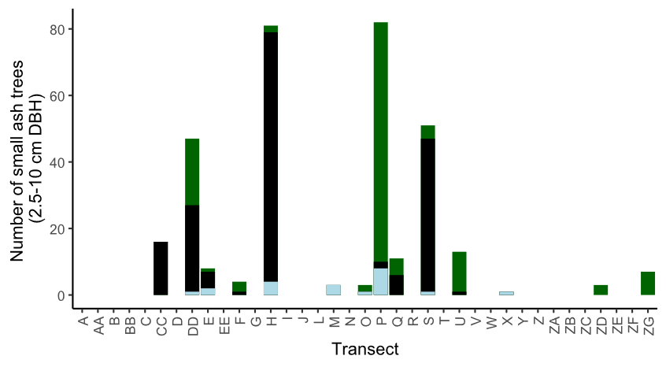

**Figure A.1.** The total number of small ash trees (2.5 – 10 cm DBH) found in 37 transects in the Upper Huron River Watershed. Small ash of all canopy conditions are counted. Bars are shaded based on the proportion of each ash species that was found in a transect. Green represents green, white, and/or pumpkin ash; black represents black ash; light blue represents unknown ash species.

**Figure A.2.** Yellow pan trap design using nested yellow bowls attached to a wooden stand and strapped to an ash tree.

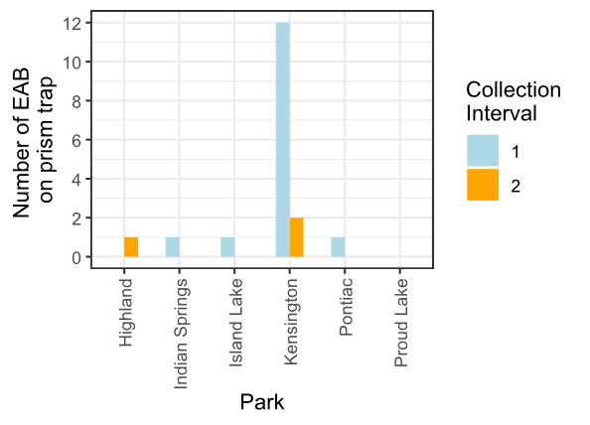

**Figure A.3.** Captures of EAB adults from Prism traps in 2024. Collection interval 1 corresponds to June, while collection interval 2 corresponds to July.

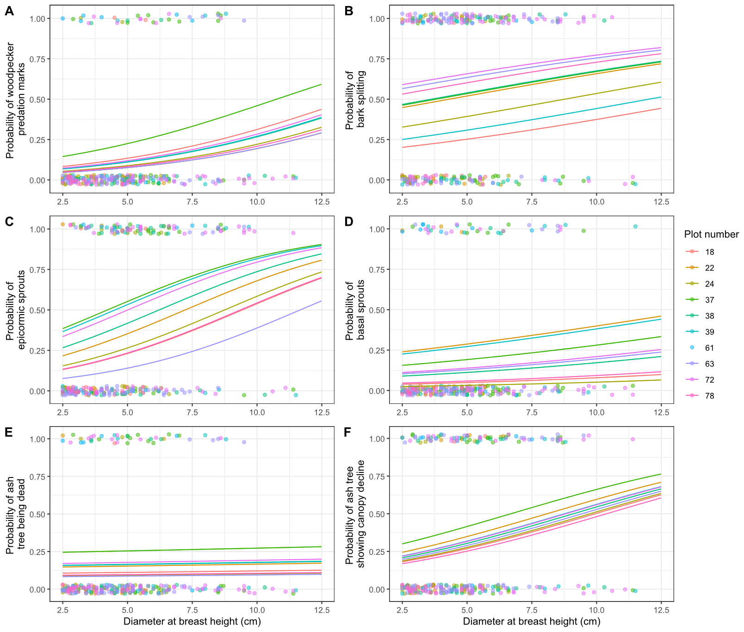

**Figure A.4.** The presence or absence of symptoms of EAB plotted against tree diameter at breast height (DBH) for 283 trees in the 10 forest plots containing at least 10 trees. Colored points are individual trees, which are plotted as y=1 for presence or y=0 for absence (points were vertically jittered slightly). Points are colored based on the plot they belong to. Colored lines show the models for each estimated random intercept corresponding to each plot.

# 

A

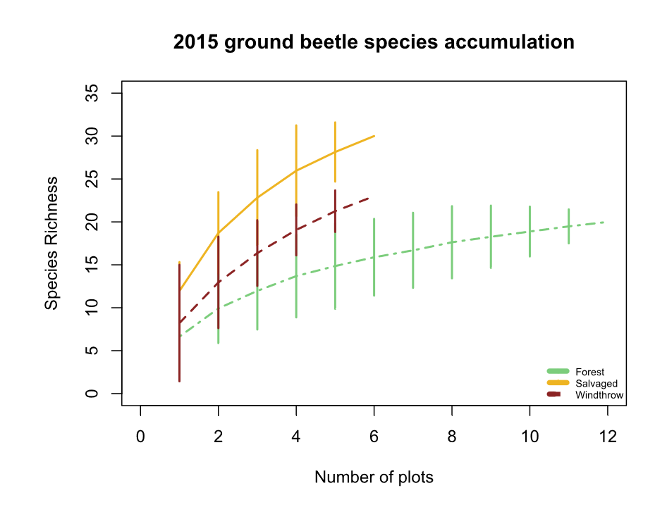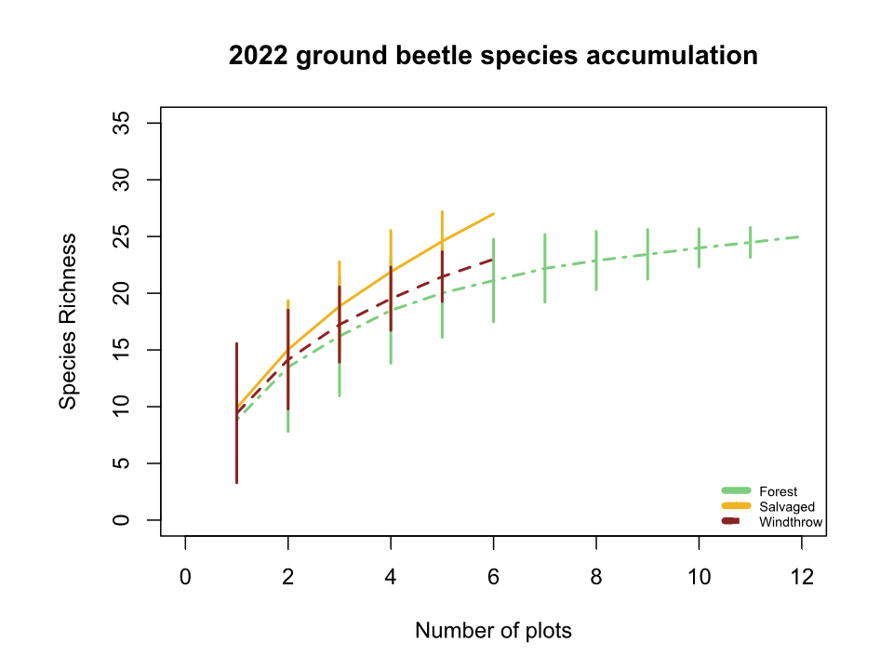

B

**Figure B.1.** Species accumulation curves for A) 2015 ground beetles and B) 2022 ground beetles. The x-axis shows the number of sampled plots, while the y-axis shows the species richness.

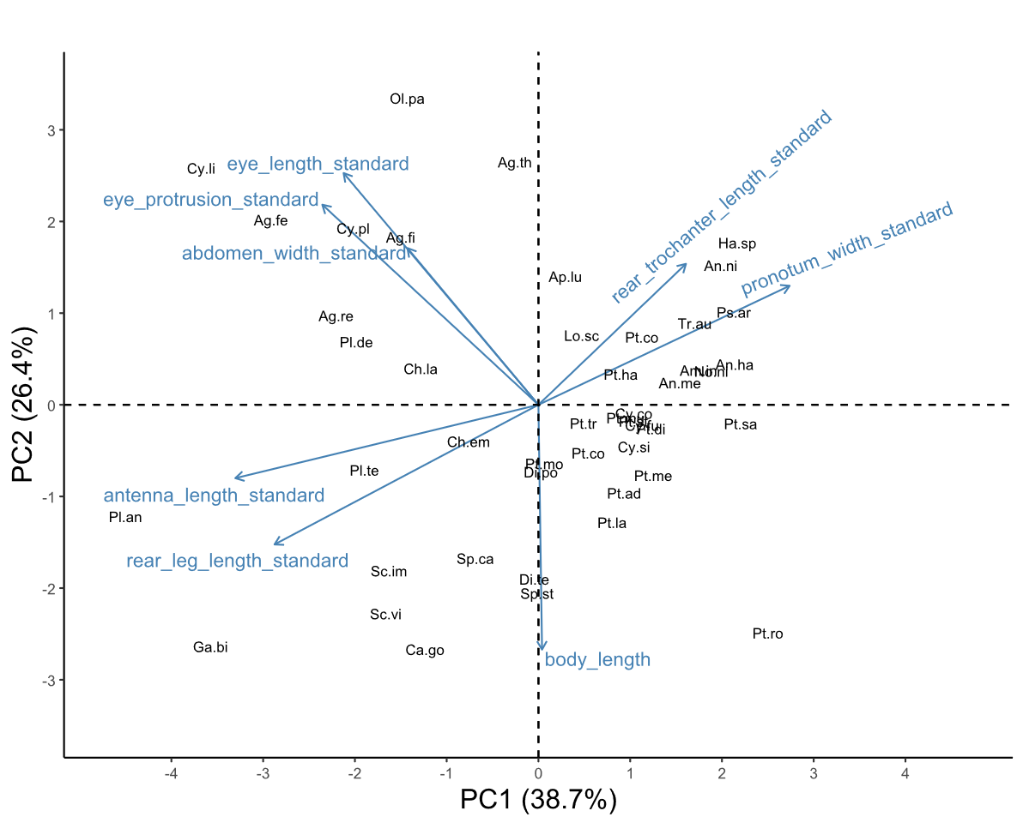

**Figure B.2.** Biplot of the first two principal component axes of the principal components analysis (PCA) of the eight numerical traits measured for 47 ground beetle species. Blue arrows with labels are the eight trait variables, which are explained in Table 1. Black text in the graph indicates the locations of each species in trait space, following the abbreviations in Table 2. The word “standard” after a variable name indicates that it has previously been divided by body length to address high correlations with body length. The species *Notiophilus aeneus* was omitted from the PCA.

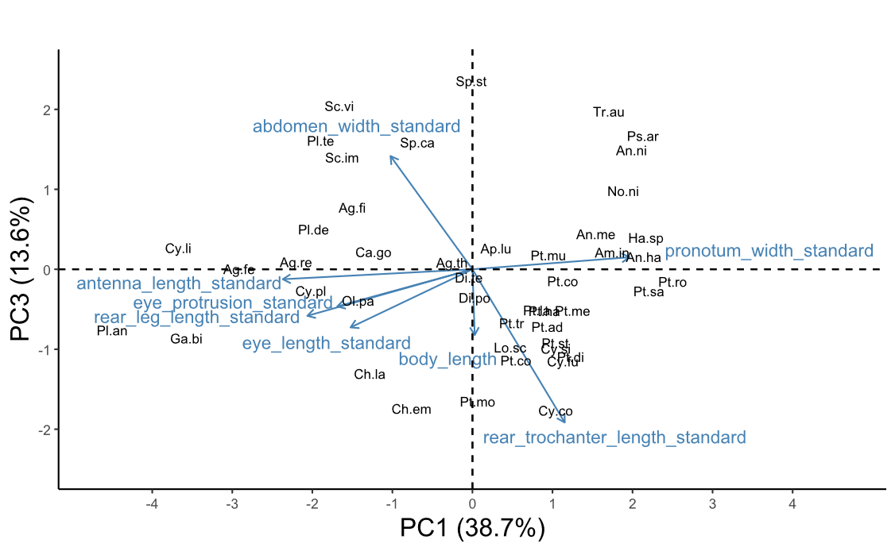

**Figure B.3.** Biplot of the third principal component axis (y-axis) against the first principal component axis (x-axis) of the principal components analysis (PCA) of the eight numerical traits measured for 47 ground beetle species. Blue arrows with labels are the eight trait variables, which are explained in Table 1. Black text in the graph indicates the locations of each species in trait space, following the abbreviations in Table 2. The word “standard” after a variable name indicates that it has previously been divided by body length to address high correlations with body length. The species *Notiophilus aeneus* was omitted from the PCA.

**Table S1.** Voucher specimens used for trait measurements in this study. The Unique ID begins with “OSUC” if the specimen was already in the Ohio State University Triplehorn Insect Collection from 2015 or a previous study, whereas Unique IDs with just a number indicate 2022 specimens which will be vouchered as part of this study.

|  |  |  |  |
| --- | --- | --- | --- |
| Species | Sex | Unique ID | Location of collection |
| *Agonoleptus thoracicus* | f | 819611 | Powdermill |
| *Agonum ferreum* | m | OSUC 671705 | Powdermill |
| *Agonum ferreum* | m | OSUC 671700 | Powdermill |
| *Agonum ferreum* | f | OSUC 671704 | Powdermill |
| *Agonum ferreum* | f | OSUC 671703 | Powdermill |
| *Agonum ferreum* | f | OSUC 671702 | Powdermill |
| *Agonum fidele* | f | 819619 | Powdermill |
| *Agonum fidele* | f | 819616 | Powdermill |
| *Agonum fidele* | f | 819613 | Powdermill |
| *Agonum retractum* | m | OSUC 671697 | Powdermill |
| *Agonum retractum* | f | OSUC 523212 | Erie Co. OH |
| *Agonum retractum* | f | OSUC 523213 | Erie Co. OH |
| *Agonum retractum* | f | OSUC 523214 | Erie Co. OH |
| *Amerizus sp.* | m | 819614 | Powdermill |
| *Amphasia interstitialis* | m | Not vouchered | Powdermill |
| *Amphasia interstitialis* | f | Not vouchered | Powdermill |
| *Amphasia interstitialis* | f | Not vouchered | Powdermill |
| *Amphasia interstitialis* | f | Not vouchered | Powdermill |
| *Anisodactylus harrisii* | m | OSUC 671671 | Powdermill |
| *Anisodactylus harrisii* | m | OSUC 740908 | Cuyahoga Co. OH |
| *Anisodactylus harrisii* | m | OSUC 740906 | Cuyahoga Co. OH |
| *Anisodactylus harrisii* | f | 819778 | Powdermill |
| *Anisodactylus harrisii* | f | OSUC 740902 | Cuyahoga Co. OH |
| *Anisodactylus harrisii* | f | OSUC 740900 | Cuyahoga Co. OH |
| *Anisodactylus melanopus* | m | 819699 | Powdermill |
| *Anisodactylus nigerrimus* | m | 819634 | Powdermill |
| *Anisodactylus nigerrimus* | m | 819631 | Powdermill |
| *Anisodactylus nigerrimus* | m | 819628 | Powdermill |
| *Anisodactylus nigerrimus* | f | 819625 | Powdermill |
| *Anisodactylus nigerrimus* | f | 819622 | Powdermill |
| *Apenes lucidula* | m | 819706 | Powdermill |
| *Apenes lucidula* | m | 819715 | Powdermill |
| *Apenes lucidula* | f | 819707 | Powdermill |
| *Apenes lucidula* | f | 819716 | Powdermill |
| *Apenes lucidula* | f | 819724 | Powdermill |
| *Carabus goryi* | m | 819636 | Powdermill |
| *Carabus goryi* | m | 819639 | Powdermill |
| *Carabus goryi* | m | 819642 | Powdermill |
| *Carabus goryi* | f | 819645 | Powdermill |
| *Carabus goryi* | f | 819648 | Powdermill |
| *Carabus goryi* | f | 819651 | Powdermill |
| *Chlaenius emarginatus* | m | 819704 | Powdermill |
| *Chlaenius emarginatus* | m | 819713 | Powdermill |
| *Chlaenius emarginatus* | m | 819722 | Powdermill |
| *Chlaenius emarginatus* | f | 819705 | Powdermill |
| *Chlaenius emarginatus* | f | 819714 | Powdermill |
| *Chlaenius emarginatus* | f | 819723 | Powdermill |
| *Chlaenius laticollis* | f | OSUC 671794 | Powdermill |
| *Chlaenius laticollis* | f | OSUC 671795 | Powdermill |
| *Cyclotrachelus convivus* | m | OSUC 671699 | Powdermill |
| *Cyclotrachelus convivus* | m | OSUC 522517 | Erie Co. OH |
| *Cyclotrachelus convivus* | m | OSUC 740962 | Cuyahoga Co. OH |
| *Cyclotrachelus convivus* | f | OSUC 522528 | Erie Co. OH |
| *Cyclotrachelus convivus* | f | OSUC 522527 | Erie Co. OH |
| *Cyclotrachelus convivus* | f | OSUC 522525 | Erie Co. OH |
| *Cyclotrachelus fucatus* | m | 819782 | Powdermill |
| *Cyclotrachelus sigillatus* | m | 819753 | Powdermill |
| *Cyclotrachelus sigillatus* | m | 819763 | Powdermill |
| *Cyclotrachelus sigillatus* | m | 819773 | Powdermill |
| *Cyclotrachelus sigillatus* | f | 819754 | Powdermill |
| *Cyclotrachelus sigillatus* | f | 819764 | Powdermill |
| *Cyclotrachelus sigillatus* | f | 819774 | Powdermill |
| *Cymindis limbata* | unknown sex | 819617 | Powdermill |
| *Cymindis platicollis* | unknown sex | 819777 | Powdermill |
| *Dicaelus politus* | m | 819708 | Powdermill |
| *Dicaelus politus* | m | 819717 | Powdermill |
| *Dicaelus politus* | m | 819725 | Powdermill |
| *Dicaelus politus* | f | 819709 | Powdermill |
| *Dicaelus politus* | f | 819718 | Powdermill |
| *Dicaelus politus* | f | 819726 | Powdermill |
| *Dicaelus teter* | m | 819604 | Powdermill |
| *Dicaelus teter* | m | 819719 | Powdermill |
| *Dicaelus teter* | m | 819727 | Powdermill |
| *Dicaelus teter* | f | 819710 | Powdermill |
| *Dicaelus teter* | f | 819720 | Powdermill |
| *Dicaelus teter* | f | 819728 | Powdermill |
| *Galerita bicolor* | f | 819640 | Powdermill |
| *Galerita bicolor* | f | 819637 | Powdermill |
| *Harpalus spadiceus* | m | 819658 | Powdermill |
| *Harpalus spadiceus* | m | 819655 | Powdermill |
| *Harpalus spadiceus* | m | 819652 | Powdermill |
| *Harpalus spadiceus* | f | 819649 | Powdermill |
| *Harpalus spadiceus* | f | 819646 | Powdermill |
| *Harpalus spadiceus* | f | 819643 | Powdermill |
| *Lophoglossus scrutator* | m | 819780 | Powdermill |
| *Myas coracinus* | m | 819733 | Powdermill |
| *Myas coracinus* | f | 819734 | Powdermill |
| *Notiobia nitidipennis* | m | 672665 | Powdermill |
| *Notiobia nitidipennis* | m | 672659 | Powdermill |
| *Notiobia nitidipennis* | m | 672651 | Powdermill |
| *Notiobia nitidipennis* | f | 672663 | Powdermill |
| *Notiobia nitidipennis* | f | 672662 | Powdermill |
| *Notiobia nitidipennis* | f | 672661 | Powdermill |
| *Notiophilus aeneus* | m | 819608 | Powdermill |
| *Olisthopus parmatus* | f | 819630 | Powdermill |
| *Olisthopus parmatus* | f | 819633 | Powdermill |
| *Olisthopus parmatus* | f | OSUC 672763 | Powdermill |
| *Olisthopus parmatus* | m | OSUC 672759 | Powdermill |
| *Olisthopus parmatus* | m | OSUC 672760 | Powdermill |
| *Patrobus longicornis* | f | 819693 | Powdermill |
| *Platynus angustatus* | m | 819612 | Powdermill |
| *Platynus angustatus* | m | 819615 | Powdermill |
| *Platynus angustatus* | m | 819618 | Powdermill |
| *Platynus angustatus* | f | 819621 | Powdermill |
| *Platynus angustatus* | f | 819624 | Powdermill |
| *Platynus angustatus* | f | 819627 | Powdermill |
| *Platynus decentis* | m | 819687 | Powdermill |
| *Platynus hypolithos* | m | 819690 | Powdermill |
| *Platynus tenuicollis* | m | 819610 | Powdermill |
| *Platynus tenuicollis* | m | 819607 | Powdermill |
| *Platynus tenuicollis* | f | 819603 | Powdermill |
| *Platynus tenuicollis* | f | 819606 | Powdermill |
| *Platynus tenuicollis* | f | 819609 | Powdermill |
| *Pseudamara arenaria* | f | 819605 | Powdermill |
| *Pseudamara arenaria* | f | OSUC 671695 | Powdermill |
| *Pterostichus adoxus* | m | 819749 | Powdermill |
| *Pterostichus adoxus* | m | 819759 | Powdermill |
| *Pterostichus adoxus* | m | 819769 | Powdermill |
| *Pterostichus adoxus* | f | 819750 | Powdermill |
| *Pterostichus adoxus* | f | 819760 | Powdermill |
| *Pterostichus adoxus* | f | 819770 | Powdermill |
| *Pterostichus atratus* | m | 819735 | Powdermill |
| *Pterostichus atratus* | f | 819736 | Powdermill |
| *Pterostichus coracinus* | m | 819751 | Powdermill |
| *Pterostichus coracinus* | m | 819761 | Powdermill |
| *Pterostichus coracinus* | m | 819771 | Powdermill |
| *Pterostichus coracinus* | f | 819752 | Powdermill |
| *Pterostichus coracinus* | f | 819762 | Powdermill |
| *Pterostichus coracinus* | f | 819772 | Powdermill |
| *Pterostichus corvinus* | m | OSUC 671808 | Powdermill |
| *Pterostichus corvinus* | f | OSUC 671807 | Powdermill |
| *Pterostichus corvinus* | f | OSUC 671809 | Powdermill |
| *Pterostichus corvinus* | f | OSUC 671810 | Powdermill |
| *Pterostichus diligendus* | m | 819781 | Powdermill |
| *Pterostichus hamiltoni* | m | 819779 | Powdermill |
| *Pterostichus lachrymosus* | m | 819682 | Powdermill |
| *Pterostichus lachrymosus* | m | 819679 | Powdermill |
| *Pterostichus lachrymosus* | m | 819676 | Powdermill |
| *Pterostichus lachrymosus* | f | 819673 | Powdermill |
| *Pterostichus lachrymosus* | f | 819670 | Powdermill |
| *Pterostichus lachrymosus* | f | 819667 | Powdermill |
| *Pterostichus melanarius* | m | OSUC 522968 | Erie Co. OH |
| *Pterostichus melanarius* | m | OSUC 522969 | Erie Co. OH |
| *Pterostichus melanarius* | m | OSUC 668451 | Powdermill |
| *Pterostichus melanarius* | f | OSUC 740950 | Cuyahoga Co. OH |
| *Pterostichus moestus* | m | 819737 | Powdermill |
| *Pterostichus moestus* | m | 819741 | Powdermill |
| *Pterostichus moestus* | m | 819745 | Powdermill |
| *Pterostichus moestus* | f | 819738 | Powdermill |
| *Pterostichus moestus* | f | 819742 | Powdermill |
| *Pterostichus moestus* | f | 819746 | Powdermill |
| *Pterostichus mutus* | m | OSUC 522813 | Erie Co. OH |
| *Pterostichus mutus* | m | OSUC 671803 | Powdermill |
| *Pterostichus mutus* | m | OSUC 671804 | Powdermill |
| *Pterostichus mutus* | f | OSUC 522811 | Erie Co. OH |
| *Pterostichus mutus* | f | OSUC 671805 | Powdermill |
| *Pterostichus mutus* | f | OSUC 671801 | Powdermill |
| *Pterostichus rostratus* | m | 819729 | Powdermill |
| *Pterostichus rostratus* | m | 819739 | Powdermill |
| *Pterostichus rostratus* | m | 819743 | Powdermill |
| *Pterostichus rostratus* | f | 819730 | Powdermill |
| *Pterostichus rostratus* | f | 819740 | Powdermill |
| *Pterostichus rostratus* | f | 819744 | Powdermill |
| *Pterostichus sayanus* | m | 819731 | Powdermill |
| *Pterostichus sayanus* | f | 819732 | Powdermill |
| *Pterostichus stygicus* | m | 819755 | Powdermill |
| *Pterostichus stygicus* | m | 819765 | Powdermill |
| *Pterostichus stygicus* | m | 819775 | Powdermill |
| *Pterostichus stygicus* | f | 819756 | Powdermill |
| *Pterostichus stygicus* | f | 819766 | Powdermill |
| *Pterostichus stygicus* | f | 819776 | Powdermill |
| *Pterostichus tristis* | m | 819747 | Powdermill |
| *Pterostichus tristis* | m | 819757 | Powdermill |
| *Pterostichus tristis* | m | 819767 | Powdermill |
| *Pterostichus tristis* | f | 819748 | Powdermill |
| *Pterostichus tristis* | f | 819758 | Powdermill |
| *Pterostichus tristis* | f | 819768 | Powdermill |
| *Scaphinotus andrewsii* | m | 819660 | Powdermill |
| *Scaphinotus andrewsii* | f | 819663 | Powdermill |
| *Scaphinotus imperfectus* | m | 819672 | Powdermill |
| *Scaphinotus imperfectus* | m | 819675 | Powdermill |
| *Scaphinotus imperfectus* | m | 819678 | Powdermill |
| *Scaphinotus imperfectus* | f | 819681 | Powdermill |
| *Scaphinotus imperfectus* | f | 819684 | Powdermill |
| *Scaphinotus ridingsii* | m | 819666 | Powdermill |
| *Scaphinotus ridingsii* | m | 819669 | Powdermill |
| *Scaphinotus viduus* | m | 819654 | Powdermill |
| *Scaphinotus viduus* | m | 819657 | Powdermill |
| *Sphaeroderus canadensis* | m | 819702 | Powdermill |
| *Sphaeroderus canadensis* | m | 819711 | Powdermill |
| *Sphaeroderus canadensis* | f | 819703 | Powdermill |
| *Sphaeroderus canadensis* | f | 819712 | Powdermill |
| *Sphaeroderus canadensis* | f | 819721 | Powdermill |
| *Sphaeroderus stenostomus* | m | 819700 | Powdermill |
| *Sphaeroderus stenostomus* | m | 819697 | Powdermill |
| *Sphaeroderus stenostomus* | m | 819694 | Powdermill |
| *Sphaeroderus stenostomus* | f | 819691 | Powdermill |
| *Sphaeroderus stenostomus* | f | 819688 | Powdermill |
| *Sphaeroderus stenostomus* | f | 819685 | Powdermill |
| *Synuchus impunctatus* | f | 819696 | Powdermill |
| *Trichotichnus autumnalis* | f | 819664 | Powdermill |
| *Trichotichnus autumnalis* | f | 819661 | Powdermill |

**Table S2.** Loading values for the first four principal components of eight numerical traits. Percentages underneath each PC column indicate the percentage of variance explained by each axis. The word “standard” after a variable name indicates that it has previously been divided by body length.

|  |  |  |  |  |
| --- | --- | --- | --- | --- |
| Trait | PC1 (39%) | PC2 (26%) | PC3 (14%) | PC4 (11%) |
| body_length | 0.01 | -0.5 | -0.3 | 0.57 |
| antenna_length_standard | -0.51 | -0.15 | -0.05 | -0.05 |
| eye_protrusion_standard | -0.37 | 0.41 | -0.17 | 0.25 |
| eye_length_standard | -0.33 | 0.48 | -0.27 | -0.21 |
| pronotum_width_standard | 0.43 | 0.24 | 0.06 | 0.4 |
| abdomen_width_standard | -0.22 | 0.32 | 0.52 | 0.58 |
| rear_leg_length_standard | -0.45 | -0.29 | -0.21 | 0.21 |
| rear_trochanter_length_standard | 0.25 | 0.29 | -0.7 | 0.17 |

**Table S3.** Comparison of the principal component analyses (PCA) run with and without *Notiophilus aeneus*, a species with unusual traits. Traits were listed under “Top loading values” if their loading value was ≥ 0.4. The word “standard” after each trait indicates that these values have been divided by body length prior to running the PCA.

|  |  |  |
| --- | --- | --- |
|  | **PCA with *Notiophilus aeneus*** | **PCA excluding *Notiophilus aeneus* (used in further analyses)** |
| Variance explained by PC1 | 33.1 % | 38.7 % |
| Variance explained by PC2 | 30.2 % | 26.4 % |
| Variance explained by PC3 | 14.0 % | 13.6 % |
| Top loading values for PC1 | antenna_length_standard (+0.53),  pronotum_width_standard (-0.50),  rear_leg_length_standard (+0.54) | antenna_length_standard (-0.51),  pronotum_width_standard (+0.43),  rear_leg_length_standard (-0.45) |
| Top loading values for PC2 | body_length (-0.41),  eye_protrusion_standard (+0.58),  eye_length_standard (+0.59), | body_length (-0.50),  eye_protrusion_standard (+0.41),  eye_length_standard (+0.48) |
| Top loading values for PC3 | abdomen_width_standard (-0.85) | abdomen_width_standard (+0.52)  rear_trochanter_length_standard (-0.70) |

**Table S4.** Specific definitions of the traits measured for ground beetles in this study. Literature-based traits were found using (Larochelle and Larivière 2003). Morphological traits were measured using an ocular micrometer. Sometimes multiple measurements were added to obtain a morphological trait. For example, body length was defined as elytron length + pronotum length + head length.

|  |  |  |  |
| --- | --- | --- | --- |
| **Literature-based traits** |  |  | **Definition** |
| Forest_affinity |  |  | Three options: forest specialist, open habitat, or eurytopic. Mark forest specialist if Larochelle and Lariviere (2003) only mention forested areas and/or shaded ground as a habitat. Mark open habitat if they only mention clearings, pastures, or fields, and/or if they only mention unshaded ground or open habitat. Mark eurytopic if both habitat affinities are mentioned, such as "forest clearings" or "shaded or open ground" or "roads and edges". |
| Water_affinity |  |  | Water affinity was coded as 0 for xerophilous species, 1 for hygrophilous species, and 0.5 for intermediate species. If the description mentions wet soil or proximity to waterway or lakes, then mark 1 (hygrophilous). If description mentions moist soil, then 0.5 (intermediate). If description mentions dry soil, then 0 (xerophilous). |
| Flight_capability |  |  | Flight capability was coded as 1 if the species is flight-capable, 0 if the species is flight-incapable, and 0.5 if the species exhibits wing dimorphism. Taken from Larochelle and Lariviere (2003) rather than from the specimens. |
|  |  |  |  |
| **Trait** | **Measured components** | **Unit** | **Definition** |
| Body_length |  | mm | Elytra_length + Pronotum_length + Head_length |
|  | Elytra_length | mm | Distance, along 1st elytral interval, from posterior edge of pronotum to posterior edge of elytra - not including the abdomen if it extends past elytra. The anterior 1/2 of the elytra should be horizontal. |
|  | Pronotum_length | mm | Distance, along midline, from anterior to posterior end of pronotum |
|  | Head_length | mm | Distance from tip of mandibles to anterior end of pronotum (follows Bousquet 2010). If mandibles are unequal in length, I'm taking the distance from the longer of the mandibles. I'm pitching the beetle up so that the mandibles are at roughly the same height as the frons. |
|  |  |  |  |
| Antenna_length |  | mm | Distance from the base to tip of antenna. Choose the left or right antenna depending on which is less curved and which one is not missing any segments. If necessary, divide the antenna into parts and add up the lengths. |
|  |  |  |  |
| Eye_protrusion |  | mm | Outer_eye_distance - Inner_eye_distance |
|  | Outer_eye_distance | mm | Distance between apical sides of each compound eye, EVEN if the head behind or around the eyes is slightly wider than the measured distance (example: *Pterostichus rostratus*) |
|  | Inner_eye_distance | mm | Looking down at the dorsal surface of the beetle's head, find the minimum separation between the interior edges of the compound eyes |
|  |  |  |  |
| Eye_length |  | mm | Look at beetle in profile. Turn the beetle so the rounded part of the eye is pointing straight up towards the lens of the microscope. Then measure from the anterior to posterior of the part covered in ommatidia. Measure along the direction from lateral pronotal edge to mandibles |
| Pronotum_width |  | mm | Distance between marginal sides of pronotum at their widest point |
|  |  |  |  |
| Abdomen_width |  | mm | Distance between marginal sides of elytra or abdomen at widest point. If the elytra are widely separated, then measure width of one elytron and multiply by 2. |
|  |  |  |  |
| Rear_leg_length |  | mm | Rear_femur_length + Rear_tibia_length + Rear_tarsi_length |
|  | Rear_femur_length | mm |  |
|  | Rear_tibia_length | mm | Distance from (the center of the apex of the femur) to end of tibia, not including tibial spurs |
|  | Rear_tarsi_length | mm | If necessary, measure each tarsal segment and add them up. Do not include tarsal claws. |
|  |  |  |  |
| Rear_trochanter_length |  | mm | Length of the bean-shaped rear trochanter |